**2025**

**131st**

**Hitz fm 93.9 BUNDABERG SHOW**

# **WEDNESDAY 28th May**

**THURSDAY 29th May**

**FRIDAY 30th May**

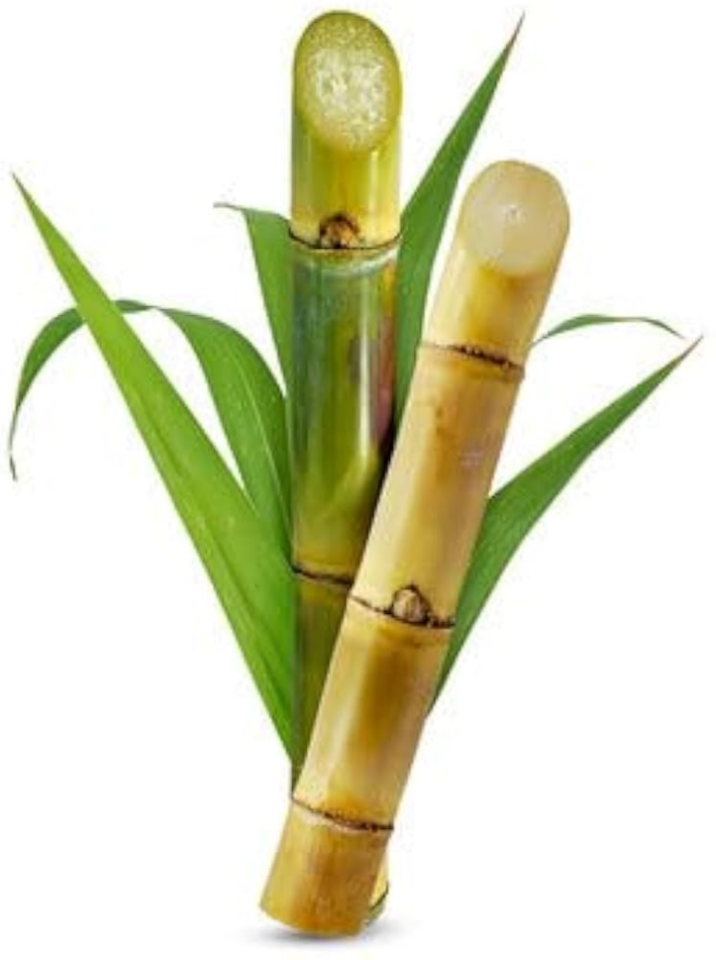

**SECTION 7**

**CANE**

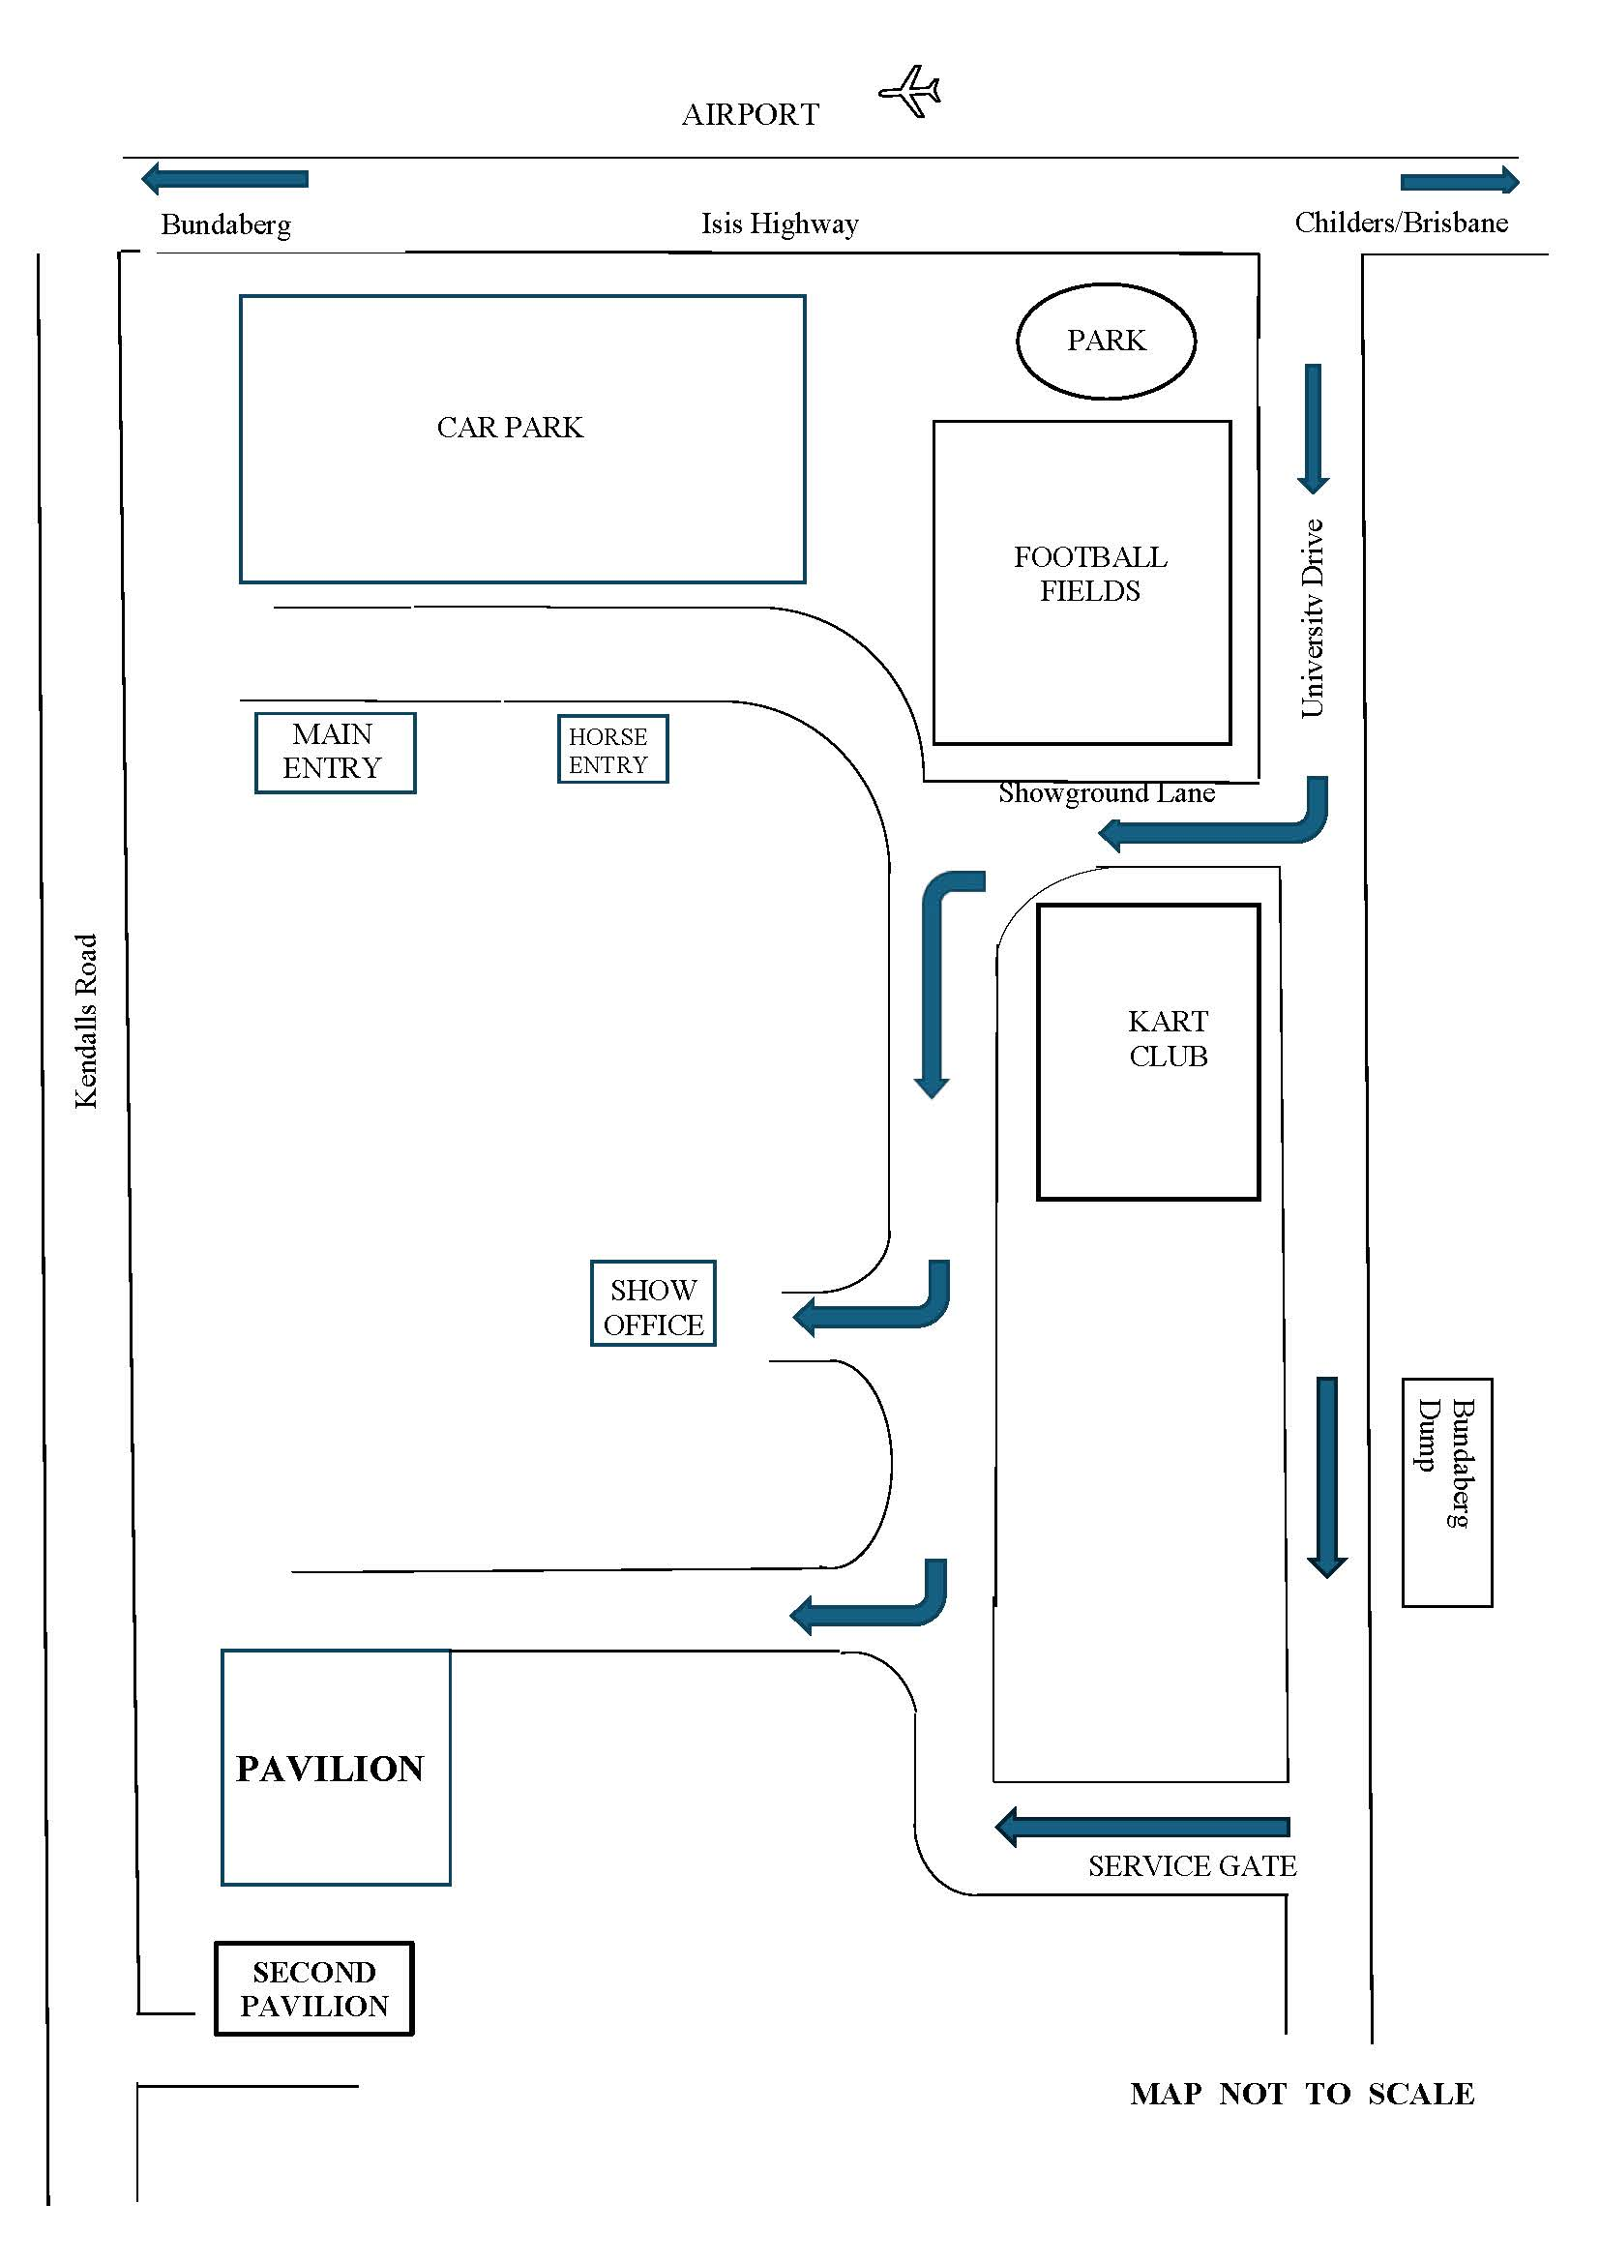

PRIVACY STATEMENT

The Information provided by Exhibitors Is used by the Queensland Chamber of Agriculture Associations Inc. and the Bundaberg A.P. & I, Society Inc. to organize , process and conduct competitions at the Bundaberg AP & I Society Inc show. By entering such competitions, you consent to your personal Information being used for this purpose Including this Information being made available to sponsors, breed Associations, the media, the public, promotional purposes. archival purposes, published in publications or as It Is otherwise required by Law.

All exhibitors have the right to access and alter personal information concerning themselves in the terms of the Privacy Act. This can be done by contacting the QCAS CEO or by writing to QCAS

WORKPLACE HEALTH AND SAFETY

All Queensland Chamber of Agriculture Societies Inc. affiliated Association Showgrounds are designated workplaces within the meaning of the Workplace Health and Safety Act 2011 and exhibitors/competitors are required to ensure that they and all persons under their direction or control, including their contractors or subcontractors, comply with all requirements of the Act. The Queensland Chamber of Agriculture Associations Inc hold each exhibitor responsible to discharge Its obligations to provide and maintain a safe place and system of work during occupation by the exhibitor/competitor of any area of the affiliated Agricultural Associations Showgrounds/Precinct.

Each exhibitor/competitor will assess the risk to themselves, staff, volunteers, family, other exhibitors, Agricultural Society staff, show visitors, children and any person foreseeably affected by the presentation of their exhibit.

Exhibits will only be held and handled by competent persons whose experience Is known to the Exhibitor/ competitor.

The exhibitors/competitors are advised that the use of Primus Stoves, any heating or lighting appliances of a like character, or any naked light, ls strictly prohibited in Pavilions/stables/barns.

Any exhibitors/competitors Intending to bring electrical equipment to the Showgrounds/Precinct will be required to ensure that such equipment Is fitted with a residual current protection and that all electrical lead s, tools and appliances have been Inspected by a licensed electrical contractor and are currently tagged. The use of double adaptors is prohibited, and all power boards must also be tested and tagged.

All exhibitors/competitors will comply with the requirements of the ACT end Its Regulations and Standards In every respect. This Is essential for the safety of all exhibitors/competitors and the general public. The ACT Imposes very severe penalties in the event of noncompliance with its provisions. Any exhibitors/competitors who do not comply will not be allowed to exhibit at "Queensland Chamber of Agriculture Association. affiliated Shows".

**BUNDABERG SHOW**

GATE ENTRY FEES:

ADULT:------------------------------$20.00

STUDENT: 6 – 17 yrs.:------------$10.00

CONCESSION:----------------------$10.00

OVER 75 YEARS :-----------------FREE

UNDER 6 YEARS:-----------------FREE

**PRE-PURCHASE TICKET ONLY**

FAMILY ONE DAY PASS $50.00

(Available until Tuesday 27th May)

(Includes 2 Adult & 2 Children 15 yrs. & under)

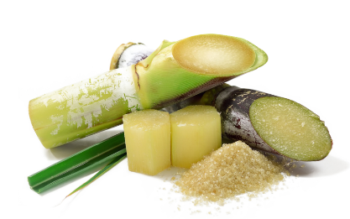

**Section 7**

**SUGAR CANE**

**CHIEF STEWARD** Paul Nicol

**ENTRY FEES** Isis Mill Covers all entry Fees

**Proudly Sponsored by - Isis Central Sugar Mill, Nutrient Ag Solutions Childers, General** Engineering **& Irrigation Childers, Bundaberg Caltex, Bundaberg Trackset, Peter Waltons Tyre and Batteries Bundaberg and Bobs Tyre’s Maryborough.**

**STEWARDS** Bruce Findlay, Troy Manderson and Paul Nicol

**JUDGES** Jim Sullivan and Jeff Geaney

**PRIZE MONEY** 1st - $20, 2nd -$5 unless otherwise stated. In some Classes Vouchers/prizes will be given instead of Prize Money.

**SPECIAL REGULATIONS**:

* All cane to be approved varieties and to be the property of the exhibitor who is a bona fide cane grower.
* **All exhibits to be delivered to the cane section at the showgrounds *between 1pm-5pm Tuesdaythe 27th of May 2025.***
* Classes 1 to 14 – Any cane without a natural top will be excluded.
* A separate exhibit in each class unless otherwise specified.
* All exhibits must bare correct variety and age of cane on class ticket.
* Approved varieties: Q135, Q138, Q151, Q155, Q183, Q200, Q208, KQ228, Q232, Q238, Q240, Q242, Q245, Q249, Q252, SRA 11, SRA 19 and SRA 20.
* No suckers in any exhibits.
* On completion of the show, all cane will be destroyed by Isis Central Sugar Mill

**GENERAL EXHIBITS**

1. Q208, Q242 Best 4 sticks of Plant or Ratoon under 12 months
2. Q135, Q252 Best 4 sticks of Plant or Ratoon under 12 months
3. Q183, Q245 Best 4 sticks of Plant or Ratoon under 12 months
4. KQ228, SRA11 Best 4 sticks of Plant or Ratoon under 12 months
5. Q240 Best 4 sticks of Plant or Ratoon under 12 months
6. SRA 19, SRA 20 Best 4 sticks of Plant or Ratoon under 12 months
7. Best 4 sticks of any other variety of Plant or Ratoon under 12 months
8. Q208, Q242 Best 4 sticks of Plant or Ratoon over 12mths & under 18mths
9. Q135, Q252 Best 4 sticks of Plant or Ratoon over 12mths & under 18mths
10. Q183, Q245 Best 4 sticks of Plant or Ratoon over 12mths & under 18mths
11. KQ228, SRA 11 Best 4 sticks of Plant or Ratoon over 12mths & under 18mths
12. Q240 Best 4 sticks of Plant or Ratoon over 12mths & under 18mths
13. SRA 19, SRA 20 Best 4 sticks of Plant or Ratoon over 12mths & under 18mths
14. Best 4 sticks of any other variety of Plant or Ratoon over 12mths & under 18mths

CHAMPION - Best 4 sticks for class 1-7 plus Mill Trophy

1st - $50+Sash, 2nd - $20, 3rd - $10

CHAMPION – Best 4 sticks for class 8-14 plus Mill Trophy

1st - $50+Sash, 2nd - $20, 3rd - $10

1. Heaviest stick of cane: 1st- $20+Sash, 2nd - $10
2. A group of bamboo stems with leaves

   Description automatically generatedLongest stick of cane: 1st - $20+Sash, 2nd - $10

**The Bundaberg A.P. & I. Society Inc**

**Wish to thank - Our Sugar Cane Section**

**MAJOR SPONSOR**

**Isis Central Sugar Mill Co. Ltd. & their Team**

**for their continued support of this Section of the Bundaberg Show – 2025**

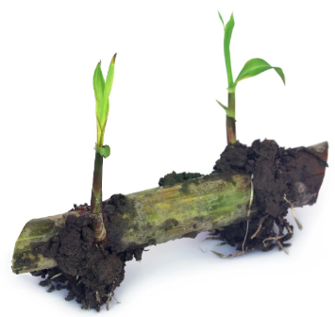

ENTRY FORM

BUNDABERG A.P. & I SOCIETY INC

THE SECRETARY, SHOWGROUNDS OFFICE

Via UNIVERSITY DRIVE, BUNDABERG QLD 4670

TELEPHONE:- (07) 4138 7605

ABN 21 134 402 026

*EACH EXHIBITOR TO BE ON A SEPARATE FORM*

PLEASE NOTE: MULTIPLE ENTRIES PER SECTION TO BE WRITTEN ON THE ONE FORM. YOU DO NOT NEED TO COMPLETE A SEPARATE ENTRY FORM PER CLASS IN ANY PARTICULAR SECTION.

Subject to the Rules, By-Laws and Regulations of your Society and the Queensland Chamber of Agricultural Societies, I make the following entries for your forthcoming Show.

EACH SECTION NOT CLASS TO BE ON A SEPARATE FORM

ONE LINE PER ENTRY

|  |  |  |  |  |
| --- | --- | --- | --- | --- |
| SECTION NUMBER | CLASS NUMBER | DESCRIPTION OF EXHIBIT (Under 12 months or 12-18 months) | VARIETY OF EXHIBIT | FREE ENTRY |
|  |  |  |  |  |
|  |  |  |  |  |
|  |  |  |  |  |
|  |  |  |  |  |
|  |  |  |  |  |
|  |  |  |  |  |
|  |  |  |  |  |
|  |  |  |  |  |
|  |  |  |  |  |
|  |  |  |  |  |
|  |  |  |  |  |
|  |  |  |  |  |
|  |  |  |  |  |
|  |  |  |  |  |
|  |  |  |  |  |
|  |  |  | TOTAL  FEES |  |

GROWER NAME

Please print

ADDRESS

PHONE NUMBER

EMAIL:

DATE ABN

SIGNATURE