**2025**

**131st**

**Hitz fm 93.9 BUNDABERG SHOW**

# WEDNESDAY 28th May

**THURSDAY 29th May**

**FRIDAY 30th May**

.

**SECTION 6**

**CAGED BIRD**

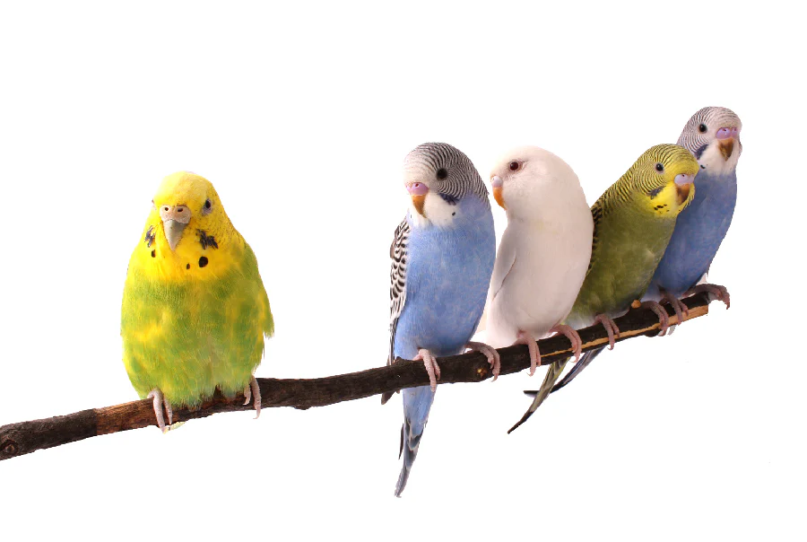

PRIVACY STATEMENT

The Information provided by Exhibitors Is used by the Queensland Chamber of Agriculture Associations Inc. and the Bundaberg A.P. & I, Society Inc. to organize , process and conduct competitions at the Bundaberg AP & I Society Inc show. By entering such competitions, you consent to your personal Information being used for this purpose Including this Information being made available to sponsors, breed Associations, the media, the public, promotional purposes. archival purposes, published in publications or as It Is otherwise required by Law.

All exhibitors have the right to access and alter personal information concerning themselves in the terms of the Privacy Act. This can be done by contacting the QCAS CEO or by writing to QCAS

WORKPLACE HEALTH AND SAFETY

All Queensland Chamber of Agriculture Societies Inc. affiliated Association Showgrounds are designated workplaces within the meaning of the

Workplace Health and Safety Act 2011 and exhibitors/competitors are required to ensure that they and all persons under their direction or control, including their contractors or subcontractors, comply with all requirements of the Act. The Queensland Chamber of Agriculture Associations Inc hold each exhibitor responsible to discharge Its obligations to provide and maintain a safe place and system of work during occupation by the exhibitor/competitor of any area of the affiliated Agricultural Associations Showgrounds/Precinct.

Each exhibitor/competitor will assess the risk to themselves, staff, volunteers, family, other exhibitors, Agricultural Society staff, show visitors, children and any person foreseeably affected by the presentation of their exhibit.

Exhibits will only be held and handled by competent persons whose experience Is known to the Exhibitor/ competitor.

The exhibitors/competitors are advised that the use of Primus Stoves, any heating or lighting appliances of a like character, or any naked light, ls strictly prohibited in Pavilions/stables/barns.

Any exhibitors/competitors Intending to bring electrical equipment to the Showgrounds/Precinct will be required to ensure that such equipment Is fitted with a residual current protection and that all electrical lead s, tools and appliances have been Inspected by a licensed electrical contractor and are currently tagged. The use of double adaptors is prohibited, and all power boards must also be tested and tagged.

All exhibitors/competitors will comply with the requirements of the ACT end Its Regulations and Standards In every respect. This Is essential for the safety of all exhibitors/competitors and the general public. The ACT Imposes very severe penalties in the event of noncompliance with its provisions. Any exhibitors/competitors who do not comply will not be allowed to exhibit at"Queensland Chamber of Agriculture Association. affiliated Shows".

**BUNDABERG SHOW**

GATE ENTRY FEES:

ADULT:------------------------------$20.00

STUDENT: 6 – 17 yrs.:------------$10.00

CONCESSION:---------------------$10.00

OVER 75 YEARS :-----------------FREE

UNDER 6 YEARS:-----------------FREE

**PRE-PURCHASE TICKET ONLY**

FAMILY ONE DAY PASS $50.00

(Available until Tuesday 27th May)

(Includes 2 Adult & 2 Children 15 yrs. & under)

**SECTION 6**

**CAGED BIRDS**

**HOW TO ENTER THE SECTIONS**

FILL OUT ENTRY FORMS

**All entries must be:**

* **On Official Entry Forms**
* **On SEPARATE Entry Forms for Each Section (NOT CLASS)**
* **Fully completed**
* **Accompanied by Entry Fees (Refer Sections)**

# ENTRIES WILL NOT BE ACCEPTED

* **Without entry fees**
* **Over the telephone**
* **After closing date**

# DELIVER ENTRY FORMS TO

**Bundaberg Show Society Office**

**via University Drive, Bundaberg**

**Enquiries – Phone 07 4138 7605**

**Delivery of entry forms – : April 2024 – Mon, Wed, & Fri 9am – 1pm .**

**May 2024 – Mon – Fri, 9am -4pm.**

# YOU WILL RECEIVE

* **Class Ticket stating Section, Class and Entry No. (if applicable)**
* **Receipt**

# DELIVER EXHIBITS

* **Accompanied by Class Ticket (ATTACHED) (if applicable)**

**(This is proof of Entry in a Class)**

* **To designated part of Showground by due date and time.**

## PLEASE REFER TO RULES FOR EACH SECTION FOR CLOSING DATES.

## PRIZE MONEY: All Prize Money to be collected from Show Office from 2pm Wednesday, 28th May to 2pm Saturday 31st . Office hours 9.00 – 4.00. Prize Money NOT COLLECTED will be deemed a donation and returned to Society’s Funds. All prize money includes GST which is payable by competitors whether registered for GST not registered for GST.

**CANARIES, FINCHES, BUDGERIGARS, PARROTS**

**QUAILS & DOVES**

**CONDITIONS OF ENTRY**

1. Refer General Conditions of Entry & Competition at the back of Schedule.

2. There will be no limit of entries.

3. No exhibit can be entered in more than one class.

4. All exhibits must have official class sticker attached.

5. Class stickers are to be affixed to the highest portion of the bottom board on the front of the cage at the LEFT HAND SIDE, other than budgerigars who will have their stickers affixed to the RIGHT HAND SIDE. No distinguishing marks may appear on the cage.

6. All exhibits shall be exhibited in STANDARD SHOW CAGES. For birds without Standard Show Cages, please use a suitable cage.

7. No birds shall be removed until after closing of the Show, without the sanction of the Chief Steward.

8. All cage bird exhibitors must provide sufficient food and water for 24 hours.

9. Cages to have floors covered with coarse grit or sand or seed.

10. The Judge shall be empowered to decline to award a Champion in any class in which specimens are not, in his opinion, of sufficient merit. No birds will be awarded any prize, unless the Judge considers it worthy. No discussion will be entered into.

11. All exhibits must be the bona fide property of the exhibitor at the time of entry. Any person infringing this rule by any device shall forfeit all entry fees and prize money.

12. Prizes to be awarded based on the relevant Australian Standard where applicable.

13. For delivery of exhibits and collection of same (refer to Steward for collection procedures), entry to the grounds may be gained via University Drive.

14. Definition of Classes - **CLEAR** - Clear, without handling; **HEAVILY VARIEGATED** - Dark colour to predominat**e; LIGHTLY VARIEGATED** - Light colour to predominate.

**15. ENTRIES CLOSE:** Friday, 24th May 2024 at 5.00 pm. No late entries accepted.

16. Exhibits to be delivered to the Bird pavilion on Tuesday, 28th May 2024 between 5 pm & 8 pm.

17. Exhibits to be collected on Friday 31st May 2024 between 4pm and 6pm, refer to Chief Steward.

18. For sale of birds (exhibitors’ birds only), birds on show bench will not be released before close of show, 10% of sale to Show Society.

## 

**CHIEF STEWARD** - **MR JOHN TADGELL** Phone 4152 9637

**ENTRY FEES** - $1.00 per entry

No refunds if change of mind or unable to attend.

**PRIZEMONEY** - 1 exhibit only 1ST $4.00

2 exhibits 1ST $4.00 2ND $2.00

3 or 4 exhibits 1ST $5.00 2ND $2.00

5 & under 10 1ST $10.00 2ND $5.00 3RD $2.00

10 & over 1ST $20.00 2ND $10.00 3RD $5.00

**$20 & SHOW RIBBONS FOR:**

**GRAND** **CHAMPION**

CANARY

BUDGERIGAR (Exhibition)

BUDGERIGAR (Heritage Budgerigar)

FINCH

LOVEBIRD

PARROT

QUAIL

DOVE

**$10 & SHOW RIBBON**

**RESERVE CHAMPION**

CANARY

BUDGERIGAR (Exhibition)

BUDGERIGAR (Heritage Budgerigar)

FINCH

LOVEBIRD

PARROT

QUAIL

DOVE

**BEST OF EACH GROUP IN EACH SECTION $10**

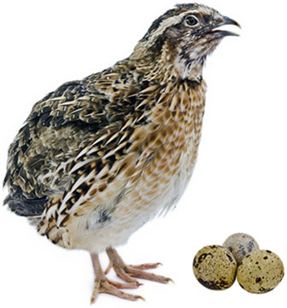

\

**YORKSHIRE CANARY**

|  |  |  |  |
| --- | --- | --- | --- |
|  | DESCRIPTION | OPEN COCK | HEN |
| YELLOW  OR  BUFF | CLEAR | 1 | 5 |
| LIGHTLY VARIEGATED | 2 | 6 |
| HEAVILY VARIEGATED | 3 | 7 |
| A.O.C. | 4 | 8 |

NORWICH CANARY

|  |  |  |  |
| --- | --- | --- | --- |
| YELLOW  OR  BUFF | CLEAR | 9 | 13 |
| LIGHTLY VARIEGATED | 10 | 14 |
| HEAVILY VARIEGATED | 11 | 15 |
| A.O.C. | 12 | 16 |

BORDER FANCY CANARY

|  |  |  |  |
| --- | --- | --- | --- |
| YELLOW  OR  BUFF | CLEAR | 17 | 21 |
| LIGHTLY VARIEGATED | 18 | 22 |
| HEAVILY VARIEGATED | 19 | 23 |
| A.O.C. | 20 | 24 |

RED FACTOR CANARY

|  |  |  |  |
| --- | --- | --- | --- |
| RED  OR  APRICOT | CLEAR | 25 | 29 |
| LIGHTLY VARIEGATED | 26 | 30 |
| HEAVILY VARIEGATED | 27 | 31 |
| A.O.C. | 28 | 32 |

GLOSTER - CONSERT CANARY

|  |  |  |  |
| --- | --- | --- | --- |
| CORONA OR  CONSORT  YELLOW  OR BUFF | CLEAR | 41 | 45 |
| LIGHTLY VARIEGATED | 42 | 46 |
| HEAVILY VARIEGATED | 43 | 47 |
| A.O.C. | 44 | 48 |

FIFE CANARY

|  |  |  |  |
| --- | --- | --- | --- |
| YELLOW  OR  BUFF | CLEAR | 49 | 53 |
| LIGHTLY VARIEGATED | 50 | 54 |
| HEAVILY VARIEGATED | 51 | 55 |
| A.O.C. | 52 | 56 |

MUTATION CANARY

|  |  |  |  |
| --- | --- | --- | --- |
|  | MOSIAC CLEAR | 57 | 61 |
| MOSIAC TKD or VARIEGATED | 58 | 62 |
| MOSIAC A.O.C. | 59 | 63 |
| MUTATION A.O.V. | 60 | 64 |

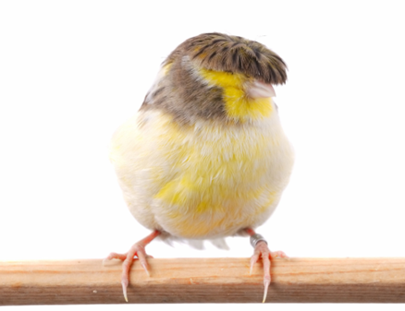

EXHIBITON BUDGERIGARS

|  |  |  |
| --- | --- | --- |
| DESCRIPTION |  |  |
| **NORMAL** | **COCK** | **HEN** |
| NORMAL GREEN SERIES | 65 | 87 |
| GREY GREEN | 66 | 88 |
| NORMAL BLUE SERIES | 67 | 89 |
| GREY | 68 | 90 |
| YELLOWFACE NORMAL | 69 | 91 |
| AUSTRALIAN Y-FACE | 70 | 92 |
| **SEX LINKED** |  |  |
| LUTINO | 71 | 93 |
| ALBINO | 72 | 94 |
| CINNAMONWING | 73 | 95 |
| LACEWING | 74 | 96 |
| OPALINE NORMAL | 75 | 97 |
| OPALINE A.O.S.V. | 76 | 98 |
| CLEARBODY | 77 | 99 |
| **PIED** |  |  |
| DOMINANT PIED | 78 | 100 |
| RECESSIVE PIED | 79 | 101 |
| **SPANGLE** |  |  |
| SPANGLE NORMAL | 80 | 102 |
| SPANGLE A.O.S.V | 81 | 103 |
|  |  |  |
| DOUBLE FACTOR AC | 81A | 103A |
| **AOV** |  |  |
| GREYWING | 82 | 104 |
| CLEARWING | 83 | 105 |
| FALLOW | 84 | 106 |
| BLACK EYE SELF | 85 | 107 |
| A.O.V. | 86 | 108 |

COLOUR BUDGERIGARS

|  |  |  |
| --- | --- | --- |
| DESCRIPTION |  |  |
| **NORMAL** | **COCK** | **HEN** |
| NORMAL GREEN SERIES | 109 | 132 |
| GREY GREEN | 110 | 133 |
| NORMAL BLUE SERIES | 111 | 134 |
| GREY | 112 | 135 |
| YELLOWFACE NORMAL | 113 | 136 |
| AUSTRALIAN Y-FACE | 114 | 137 |
| **SEX LINKED** |  |  |
| LUTINO | 115 | 138 |
| ALBINO | 116 | 139 |
| CINNAMONWING | 117 | 140 |
| LACEWING | 118 | 141 |
| OPALINE NORMAL | 119 | 142 |
| OPALINE A.O.S.V. | 120 | 143 |
| CLEARBODY | 121 | 144 |
| **PIED** |  |  |
| DOMINANT PIED | 122 | 145 |
| RECESSIVE PIED | 123 | 146 |
|  |  |  |
| **SPANGLE** |  |  |
| SPANGLE NORMAL | 124 | 147 |
| SPANGLE A.O.S.V | 125 | 148 |
| DOUBLE FACTOR AC | 126 | 149 |
| **AOV** |  |  |
| GREYWING | 127 | 150 |
| CLEARWING | 128 | 151 |
| FALLOW | 129 | 152 |
| BLACK EYE SELF | 130 | 153 |
| A.O.V. | 131 | 154 |

FINCHES

|  |  |  |  |
| --- | --- | --- | --- |
| **AUSTRALIAN** |  | **FOREIGN** |  |
| CHESTNUT BREASTED | 155 | BENGALESE A.V. | 171 |
| DOUBLE BAR | 156 | JAVA - BLUE | 172 |
| GOULDIAN-RED HD | 157 | JAVA - FAWN | 173 |
| GOULDIAN-BLACK HD | 158 | JAVA - PIED | 174 |
| GOULDIAN –YELLOW HD | 159 | JAVA - WHITE | 175 |
| GOULDIAN – WHITE BRSTD | 160 | BLACKHEADED NUN | 176 |
| GOULDIAN - AOC | 161 | WHITEHEADED NUN | 177 |
| STAR FINCH - RED | 162 | TRI COLOURED NUN | 178 |
| STAR FINCH - YELLOW | 163 | SPICE or NUTMEG | 179 |
| A.O.V. AUSTRALIAN | 164 | ORANGE BREAST | 180 |
|  |  | RUDDY or FIRE FINCH | 181 |
| **ZEBRA** **FINCHES** |  | CORDON BLEU | 182 |
| NORMAL | 165 | ST HELENA | 183 |
| FAWN | 166 | A.O.V. FOREIGN | 184 |
| WHITE AFFECTED | 167 |  |  |
| BLACK AFFECTED | 168 |  |  |
| PIED | 169 |  |  |
| A.O.V. ZEBRA FINCH | 170 |  |  |
|  |  |  |  |
|  |  |  |  |
| **LOVEBIRD** |  | **LOVEBIRD** |  |
| PEACHFACE - NORMAL | 185 | MASKED - BLUE | 192 |
| PEACHFACE – PASTEL | 186 | MASKED - A.O.C. | 193 |
| PEACHFACE – COBALT | 187 | NYASSA - NORMAL | 194 |
| PEACHFACE – SYD. YELLOW | 188 | NYASSA - A.O.C. | 195 |
| PEACHFACE - CREAMINO | 189 | FISCHER - NORMAL | 196 |
| PEACHFACE – A.O.C. | 190 | FISCHER – A.O.C. | 197 |
| MASKED-NORMAL | 191 | LOVEBIRD – A.O.V. | 198 |

PARROTS

|  |  |  |  |
| --- | --- | --- | --- |
| **COCKATIEL** |  | **NEOPHEMAS** |  |
| NORMAL | 199 | TORQUOISINE–NORMAL | 213 |
| CINNAMON | 200 | TORQUOISINE – A.O.V. | 214 |
| LUTINO | 201 | ELEGANT - NORMAL | 215 |
| PEARL | 202 | ELEGANT – A.O.V. | 216 |
| PIED AC | 203 | SCARLET - NORMAL | 217 |
| PLATINUM | 204 | SCARLET – A.O.V. | 218 |
| WHITEFACED AV | 205 |  |  |
| A.O.V. | 206 | **LORIKEET** |  |
| **PSEPHOTUS** |  | RAINBOW | 219 |
| RED RUMP – NORMAL | 207 | SCALY BREASTED | 220 |
| RED RUMP – A.O.V. | 208 | LORIKEET A.O.V**.** | 221 |
|  |  |  |  |
| **NEOPSEPHOTUS** |  | **LARGE AUST PARROT** |  |
| BOURKE - NORMAL | 209 | ROSELLA A.V. | 222 |
| BOURKE - ROSA | 210 | GALAH | 223 |
| BOURKE - PINK | 211 | SULPHUR CRESTED | 224 |
| BOURKE - A.O.C. | 212 | A.O.V. AUSTRALIAN PARROT | 225 |
|  |  |  |  |
| **FOREIGN PARROT** |  | **FOREIGN QUAIL** |  |
| INDIAN RINGNECK - GREEN | 226 | JAP - PHAROAH | 235 |
| INDIAN RINGNECK – A.O.C. | 227 | JAP – ITALIAN | 236 |
| ALEXANDRINE | 228 | JAP – TUXEDO | 237 |
| PLUMHEAD | 229 | JAP – MANCHURIAN | 238 |
| KAKARIKI - NORMAL | 230 | JAP – ENGLISH WHITE | 239 |
| KAKARIKI – A.O.C. | 231 | BOB WHITE | 240 |
| CONURE – SUN | 232 | CALIFORNIAN | 241 |
| CONURE - A.O.V. | 233 | A.O.V. QUAIL FOREIGN | 242 |
| A.O.V. FOREIGN PARROT | 234 |  |  |
| **AUSTRALIAN QUAIL** |  | **DOVE** |  |
| KING – NORMAL | 243 | PEACEFUL | 247 |
| KING – SILVER | 244 | TURTLE | 248 |
| KING – CINNAMON | 245 | DIAMOND | 249 |
| A.O.V.AUSTRALIAN | 246 | A.O.V. DOVE | 250 |
|  |  |  |  |
|  |  |  |  |
|  |  |  |  |
|  |  |  |  |

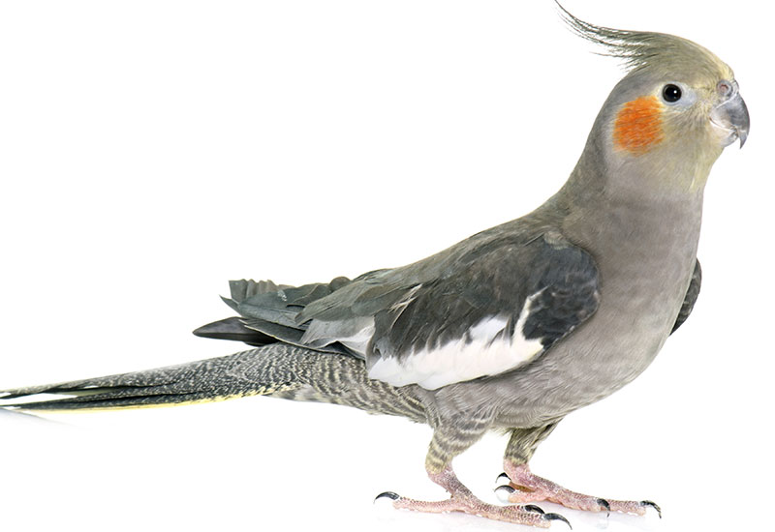

**CAGED BIRD ENTRY FORM**

|  |  |  |  |
| --- | --- | --- | --- |
| **Class** | **Cage No** | **Breed or Variety** | **Ring No** |
|  |  |  |  |
|  |  |  |  |
|  |  |  |  |
|  |  |  |  |
|  |  |  |  |
|  |  |  |  |
|  |  |  |  |
|  |  |  |  |
|  |  |  |  |
|  |  |  |  |
|  |  |  |  |
|  |  |  |  |
|  |  |  |  |
|  |  |  |  |
|  |  |  |  |
|  |  |  |  |
|  |  |  |  |
|  |  |  |  |
|  |  |  |  |
|  |  |  |  |
|  |  |  |  |
|  |  |  |  |

I hereby enter the above, subject to the Rules and Regulations of the Society.

Exhibitor’s Full Initial, Name and Address in BLOCK LETTERS

NAME ________________________________________________________________________________

ADDRESS_____________________________________________________________________________

______________________________________________________________________________________

STATUS_______________________________________________________________________________

ENTRY FEE___________________________________ BIRDS AT_______________________________

AMOUNT ENCLOSED __________________________ DONATION______________________________