**131st**

**Hitz fm 93.9 BUNDABERG SHOW**

**2025**



# WEDNESDAY 28th May

**THURSDAY 29th May**

**FRIDAY 30th May**

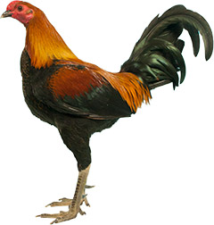

**POULTRY**

**Section 5**

PRIVACY STATEMENT

The Information provided by Exhibitors Is used by the Queensland Chamber of Agriculture Associations Inc. and the Bundaberg A.P. & I, Society Inc. to organize , process and conduct competitions at the Bundaberg AP & I Society Inc show. By entering such competitions, you consent to your personal Information being used for this purpose Including this Information being made available to sponsors, breed Associations, the media, the public, promotional purposes. archival purposes, published in publications or as It Is otherwise required by Law.

All exhibitors have the right to access and alter personal information concerning themselves in the terms of the Privacy Act. This can be done by contacting the QCAS CEO or by writing to QCAS

WORKPLACE HEALTH AND SAFETY

All Queensland Chamber of Agriculture Societies Inc. affiliated Association Showgrounds are designated workplaces within the meaning of the

Workplace Health and Safety Act 2011 and exhibitors/competitors are required to ensure that they and all persons under their direction or control, including their contractors or subcontractors, comply with all requirements of the Act. The Queensland Chamber of Agriculture Associations Inc hold each exhibitor responsible to discharge Its obligations to provide and maintain a safe place and system of work during occupation by the exhibitor/competitor of any area of the affiliated Agricultural Associations Showgrounds/Precinct.

Each exhibitor/competitor will assess the risk to themselves, staff, volunteers, family, other exhibitors, Agricultural Society staff, show visitors, children and any person foreseeably affected by the presentation of their exhibit.

Exhibits will only be held and handled by competent persons whose experience Is known to the Exhibitor/ competitor.

The exhibitors/competitors are advised that the use of Primus Stoves, any heating or lighting appliances of a like character, or any naked light, ls strictly prohibited in Pavilions/stables/barns.

Any exhibitors/competitors Intending to bring electrical equipment to the Showgrounds/Precinct will be required to ensure that such equipment Is fitted with a residual current protection and that all electrical lead s, tools and appliances have been Inspected by a licensed electrical contractor and are currently tagged. The use of double adaptors is prohibited, and all power boards must also be tested and tagged.

All exhibitors/competitors will comply with the requirements of the ACT end Its Regulations and Standards In every respect. This Is essential for the safety of all exhibitors/competitors and the general public. The ACT Imposes very severe penalties in the event of noncompliance with its provisions. Any exhibitors/competitors who do not comply will not be allowed to exhibit at"Queensland Chamber of Agriculture Association. affiliated Shows".

**BUNDABERG SHOW**

GATE ENTRY FEES:

ADULT:------------------------------$20.00

STUDENT: 6 – 17 yrs:------------$10.00

CONCESSION:---------------------$10.00

OVER 75 YEARS :-----------------FREE

UNDER 6 YEARS:-----------------FREE

**PRE-PURCHASE TICKET ONLY**

FAMILY ONE DAY PASS $50.00

(Available until Tuesday 27th May 2025)

(Includes 2 Adult & 2 Children 15 yrs & under)

**HOW TO ENTER THE SECTIONS**

FILL OUT ENTRY FORMS

**All entries must be:**

* **On Official Entry Forms**
* **On SEPARATE Entry Forms for Each Section (NOT CLASS)**
* **Fully completed**
* **Accompanied by Entry Fees (Refer Sections)**

# ENTRIES WILL NOT BE ACCEPTED

* **Without entry fees**
* **Over the telephone**
* **After closing date**

# DELIVER ENTRY FORMS TO

**Bundaberg Show Society Office**

**via University Drive, Bundaberg**

**Enquiries – Phone 07 4138 7605**

**Delivery of entry forms: APRIL – Mon Wed & Fri 9am – 1pm**

**MAY – Mon - Fri 9am – 4pm**

## PLEASE REFER TO THE RULES FOR EACH SECTION FOR CLOSING

**Prize money** to be collected from the Show Office from 2pm Wed. 28th May to 2pm Sat. 31st May 2025. Office hours 9.00am to 4.00pm. After the show, prize money not collected will be returned to the Society’s Funds. All prize money includes GST which is payable by competitors whether registered for GST or not registered.

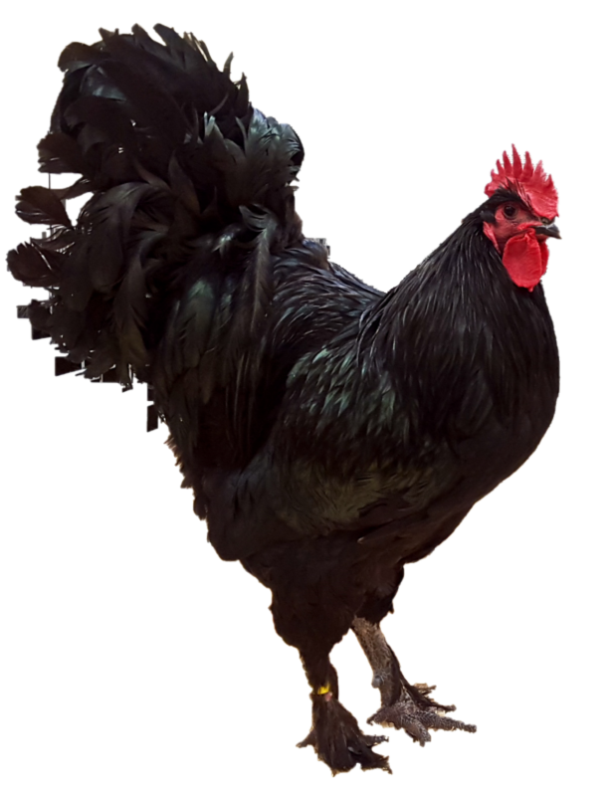

Section 5

**POULTRY**

# CONDITIONS OF ENTRY

. Late entries or substitute birds will not be accepted.

. There will be no limit of entries.

. No exhibit can be entered in more than one class.

. Any bird dyed or in any way interfered with will be disqualified and the exhibitor

dealt with as the Committee may think fit.

. . Any person found removing eggs from the coops in the show shall be prosecuted.

. All eggs are the property of the Show Society.

. Should any dispute arise for which no specific rule is laid down, the matter will be referred to the Committee, whose decision shall be final.

. Weight of pit game to be the responsibility of the exhibitor.

. Exhibits must be presented clean, free of disease and vermin.

. All exhibits must be the bona fide property of the exhibitor at the time of entry.

. Exhibits will be fed by the Society, without charge to the exhibitor.

. Judging will be open to the public.

. Young bird's category - cockerel & pullet (no older than 12 months) will be up to the decision of the judge.

. For delivery of exhibits and collection of same, entry to the grounds may be gained through the University Drive gate, where a list of all bona fide exhibitors will be kept. Only persons on this list will be admitted.

. No attendants' passes will be issued on this section.

. ENTRIES CLOSE FRIDAY 23rd May 2025 at 4.00 pm. FIRM

. Exhibits to be delivered to Poultry Pavilion Tuesday 27th May between 2.00 pm & 7.00 pm.

. Exhibits to be collected on Friday 30th May between 2.30pm & 5.00pm. Refer to Chief Steward for collection details.

###### CHIEF STEWARD Mal McDougal 0412 797 892

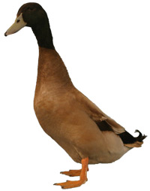

**ENTRY FEES** $2.00 per entry

No refunds if change of mind or unable to attend.

**PRIZEMONEY 1st 2nd 3rd**

1 exhibit $5.00

2 to 5 exhibits $6.00 $3.00 $2.00

5 & under 10 $8.00 $5.00 $3.00

10 & over $15.00 $10.00 $5.00

*Prize money will be paid according to the number of exhibits and not entries in each class.*

ANY SECTION UNDER 50 ENTRIES WILL BE JUDGED MALE, FEMALE & CHAMPION ONLY.

## HARDFEATHER LARGE FOWL

### OLD ENGLISH GAME

5/1 BLACK RED

5/2 DUCKWING A.C.

5/3 BLUE RED

5/4 PILE

5/5 BROWN RED

5/6 A.O.C. (State Colour)

5/7 INDIAN GAME

5/8 HEAVY PIT GAME

Males over 2.5kg, females over 2kg

5/9 LIGHT PIT GAME

Males under 2.5kg, females under 2kg

5/10 A.O.V. (State variety)

## SOFTFEATHER LARGE FOWL

5/11 AUSTRALORP

5/12 WHITE WYANDOTTE

5/13 CHINESE LANGSHAN

5/14 RHODE ISLAND RED

5/15 LIGHT SUSSEX

5/16 HAMPSHIRE - NEW

5/17 BUFF ORPINGTON

5/18 PLYMOUTH ROCK

5/19 WHITE LEGHORN

5/20 LEGHORN A.O.C

5/21 MINORCA

5/22 ANCONAS

5/23 SILKIES

5/24 A.O.V.

HARDFEATHER BANTAM

MODERN GAME

5/25 BLACK RED

5/26 BLUE RED

5/27 DUCKWING

5/28 PILE

5/29 A.O.C. (State colour)

## OLD ENGLISH GAME

5/30 BLACK RED

5/31 PARTRIDGE L/L

5/32 PARTRIDGE D/L

5/33 WHEATEN

5/34 SPANGLED

5/35 DUCKWING A.C.

5/36 BLUE RED

5/37 BLUETAIL WHEATEN

5/38 PILE

5/39 A.O.C. (State colour)

5/40 INDIAN GAME

5/41 JUBILEE GAME

5/42 PIT GAME

5/43 A.O.V.

## SOFTFEATHER BANTAM

5/44 BLACK ROSECOMB

5/45 AUSTRALORP

5/46 WHITE PEKIN

5/47 BLACK PEKIN

5/48 PEKIN A.O.C.

5/49 WHITE WYANDOTTE

5/50 WHITE LEGHORN

5/51 LEGHORN A.O.C.

5/52 RHODE ISLAND RED

5/53 LANGSHAN

5/54 LANGSHAN AOC

5/55 SUSSEX

5/56 ANCONAS

5/57 A.O.V.

5/58 SEABRIGHT (A.O.C.)

## WATERFOWL

## DUCKS

5/59 MUSCOVY

5/60 ROUEN

5/61 INDIAN RUNNER

5/62 KHAKI CAMPBELL

5/63 MALLARD - NATURAL

5/64 MALLARD - WHITE

5/65 PEKIN

5/66 CRESTED

5/67 CAYUGA

5/68 SILVER APPLEYARD

5/69 A.O.V. (State breed)

5/70 GEESE

5/71 TURKEYS

5/72 GUINEA FOWLS

## EXHIBITION PAIRS

5/73 HARDFEATHER LARGE

5/74 SOFTFEATHER LARGE

5/75 HARDFEATHER BANTAM

5/76 SOFTFEATHER BANTAM

5/77 WATERFOWL

5/77A PET CLASS

5/77B PET CLASS – PAIR FEMALES

## PAIR OF PULLETS OR FEMALES

5/78 HARDFEATHER LARGE

5/79 SOFTFEATHER LARGE

5/80 HARDFEATHER - BANTAM

5/81 SOFTFEATHER – BANTAM

5/100 PAIR OF FEMALES WATERFOWL

5/101 PET CLASS

**EGGS**

5/102 PLATE OF SIX EGG FROM SAME BREED eg. ALL BANTAM, LG FOWL QUAIL, TURKEY OR WATERFOWL

**BACK YARD POULTRY**

5/102 NOT PUREBRED

**RIBBONS**

CHAMPION BIRD OF SHOW

RESERVE CHAMPION BIRD OF SHOW

CHAMPION SOFTFEATHER LARGE FOWL

RESERVED CHAMP SOFTFEATHER LGE FOWL

CHAMPION HARDFEATHER LARGE FOWL

RESERVED CHAMP HARDFEATHER LGE FOWL

CHAMPION HARDFEATHER BANTAM

RESERVED CHAMP HARDFEATHER BANTAM

CHAMPION SOFTFEATHER BANTAM

RESERVED CHAMP SOFTFEATHER BANTAM

CHAMPION WATERFOWL

RESERVE CHAMP WATERFOWL

**CHAMPION EXHIBITION PAIR OF** –

CHAMPION HARDFEATHER LGE FOWLS

RESERVE CHAMP HARDFEATHER LG FOWLS

CHAMPION SOFTFEATHER LG FOWLS

RESERVE CHAMP SOFTFEATHER LG FOWLS

CHAMPION HARDFEATHER BANTAMS

RESERVE CHAMP HARDFETHER BANTAMS

CHAMION SOFTFREATHER BANTAMS

CHAMPION WATERFOWLS

RESERVE CHAMPION WATERFOWLS

CHAMPION FEMALE SOFTFEATHER BANTAM

RESERVE CHAMP FEMALE SOFTFEATHER BANTAMS

CHAMPION MALE SOFTFEATHER BAMTAM

RESERVE MALE SOFTFEATHER BANTAM

CHAMPION FEMALE HARDFEATHER BANTAM

RESERVE CHAMP FEMALE HARDFEATHER BANTAM

CHAMPION MALE HARDFEATHER BANTAM

RESERVE CHAMP MALE HARDFEATHER BANTAM

CHAMPION FEMALE H/FEATHER LARGE FOWL

RESERVED CHAMP FEMALE H/FEATHER LGE FOWL

CHAMPION FEMALE SOFTFEATHER WATERFOWL

RESERVE FMALE SOFTFEATHER WATERFOWL

CHAMPION MALE SOFTFEATHER WATERFOWL

RESERVE MALE SOFTFEATHER WATERFOWL

CHAMPION PLATE OF SIX EGGS

RESERVE CHAMPION PLATE OF SIX EGGS

CHAMPION NOT PUREBRED

RESERVE CHAMPION NOT PUREBRED

CHAMPION BACKYARD POULTRY

RESERVE CHAMPION BACKYARD POULTRY

**CHAMPION BIRD OF THE SHOW $**75.00

**RES CHAMPION BIRD OF SHOW $**25.00 **CHAMPION EXHIBITION PAIR OF SHOW** $15.00

**CHAMPION HARDFEATHER - LARGE FOWL** $15.00

**CHAMPION SOFTFEATHER - LARGE FOWL** $15.00

**CHAMPION HARDFEATHER BANTAM $**15.00

**CHAMPION SOFTFEATHER BANTAM** $15.00

**CHAMPION PAIR OF PULLETS $**15.00

**CHAMPION WATERFOWL $**15.00

**CHAMPION MALE, RESERVE CHAMPION MALE,**

**CHAMPION FEMALE, RESERVE CHAMPION FEMALE** $10.00

**BREED CHAMPION – EACH BREED** $ 5.00

**CHAMPION – EGGS** $10

**CHAMPION RESERVE – EGGS** $5.00

*There must be six (6) exhibits in each breed or colour to qualify.*

*The Society wishes to thank –*

**BUNDABERG POULTRY FANCIERS CLUB,**

**BOYLANS PRODUCE** for their donations to the Poultry Section.

**PLEASE NOTE:**



The Society wishes to advise that **NO** **PEAFOWL ENTRIES** will be accepted, as the pens are not large enough to accommodate same.

POULTRY ENTRY FORM

*EACH EXHIBITOR TO BE ON A SEPARATE FORM*

PLEASE NOTE: MULTIPLE ENTRIES PER SECTION TO BE WRITTEN ON THE ONE FORM. YOU DO NOT NEED TO COMPLETE A SEPARATE ENTRY FORM PER CLASS IN ANY PARTICULAR SECTION.

To the Secretary: Subject to the Rules, By-Laws and Regulations of your Society and the Queensland Chamber of Agricultural Societies, I make the following entries for your forthcoming Show.

EACH SECTION NOT CLASS TO BE ON A SEPARATE FORM

ONE LINE PER ENTRY

PLEASE PRINT

NAME OF EXHIBITOR_____________________________________________________________

ADDRESS ______________________________________________________________________

PHONE NUMBER _________________________ EMAIL: ______________________________

FCAQ CERTIFICATE NO: ________________

|  |  |  |  |  |  |  |  |
| --- | --- | --- | --- | --- | --- | --- | --- |
| SECTION | BREED & COLOUR | COCK | HEN | CKL | PULLET | EXHIB PAIR | PAIR FEMALES |
| **EXAMPLE**  **5/20** | **Black Leghorn** | **1** | **2** | **3** | **5** | **1** | **1** |
|  |  |  |  |  |  |  |  |
|  |  |  |  |  |  |  |  |
|  |  |  |  |  |  |  |  |
|  |  |  |  |  |  |  |  |
|  |  |  |  |  |  |  |  |
|  |  |  |  |  |  |  |  |
|  |  |  |  |  |  |  |  |
|  |  |  |  |  |  |  |  |
|  |  |  |  |  |  |  |  |
|  |  |  |  |  |  |  |  |
|  |  |  |  |  |  |  |  |
|  |  |  |  |  |  |  |  |
|  |  |  |  |  |  |  |  |
|  |  |  |  |  |  |  |  |
|  |  |  |  |  |  |  |  |
|  |  |  |  |  |  |  |  |

NUMBER OF ENTRIES ______________________________ ENTRY FEE $_______________

ALL EXHIBITS to be penned on Tuesday 27th May 2025 between 2pm and 7pm.

Entries close 4pm Friday 23rd May 2025. FIRM

Queensland Agricultural Shows

Biosecurity Animal Health Declaration/Movement Record

*(as modified for use by Bundaberg Poultry Fanciers Club Inc)*

**Name of Event/Activity: Date _________________**

|  |  |  |  |  |  |  |  |
| --- | --- | --- | --- | --- | --- | --- | --- |
| **OWNER OR PERSON IN CHARGE OF ANIMALS** | | | | ***f,*** |  | | |
| FULL NAME: | | | |  | | |
| HOME ADDRESS: | | | | | | | |
| POSTAL | ADDRESS: |  | |  |  |  |  |
| EMAIL: | | | | | | | |
| PHONE: |  | I MOBILE: | |  |  |  |  |
| **DETAILS OF ALL ANIMALS BEING BROUGHT ONTO THE GROUNDS** (USEADDITIONALSHEETSASREQUIRED) | | | | | | | |
| CLASS NO. | **REGISTERED NAME/DESCRIPTION**  **(i.e. 4 island red, poultry)** | **SEX** | **MICROCHIP/BRAND/NUS** | | | **ENTRY FEE** | FREE of notifiable diseases including JD  **Yes/No** |
|  |  |  |  | | |  |  |
|  |  |  |  | | |  |  |
|  |  |  |  | | |  |  |
|  |  |  |  | | |  |  |
|  |  |  |  | | |  |  |

**ENTRY FEES MUST ACCOMPANY THIS FORM.**

ENCLOSED TOTAL:$

Are animals being contained overnight at this event? YES NO

**Declaration by owner or person in charge of animal/s attending:**

I, declare that the animals named above has / have been in good health, eating normally and not have shown signs of illness during the last 3 days leading up to this event. I give my authorisation for the Event Organising Committee/Manager to call for veterinary inspection of the animals named above and, in my care, should they be showing signs of illness at any time during the course of the event. I agree to pay any veterinary fees incurred for the abovementioned animals as a result of this veterinary examination.

Signature Date

NOTE: It is recommended to keep a copy of this form by the owner or person in charge of animal/s and event committee for a minimum of 5 years. This form covers all other animals besides horses. These include cattle/sheep/goats/camelids/alpaca/pigs/poultry