2025

131st

# Hitz fm 93.9

# BUNDABERG SHOW

**WEDNESDAY 28th May THURSDAY 29th May**

**FRIDAY 30th May**

# 

# SECTION 34 WOODWORK

PRIVACY STATEMENT

The Information provided by Exhibitors Is used by the Queensland Chamber of Agriculture Associations Inc. and the Bundaberg A.P. & I, Society Inc. to organize , process and conduct competitions at the Bundaberg AP & I Society Inc show. By entering such competitions, you consent to your personal Information being used for this purpose Including this Information being made available to sponsors, breed Associations, the media, the public, promotional purposes. archival purposes, published in publications or as It Is otherwise required by Law.

All exhibitors have the right to access and alter personal information concerning themselves in the terms of the Privacy Act. This can be done by contacting the QCAS CEO or by writing to QCAS

WORKPLACE HEALTH AND SAFETY

All Queensland Chamber of Agriculture Societies Inc. affiliated Association Showgrounds are designated workplaces within the meaning of the

Workplace Health and Safety Act 2011 and exhibitors/competitors are required to ensure that they and all persons under their direction or control, including their contractors or subcontractors, comply with all requirements of the Act. The Queensland Chamber of Agriculture Associations Inc hold each exhibitor responsible to discharge Its obligations to provide and maintain a safe place and system of work during occupation by the exhibitor/competitor of any area of the affiliated Agricultural Associations Showgrounds/Precinct.

Each exhibitor/competitor will assess the risk to themselves, staff, volunteers, family, other exhibitors, Agricultural Society staff, show visitors, children and any person foreseeably affected by the presentation of their exhibit.

Exhibits will only be held and handled by competent persons whose experience Is known to the Exhibitor/ competitor.

The exhibitors/competitors are advised that the use of Primus Stoves, any heating or lighting appliances of a like character, or any naked light, ls strictly prohibited in Pavilions/stables/barns.

Any exhibitors/competitors Intending to bring electrical equipment to the Showgrounds/Precinct will be required to ensure that such equipment Is fitted with a residual current protection and that all electrical lead s, tools and appliances have been Inspected by a licensed electrical contractor and are currently tagged. The use of double adaptors is prohibited, and all power boards must also be tested and tagged.

All exhibitors/competitors will comply with the requirements of the ACT end Its Regulations and Standards In every respect. This Is essential for the safety of all exhibitors/competitors and the general public. The ACT Imposes very severe penalties in the event of noncompliance with its provisions. Any exhibitors/competitors who do not comply will not be allowed to exhibit at"Queensland Chamber of Agriculture Association. affiliated Shows".

**BUNDABERG SHOW**

GATE ENTRY FEES:

ADULT:------------------------------$20.00

STUDENT: 6 – 17 yrs.:-----------$10.00

CONCESSION:---------------------$10.00

OVER 75 YEARS :-----------------FREE

UNDER 6 YEARS:-----------------FREE

**PRE-PURCHASE TICKET ONLY**

FAMILY ONE DAY PASS $50.00

(Available until Tuesday 27th May 2025)

(Includes 2 Adult & 2 Children 15 yrs. & under)

**HOW TO ENTER THE SECTIONS**

**FILL OUT ENTRY FORMS**

**All entries must be:**

* **On Official Entry Forms**
* **On SEPARATE Entry Forms for Each Section (NOT CLASS)**
* **Fully completed**
* **Accompanied by Entry Fees (Refer Sections)**
* **Handcraft, Photography and Fruit & Vegetables have separate entry forms**

## ENTRIES WILL NOT BE ACCEPTED

* 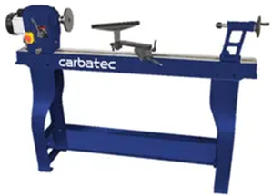**Without entry fees**
* **Over the telephone**
* **After closing date**

## DELIVER ENTRY FORMS TO

**Bundaberg Show Society Office via University Drive, Bundaberg**

**Enquiries – Phone 07 41387605**

**Delivery of entry forms – April – Mon, Wed & Fri 9am – 1pm.**

**May – Mon to Fri, 9am – 4pm**

## YOU WILL RECEIVE

* **Class Ticket stating Section, Class and Entry No.**
* **Receipt**

## DELIVER EXHIBITS

* **Accompanied by Class Ticket (ATTACHED) (This is proof of Entry in a Class)**
* **To designated part of Showground by due date and time.**

## PLEASE REFER TO EACH SECTION FOR CLOSING, DELIVERY & COLLECTION

**PRIZE MONEY** Prize moneyto be collected from the Show Office during the Show from 2pm Wednesday 28th May until 2pm Saturday 31st May. Office hours 9.00 – 4.00.

Prize money NOT COLLECTED will be deemed a donation and returned to Society Funds. All prize money/entry fees contain GST whether registered or not for GST purposes.

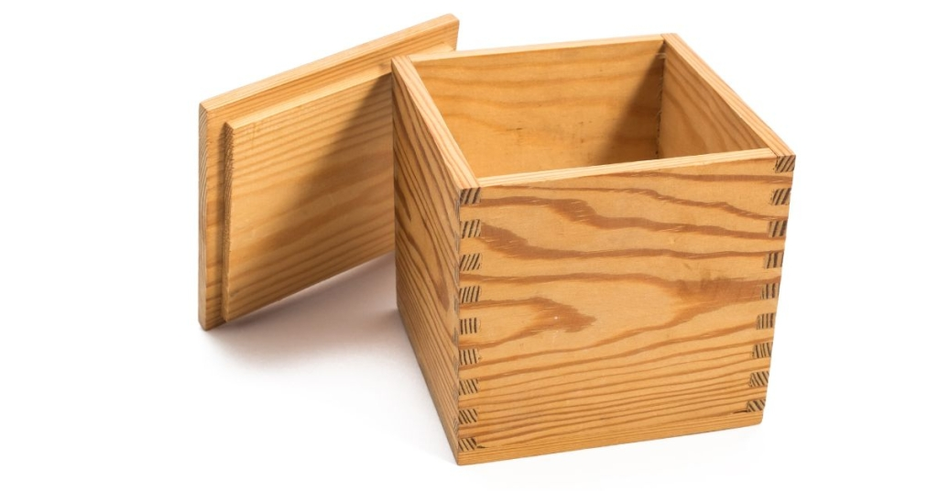

CONDITIONS OF ENTRY

1. Class ticket must be attached to the bottom of the exhibit by sticky tape.
2. Entries shall not have the names of the exhibitor written, stamped, carved, or engraved on them.
3. Entries in all classes except class 3 must be made predominantly of wood.
4. Entries that are highly segmented must be entered in class 2, except for pieces in class 13.
5. The variety of wood used is to be written on the class ticket.
6. Lasers, laser cutters and CNC machines are not permitted in any Woodwork Classes.
7. No entry can be entered in more than one class.
8. Entries must be entirely original and not on purchased wood items.
9. All exhibits must be the bona fide work of the exhibitor.
10. Each exhibit must have been completed within 12 months prior to the first day of the show.
11. Each and every exhibit must NOT have won a prize at a previous Regional Show.
12. If there are fewer than three entries in a class, only one prize will be awarded.
13. Restricted to amateurs and hobbyists only.
14. Security – The Bundaberg Woodworkers Guild is a sponsor and manages the Woodwork competition of behalf of the Show Society. All care is taken with exhibits, however, exhibits too large to fit into the secure showcases shall be entered at the risk of the owner.

**JUDGING**

1. Once in the hands of the Stewards, exhibits must not be handled without the consent of the Chief Steward.
2. If in the Chief Steward’s opinion an exhibit is entered in the wrong class, such exhibit may be re-classed and judged accordingly.
3. If insufficient entries occur in a class the Chief Steward may have the Judge award a reduced number of prizes, (less than three (3) entries per class, one (1) prize will be awarded).
4. The Judges may withhold a prize if, in their opinion, an entry is not of sufficient standard to warrant an award. The Judge’s decision is final.
5. ENTRIES CLOSE - Friday 24th May at 4.00 pm
6. Exhibits to be delivered to the Main Pavilion, via University Drive, on SUNDAY 26th May BETWEEN 10.00am and 12.00 pm.
7. Exhibits to be collected on Saturday 1st June, between 9.00am and 10.00am.
8. Stewards only present at Judging.

CHIEF STEWARD Darren K. Reid MOB 0478 072 000

ENTRY FEES $2.00 per entry unless otherwise stated which

includes G.S.T.

No refunds if change of mind or unable to attend.

**PRIZEMONEY**

1st $15.00 2nd $10.00 3rd $5.00 unless otherwise stated

PRIZE MONEY to be collected from the Show office during the show from Wednesday 2pm till 5pm 28th May until 2pm Saturday 31st May. Prize money NOT COLLECTED will be deemed a donation and returned to Society Funds. All prize money/entry fees contain GST whether registered or not for GST purposes.

**If there are fewer than three entries in a class, only one prize will be awarded.**

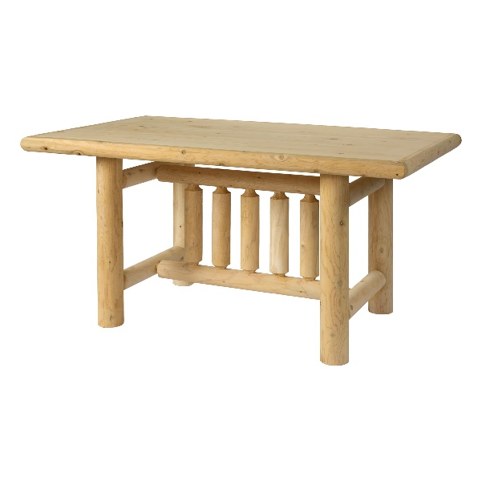

**WOODWORK CLASSES**

**WOODTURNING**

**34/1 MINIATURE-** A scale version of a real item. Finished item must fit within a 25mm cube. Laminating and segmenting may be included in these pieces.

**34/2 CLOSED SEGMENTED, OPEN SEGMENTED or LATTICE FORM TURNING-** A turned laminated/segmented item no greater than 400mm in diameter.

**34/3 LIDDED CONTAINER-** The lid may be free, threaded or hinged. Threads or hinges of other materials are allowed. Laminated material may be used. Open or closed segments must not exceed 20% of the design. Subject to note 4. Where an item contains surface colouring or embellishment, this aspect will be considered as a part of the Design Criteria/Centre of interest for judging purposes.

**34/4 TURNED BOWL – SMALL (** Up to 200mm in diameter). The opening must be greater than 50% of maximum diameter. Overall height must be less than maximum diameter. Laminated material may be used. Open and closed segments must not exceed 20% of the design. Subject to note 4. Where an item contains surface colouring or embellishment, this aspect will be considered as a part of the Design Criteria/Centre of interest for judging purposes.

**34/5 TURNED BOWL – LARGE (** Greater than 200mm but no bigger than 500mm). The opening must be greater than 50% of maximum diameter. Laminated materials may be used. Open and closed segments must not exceed 20% of the design. Subject to note 4. Where an item contains surface colouring or embellishment, this will be considered as a part of the Design Criteria/Centre of interest for judging purposes.

**34/6 TURNED PLATTER OR PLATE –** Diameter of the platter **MUST** exceed 300mm and a plate **MUST NOT** exceed 300mm and the height must not be more than 15% of the maximum diameter. Laminated material may be used. Open or closed segments must not exceed 20% of the design. Subject to note 4. Where an item contains surface colouring or embellishment, this aspect will be considered as a part of the Design Criteria/Centre of interest for judging purposes.

**34/7 TURNED VASE –** Height must be more than the maximum diameter. Laminated material may be used. Open and closed segments must not exceed 20% of the design. (See note 4). Where an item contains surface colouring or embellishment, this aspect will be considered as a part of the Design Criteria/Centre of interest for judging purposes.

**34/8 HOLLOW FORM –** Opening must be less than 20% of maximum diameter. Laminated material may be used. Open and closed segments must not exceed 20% of the design. Subject to note 4. Where an item contains surface colouring or embellishment, this aspect will be considered as a part of the Design Criteria/Centre of interest for judging purposes.

**34/9 SPINDLE TURNING –** Long grain turned between centres. Examples include balustrades, lamps stands, legs of tables or chairs, bedpost, finials etc. Laminated materials and segmenting may be incorporated in this category . Subject to the note 4.

**34/10 GOBLETS –** These pieces incorporate a combination of spindle and face plate turning. Laminated material and segmenting may be incorporated into this category. Subject to note 4. Where an item contains surface colouring or embellishment, this aspect will be considered as a part of the Design Criteria/Centre of interest for judging purposes.

**34/11 PENS AND PENCILS –** Substantially turned from either wood, hybrids or acrylic material. Pens or pencils may have bands (e.g. laminating) or other features made of wood, non-ferrous metals, Acrylic resins or other material that is turned in the process of producing the pen or pencil. Metal components may be used in this category. The pen or pencil must be capable of producing writing at the time of judging. Segmenting may be incorporated in this category.

**34/12 IDENTICAL PAIRS –** Identical in every way. Examples include goblets, eggs, fruit, chess pieces, a set of coasters, salt and pepper grinders, candle stick etc. Where an item contains surface colouring or embellishment, this aspect will be considered as a part of the Design Criteria/Centre of interest for judging purposes.

**34/13 ARTICLES INCORPORATING OTHER WORK OR MATERIALS –** Any size up to 400mm in diameter and height. Includes additional work to enhance the basic turned article. Articles incorporating other work may include segmenting, carving, pyrography, colouring, routing, piercing, scroll sawing etc. Articles with other materials other materials may incorporate metal, leather, plastic or resin.

**34/14 OTHER TURNED ITEMS –** Articles turned of wood that do not fit the stated guidelines of class 1 to 13. Where an item contains surface colouring or embellishment, this aspect will be considered as a part of the Design Criteria/Centre of interest for judging purposes.

**34/15 ANY TURNED ITEM SCHOOL STUDENT –** Any turned item no greater than 400mm diameter and height by a school student.

**34/16 NOVICE-** A turned item from any wood. Any clear finish. **Novice Class is restricted to persons who have less than two (2) years’ experience in woodturning and has never won a First, Second or Third prize in any wood turning competition.**

**WOODWORK**

**34/17 WOODEN ITEM/BANDSAW BOX-** Single item featuring artistic design crafted using woodworking tools. Maximum size to occupy no more than 0.25m2 of floor or shelf space and height of 500mm. Material is to be mainly timber with a clear finish.

**34/18 TRINKET BOX /CHEST-** A Box/ Chest handcrafted from wood. Maximum size to occupy no more than 0.5m2 of floor or shelf space and height of 500mm. It is to be mainly of wood, but may incorporate other materials. Any clear or stain finish.

**34/19 ANY ITEM-** A single item of woodwork, indoor or outdoor. Maximum size to occupy no more than 0.5m2 of floor or shelf space and height of 1.5m. to be mainly of wood or wood product but may incorporate other materials. For example, hybrid material (wood and resin. Wood must be the predominant visible material. Any clear or stain finish.

**34/20 PYROGRAPHY-** An article featuring pyrography shaded naturally. Maximum size 1m x 500mm x 500mm on wood or wood product. Items produced with the aid of a laser, laser cutter or CNC machine is not permitted. A frame may be used in this category. Judging will be of the pyrography work, not the whole article. No added colour with clear finish only.

**34/21 PYROGRAPHY-** An article featuring pyrography. Maximum size 1m x 500mm x 500mm on wood or wood product. A frame may be used in this category. Items produced with the aid of a laser, laser cutter or CNC machine is not permitted. Judging will be of the pyrography work, not the whole article. Shaded naturally with colour and clear finish only.

**34/22 SCROLL SAW WORK/FRET WORK ANY TIMBER ANY CLEAR FINISH-** A scroll sawn item to fit into a space no larger than 1.5m x 500mm x 500mm on wood or wood product. A frame may be used in this category. Items produced with the aid of lasers, laser cutters or CNC machine is not permitted. Judging will be of the scroll saw work, not the whole article. Any clear finish.

**34/23 SCROLL SAW COMPOUND CUTTING –** Any wood any clear finish. Items produced with lasers, laser cutters or CNC machines is not permitted.

**34/24 SCROLL SAW INTARSIA –** Timber only NO artificial colour or compounds. Item to fit into a space no larger than 1.5m x 500mm x 500mm. Items produced with the aid of lasers, laser cutters or CNC machines is not permitted. A frame may be used in this category. Judging will be of the scroll saw work, not the whole article. Any clear finish.

**34/25 TOYS/MODELS**- A handcrafted item (including toys and models). Maximum size to occupy no more than 0.5m2 of floor or shelf space and height of 500mm. Wood must be the predominant material. Any finish including paint.

**34/26 CARVING-** A carved wooden item. Maximum size to occupy no more than 0.5m2 of floor or shelf space and height of 1.0m. Any clear finish.

**CHAMPION WOODTURNING EXHIBIT**

$40.00 Voucher

SOCIETY’S CHAMPION RIBBON

**CHAMPION SCROLLSAW EXHIBIT**

$40.00 Voucher

SOCIETY’S CHAMPION RIBBON

**CHAMPION WOODWORK EXHIBIT**

$40.00 Voucher

SOCIETY’S CHAMPION RIBBON

**CHAMPION STUDENT EXHIBIT**

$20.00 Voucher

SOCIETY’S CHAMPION RIBBON

**GRAND CHAMPION EXHIBIT**

SOCIETY’S GRAND CHAMPION RIBBON

*The Society thanks the Sponsors for their donations to this section*

***Councillor John Learmonth***

***Ace Grinding***

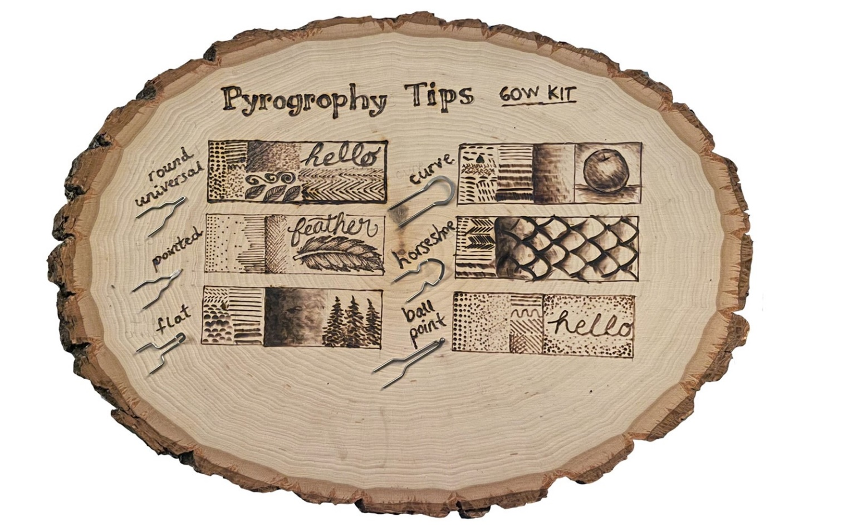

ENTRY FORM

BUNDABERG A.P. & I SOCIETY INC THE SECRETARY, SHOWGROUNDS OFFICE

Via UNIVERSITY DRIVE, BUNDABERG QLD 4670 TELEPHONE:- (07) 4138 7605

ABN 21 134 402 026

*EACH EXHIBITOR TO BE ON A SEPARATE FORM*

PLEASE NOTE: MULTIPLE ENTRIES PER SECTION TO BE WRITTEN ON THE ONE FORM. YOU DO NOT NEED TO COMPLETE A SEPARATE ENTRY FORM PER CLASS IN ANY PARTICULAR SECTION.

To the Secretary: Subject to the Rules, By-Laws and Regulations of your Society and the Queensland Chamber of Agricultural Societies, I make the following entries for your forthcoming Show.

EACH SECTION NOT CLASS TO BE ON A SEPARATE FORM ONE LINE PER ENTRY

|  |  |  |  |  |
| --- | --- | --- | --- | --- |
| SECTION NUMBER | CLASS NUMBER | DESCRIPTION OF EXHIBIT | FOR  SALE PRICE | ENTRY FEE |
|  |  |  |  |  |
|  |  |  |  |  |
|  |  |  |  |  |
|  |  |  |  |  |
|  |  |  |  |  |
|  |  |  |  |  |
|  |  |  |  |  |
|  |  |  |  |  |
|  |  |  |  |  |
|  |  |  |  |  |
|  |  |  |  |  |
|  |  |  |  |  |
|  |  |  |  |  |
|  |  |  |  |  |
|  |  |  |  |  |
|  |  |  | TOTAL  FEES |  |

