**2025**

**131st**

**Hitz fm 93.9**

**BUNDABERG SHOW**

**WEDNESDAY 28th May**

**THURSDAY 29th May**

**FRIDAY 30th May**

**SECTION 26 LAPIDARY**

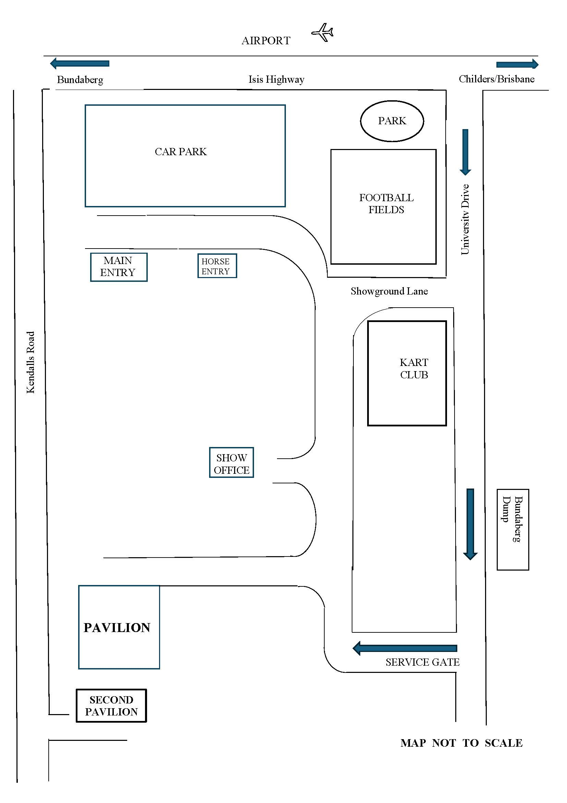

**PRIVACY STATEMENT**

The information provided by Exhibitors is used by the Queensland Chamber of Agriculture Associations Inc. and the Bundaberg A.P. & I. Society Inc. to organize , process and conduct competitions at the Bundaberg A P & I Society Inc show. By entering such competitions, you consent to your personal information being used for this purpose including this information being made available to sponsors, breed Associations, the media, the public, promotional purposes, archival purposes, published in publications or as it is otherwise required by Law.  
All exhibitors have the right to access and alter personal information concerning themselves in the terms of the Privacy Act. This can be done by contacting the QCAS CEO or by writing to QCAS.

**WORKPLACE HEALTH AND SAFETY**

All Queensland Chamber of Agriculture Societies Inc. affiliated Association Showgrounds are designated workplaces within the meaning of the   
Workplace Health and Safety Act 2011 and exhibitors/competitors are required to ensure that they and all persons under their direction or control, including their contractors or subcontractors, comply with all requirements of the Act. The Queensland Chamber of Agriculture Associations Inc hold each exhibitor responsible to discharge its obligations to provide and maintain a safe place and system of work during occupation by the exhibitor/competitor of any area of the affiliated Agricultural Associations Showgrounds/Precincts.

Each exhibitor/competitor will assess the risk to themselves, staff, volunteers, family, other exhibitors, Agricultural Society staff, show visitors, children and any person foreseeably affected by the presentation of their exhibit.

Exhibits will only be held and handled by competent persons whose experience is known to the Exhibitor/competitor.

The exhibitors/competitors are advised that the use of Primus Stoves, any heating or lighting appliances of a like character, or any naked light, is strictly prohibited in Pavilions/stables/barns.

Any exhibitors/competitors intending to bring electrical equipment to the Showgrounds/Precinct will be required to ensure that such equipment is fitted with a residual current protect6ion and that all electrical leads, tools and appliances have been inspected by a licensed electrical contractor and are currently tagged. The use of double adaptors is prohibited, and all power boards must also be tested and tagged.

All exhibitors/competitors will comply with the requirements of the ACT and its Regulations and Standards in every respect. This is essential for the safety of all exhibitors/competitors and the general public. The ACT imposes very severe penalties in the event of noncompliance with its provisions. Any exhibitors/competitors who do not comply will not be allowed to exhibit at “Queensland Chamber of Agriculture Association Inc. affiliated Shows”.

**BUNDABERG SHOW**

GATE ENTRY FEES:

ADULT:------------------------------$20.00

STUDENT: 6 – 17 yrs.:------------$10.00

CONCESSION:---------------------$10.00

OVER 75 YEARS :-----------------FREE

UNDER 6 YEARS:-----------------FREE

**PRE-PURCHASE TICKET ONLY**

FAMILY ONE DAY PASS $50.00

(Available until Tuesday 27th May)

(Includes 2 Adult & 2 Children 15 yrs. & under)

**HOW TO ENTER THE SECTIONS**

**FILL OUT ENTRY FORMS**

**All entries must be:**

* **On Official Entry Forms**
* **On SEPARATE Entry Forms for Each Section (NOT CLASS)**
* **Fully completed**
* **Accompanied by Entry Fees (Refer Sections)**
* **Handcraft, Photography and Fruit & Vegetables have separate entry forms**

**ENTRIES WILL NOT BE ACCEPTED**

* **Without entry fees**
* **Over the telephone**
* **After closing date**

**DELIVER ENTRY FORMS TO**

**Bundaberg Show Society Office via University Drive, Bundaberg**

**Enquiries – Phone 07 4138 7605**

**Delivery of entry forms May Mon-Fri 9am – 4pm**

**YOU WILL RECEIVE**

* **Class Ticket stating Section, Class and Entry No.**
* **Receipt**

**DELIVER EXHIBITS**

* **Accompanied by Class Ticket (ATTACHED) (This is proof of Entry in a Class)**
* **To designated part of Showground by due date and time.**

**PLEASE REFER TO EACH SECTION FOR CLOSING, DELIVERY & COLLECTION**

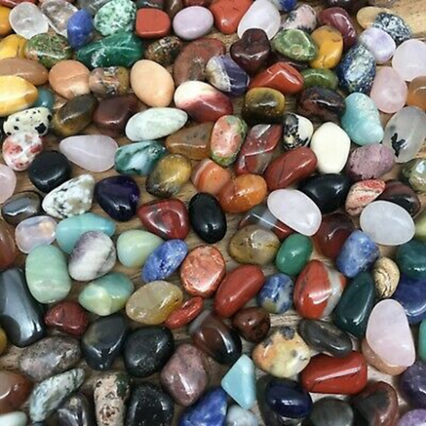**PRIZE MONEY** Prize moneyto be collected from the Show Office during the Show from 2pm Wednesday 28th May until 2pm Saturday 31st May. Office hours 9.00 – 4.00. Prize money NOT COLLECTED will be deemed a donation and returned to Society Funds. All prize money/entry fees contain GST whether registered or not for GST purposes.

Bundaberg Gem & Mineral Soc. Inc.

Competition Schedule 2025

Section 26 - Lapidary

This is a level 2 competition

**CONDITIONS OF ENTRY**

1. Refer to schedule for general rules and special conditions.
2. Postal entries are to be in the hands of the Secretary of the Bundaberg Gem & Mineral Soc. by close of mail Friday 16 May 2025 *with return postage.*

PO Box 386

Bundaberg Qld 4670

1. Each variety of stone in a showcase must be labelled with the correct spelling.
2. Insurance is the responsibility of the entrant.
3. There will be a limit of **2** entries per class per person.
4. No exhibit can be entered in more than one class.
5. All worked exhibits must be that of the competitor unless otherwise stated.
6. Jewellery in the metalwork sections must be the entrant’s own work; however commercial ancillary parts e.g. brooch pins, earring screws, gallery wire etc. may be fabricated into the article but must not predominate.
7. Judging will be done in accordance with the AFLACA “April 2015: issue 8” competitor and judging manual.
8. Sections have been numbered in accordance with the “April 2015: issue 8” AFLACA judging manual.

**ENTRIES CLOSE - 4p.m. Friday 16 May 2025**

***COMPLETED ENTRY FORMS WITH FEES MUST BE DELIVERED TO THE CLUB ROOMS SATURDAY 17 May 2025– 12.00pm to 1.00 pm***

**Exhibits other than flora lapis and showcases to be delivered to the club rooms at Kendalls Rd on Saturday *24 May 2025*  12.00pm and 1.00pm.**

**Flora Lapis and Showcase entries to be delivered to Show Pavilion Tuesday 27 May 2025 after 12.30 pm and must be ready for judging by 2pm. These entries must be collected from the show grounds between 8.30 and 10am, Saturday 31st May after show finishes.**

**All other entries can be picked up at your next session. Please see the session supervisor for these.**

**CHIEF STEWARD** Sherry Leigh ph 0416 562 607

**ENTRY FEES**  Showcase $2.50.

All other classes $1.00 Juniors, $2.00 seniors

Prices include G.S.T.

**PRIZE MONEY** Showcase: 1st $25.00 2nd $15.00 3rd $10.00

All other classes: 1st $15.00 2nd $10.00 3rd $5.00

***If there are fewer than three entries in a class, only one prize will be awarded which will be a second prize only. This may be subject to variance, depending on the points. If a novice section, second prize will be the highest given.***

**Competition Schedule 2025**

***To assist everyone with their entries, please find page numbers of the schedule to ensure all entrants can check judging sections. Please ensure these are read before pieces entered, this will lower the number of invalid entries.***

***Lapidary item definitions can be found on page 19 of AFLACA judging manual.***

***Main definitions for each section can be found:***

1. ***Sections 1 to 17 pages 19 to 21***
2. ***Sections 18 to 28 pages 63 to 65***
3. ***Sections 29 to 31 pages 87 to 91***
4. ***Section 34 to 38 pages 107 to 117***

**26/ 1A 1** **CABOCHON STANDARD AA** Natural material. Min size 25mm x18mm. **Page 22-27**

**Open**

**Novice**

**Junior**

**1A 2** C**ABOCHON STANDARD Craftmanship** Natural material. Min size 25mm x 18mm. **Page 22-27**

**Open**

**Novice**

**Junior**

**1B FANCY CABOCHON AA**  Natural material. Maximum size 60mm long axis. Must not pass through a 10mm hole. **Page 22-27**

**Open**

**Novice**

**Junior**

**3 B1 FREEFORM AA Natural** Material Maximum size 60mm on long axis. Must not pass through 10mm hole. **Page 32**

**Open**

**Junior**

**3 B2 SC FREEFORM AA OPAL ONLY May contain matrix** Maximum size 60mm on long axis. Must not pass through 10mm hole. **Page 32**

**Open**

**Junior**

**5 A CARVING – 3 DIMENSIONAL Any natural material. Maximum size 20cm.** Shall be hand cut or hand-held machine cut. Ancillary items (not mounts) such as tusks, eyes, legs made from metals and other materials are permitted, but NOT wood or plastic. **Page 37**

**Open**

**8A FACETING Standard Round Brilliant –** Continuous Girdle. Coloured CZ ONLY Min 8mm **page 44**

**Open**

**Novice**

**Specifications**

Facets : 58

Meets : 41

**8B FACETING Standard Round Brillian – Faceted Girdle**, Amethyst ONLY min 7mm **page 50**

**Open**

**Novice**

**Specifications**

Facets : 73

Meets 57

**9B FACETING Standard Square Step Cut with Cut Corners**, Quartz ONLY min 7mm **page 47**

**Open**

**Novice**

**Specifications**

Facets : 53

Meets : 45

**12A TUMBLED STONES Preformed. Page 55**

Group of any three material. Min size must not pass through 15mm hole with max size 40mm

**Open**

**13** A **POLISHED FACE – Flat surface.** Natural material, edges not bevelled or sawn. Minimum 50mm on the shortest axis - Maximum 200mm. **page 57-58**

**Open**

**13 B**  **POLISHED FACE – Flat surface JUNIORS ONLY.** Natural material, edges not bevelled or sawn. Minimum 30mm on the shortest axis - Maximum 75mm. **page 56-57**

**Junior**

**16 GEM TREES** SC– Single tree – commercial cut or tumbled stones may be used. Min size must not fit in 15cm cube, max size must fit within 30cm cube. Wire purchased from the club may be used, any other wire must not be coated. **Page 61**

**Open**

**Junior**

**17A NOVELTY** – natural lapidary material. Lapidary material must dominate. Commercial cut or commercial stones not permitted. Min size 80mm, max size 300mm including base or mounting material if used. Carving not included (Must be its own section) Must be accompanied by label stating what item represents and the main material used. Label will NOT be judged. **Page 62**

**Open**

**17ASC NOVELTY** – **JUNIORS** **ONLY** natural lapidary material. Lapidary material must dominate. Commercial cut or commercial stones are permitted. Min size 80mm, max size 300mm including base or mounting material if used. Rocks must not be covered.

Must be accompanied by label stating what item represents and the main material used. Label will NOT be judged. **Page 62**

**Junior**

**17B S.C. NOVELTY – Flora Lapis** – Informal arrangement of rough rock / mineral or fossil and flora. Rock / mineral or fossil must predominate. Base of rock may be sawn to sit flat. Flowers/foliage must be fabric not fresh or plastic. Must be on a base and movable. Single piece of rock, mineral or fossil, only and must fit within 30cm cube.

**Open**

**18A HAND FABRICATED JEWELLERY** Hand fabricated Jewellery Not Intended to include

Lapidary, Fossil, or Mineral Items. Entries must be entirely of Metal*.* **Page 66**

**Open**

**Novice**

**Junior**

**18D 1 HAND FABRICATED JEWELLERY** with commercial lapidary item. **Page 66**

**Open**

**Novice**

**Junior**

**18B WIRE WRAPPED JEWELLERY** with lapidary items cut and set by competitor. **Page 66**

**Open**

**Novice**

**18F WIRE WRAPPED JEWELLERY** with commercial lapidary items set by competitor. **Page 66**

**Open**

**Junior**

**21A CAST JEWELLERY, commercial mould / pattern**  not intended to include lapidary item. **Page 69**

**Open**

**Junior**

**22A DROP CASTING** not intended to include lapidary **Page 70**

**Open**

**Junior**

**22D DROP CASTING** with commercial lapidary item. **Page 70**

**Open**

**Junior**

**23ASC COMBINED JEWELLERY** no lapidary. Entries must be entirely metal. Partly hand – fabricated and part cast by entrant. commercial mould / pattern or drop cast are permitted. . **Page 63-65 and page 71**

**Open**

**Junior**

**25 2 SINGLE CABOCHON IN COMMERCIAL MOUNT** min size 18 x 13 Stone must be cut by

competitor. **Page 78**

**Open**

**Novice**

**Junior**

**26A ENAMELLED JEWELLERY IN COMMERCIAL MOUNT demonstrates workmanship and** artistry. To suitable backing, fitted by entrant into commercial mount. **Page 80**

**Open**

**26B AA ENAMELLED JEWELLERY WITH / WITHOUT MOUNT** backing material maybe be bought or formed by entrant. Commercial spacer beads and caps permitted in bracelets and necklaces, must not dominate, and will not be judged. Mount will not be judged. **Page 81**

**Open**

**26C ENAMELLED NON-JEWELLERY** backing material may be handmade or commercial. May be functional or non. Min size 50mm, Max size 300 – INCLUDING BASE **Page 82**

**Open**

**31 SHOWCASE Themed lit**, Any song from 1962 to 1966, Minimum 20 Lapidary items, owned by entrant or immediate Family. Refer to manual **page 96**.

Labels are not mandatory on individual items.

**Open**

**Section 8A Standard Round Brilliant – Continuous Girdle – Coloured CZ** Minimum Size 8mm

  

**Standard Round Brilliant with Continuous Girdle – Coloured CZ**

Meets (Crown 24 + Pavilion 17) Total 41



Angles for R.I. = 2.160

57 + 1 girdles = 58 facets

8-fold radial symmetry

96 index

L/W = 1.000 T/W = 0.602 U/W = 0.602

P/W = 0.444 C/W = 0.118

Vol./W³ = 0.201

PAVILION

P1 40.99° 03-09-15-21-27-33-39-45- Cut a TCP

51-57-63-69-75-81-87-93

G1 90.00° (96 total) Cut as a Continuous Girdle. - Cut to Size.

P2 39.02° 96-12-24-36-48-60-72-84 Meet P1, G1. - Form PCP.

CROWN

C1 41.99° 03-09-15-21-27-33-39-45- Set Girdle Thickness.

51-57-63-69-75-81-87-93

C2 34.15° 96-12-24-36-48-60-72-84 Meet C1, G1.

C3 19.98° 06-18-30-42-54-66-78-90 Meet C1, C2.

T 0.00° Table Meet C2.

**Section 8B-N Standard Round Brilliant – Faceted Girdle - Amethyst**

Minimum Size 7mm

 

Meets (Crown 32 + Pavilion 25) Total 57

Angles for R.I. = 1.540

57 + 16 girdles = 73 facets

8-fold radial symmetry

96 index

L/W = 1.000 T/W = 0.613 U/W = 0.613

P/W = 0.423 C/W = 0.094

Vol./W³ = 0.177

PAVILION

P1 42.22° 03-09-15-21-27-33-39-45- Cut to TCP

51-57-63-69-75-81-87-93

G1 90.00° 03-09-15-21-27-33-39-45- Cut Girdle, Meet P1.

51-57-63-69-75-81-87-93

P2 40.23° 96-12-24-36-48-60-72-84 Meet P1, G1. - PCP

CROWN

C1 32.94° 03-09-15-21-27-33-39-45- Set Girdle Thickness.

51-57-63-69-75-81-87-93

C2 26.03° 96-12-24-36-48-60-72-84 Meet C1, G1.

C3 14.67° 06-18-30-42-54-66-78-90 Meet C2, C3.

T 0.00° Table Meet C2.

**Section 9B Standard Square Step Cut – Cut Corners – Quartz**

Minimum Size 7mm

  



Meets ( Crown 24 + Pavilion 21 ) Total 45

Angles for R.I. = 1.540

45 + 8 girdles = 53 facets

4-fold radial symmetry

96 index

L/W = 1.000 T/W = 0.607 U/W = 0.607

P/W = 0.471 C/W = 0.165

Vol./W³ = 0.299

PAVILION

G1 90.00° 96-24-48-72 Set size

P1 48.02° 96-24-48-72 Cut to TCP.

P2 42.98° 96-24-48-72 Judge Depth by Eye. TCP.

P3 38.04° 96-24-48-72 Judge Depth by Eye. PCP.

P4 42.98° 12-36-60-84 Cut Corner to Meet P3.

P5 48.02° 12-36-60-84 Cut a Level Tier, Meet P1, P2, P4.

G2 90.00° 12-36-60-84 level Girdle, Meet P1,P2,P5.

CROWN

C1 48.81° 96-24-48-72 Set Girdle Thickness.

C2 48.81° 12-36-60-84 Level Girdle.

C3 35.77° 96-24-48-72 Judge Height by Eye.

C4 35.77° 12-36-60-84 Level Tier. Meet C1, C2.

C5 21.32° 96-24-48-72 Judge Height by Eye.

C6 21.32° 12-36-60-84 Level Tier. Meet C3, C4.

T 0.00° Table Judge Height By Eye.

**SPECIAL AWARDS**

**BEST ITEM – LAPIDARY COMPETITION –** (single item)

Society’s ribbon. To be judged from first prize winners.

**MOST SUCCESSFUL COMPETITOR – Junior and Senior**

Society’s ribbon. Points scored as follows 1st 3 points, 2nd 2 points, 3rd 1 point

**INCENTIVE PRIZES** To be judged by the chief steward and stewards

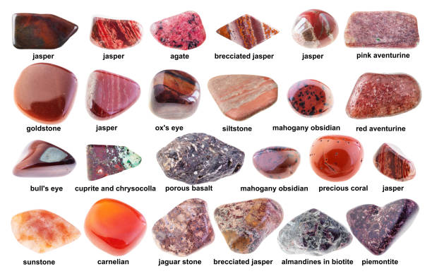

TELEPHONE:- (07) 4138 7605

ABN 21 134 402 026

*EACH EXHIBITOR TO BE ON A SEPARATE FORM*

PLEASE NOTE: MULTIPLE ENTRIES PER SECTION TO BE WRITTEN ON THE ONE FORM. YOU DO NOT NEED TO COMPLETE A SEPARATE ENTRY FORM PER CLASS IN ANY PARTICULAR SECTION.

Subject to the Rules, By-Laws and Regulations of your Society and the Queensland Chamber of Agricultural Societies, I make the following entries for your forthcoming Show.

EACH SECTION NOT CLASS TO BE ON A SEPARATE FORM

ONE LINE PER ENTRY

|  |  |  |  |  |
| --- | --- | --- | --- | --- |
| SECTION NUMBER | CLASS NUMBER | DESCRIPTION OF EXHIBIT | FOR SALE PRICE | ENTRY FEE |
|  |  |  |  |  |
|  |  |  |  |  |
|  |  |  |  |  |
|  |  |  |  |  |
|  |  |  |  |  |
|  |  |  |  |  |
|  |  |  |  |  |
|  |  |  |  |  |
|  |  |  |  |  |
|  |  |  |  |  |
|  |  |  |  |  |
|  |  |  |  |  |
|  |  |  |  |  |
|  |  |  |  |  |
|  |  |  | TOTAL  FEES |  |

DATE OF BIRTH FOR CHILD EXHIBITOR

PLEASE PRINT

NAME OF EXHIBITOR

ADDRESS

PHONE NUMBER

EMAIL:

DATE ABN

SIGNATURE TO BE COLLECTED YES/NO