**2025**

**131st**

**Hitz fm 93.9**

**BUNDABERG**

**SHOW**

# **WEDNESDAY 28th May**

**THURSDAY 29th May**

**FRIDAY 30th May**

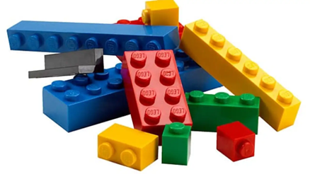

**SECTION 25**

**LEGO**

PRIVACY STATEMENT

The Information provided by Exhibitors Is used by the Queensland Chamber of Agriculture Associations Inc. and the Bundaberg A.P. & I, Society Inc. to organize , process and conduct competitions at the Bundaberg AP & I Society Inc show. By entering such competitions, you consent to your personal Information being used for this purpose Including this Information being made available to sponsors, breed Associations, the media, the public, promotional purposes. archival purposes, published in publications or as It Is otherwise required by Law.

All exhibitors have the right to access and alter personal information concerning themselves in the terms of the Privacy Act. This can be done by contacting the QCAS CEO or by writing to QCAS

WORKPLACE HEALTH AND SAFETY

All Queensland Chamber of Agriculture Societies Inc. affiliated Association Showgrounds are designated workplaces within the meaning of the

Workplace Health and Safety Act 2011 and exhibitors/competitors are required to ensure that they and all persons under their direction or control, including their contractors or subcontractors, comply with all requirements of the Act. The Queensland Chamber of Agriculture Associations Inc hold each exhibitor responsible to discharge Its obligations to provide and maintain a safe place and system of work during occupation by the exhibitor/competitor of any area of the affiliated Agricultural Associations Showgrounds/Precinct.

Each exhibitor/competitor will assess the risk to themselves, staff, volunteers, family, other exhibitors, Agricultural Society staff, show visitors, children and any person foreseeably affected by the presentation of their exhibit.

Exhibits will only be held and handled by competent persons whose experience Is known to the Exhibitor/ competitor.

The exhibitors/competitors are advised that the use of Primus Stoves, any heating or lighting appliances of a like character, or any naked light, ls strictly prohibited in Pavilions/stables/barns.

Any exhibitors/competitors Intending to bring electrical equipment to the Showgrounds/Precinct will be required to ensure that such equipment Is fitted with a residual current protection and that all electrical lead s, tools and appliances have been Inspected by a licensed electrical contractor and are currently tagged. The use of double adaptors is prohibited, and all power boards must also be tested and tagged.

All exhibitors/competitors will comply with the requirements of the ACT end Its Regulations and Standards In every respect. This Is essential for the safety of all exhibitors/competitors and the general public. The ACT Imposes very severe penalties in the event of noncompliance with its provisions. Any exhibitors/competitors who do not comply will not be allowed to exhibit at "Queensland Chamber of Agriculture Association. affiliated Shows".

**BUNDABERG SHOW**

GATE ENTRY FEES:

ADULT:------------------------------$20.00

STUDENT: 6 – 17 yrs.:------------$10.00

CONCESSION:---------------------$10.00

OVER 75 YEARS :-----------------FREE

UNDER 6 YEARS:-----------------FREE

**PRE-PURCHASE TICKET ONLY**

FAMILY ONE DAY PASS $50.00

(Available until Tuesday 28th May)

(Includes 2 Adult & 2 Children 15 yrs. & under)

**HOW TO ENTER THE SECTIONS**

FILL OUT ENTRY FORMS

**All entries must be:**

* **On Official Entry Forms**
* **On SEPARATE Entry Forms for Each Section (NOT CLASS)**
* **Fully completed**
* **Accompanied by Entry Fees (Refer Sections)**
* **Handcraft, Photography and Fruit & Vegetables have separate entry forms**

# **ENTRIES WILL NOT BE ACCEPTED**

* **Without entry fees**
* **Over the telephone**
* **After closing date**

# **DELIVER ENTRY FORMS TO**

**Bundaberg Show Society Office**

**via University Drive, Bundaberg**

**Enquiries – Phone 07 4138 7605**

**Delivery of entry forms: APRIL – Mon, Wed & Fri 9am – 1pm**

**MAY – Mon - Fri 9am – 4pm**

# **YOU WILL RECEIVE**

* **Class Ticket stating Section, Class and Entry No.**
* **Receipt**

# **DELIVER EXHIBITS**

* **Accompanied by Class Ticket (ATTACHED)**

**(This is proof of Entry in a Class)**

* **To designated part of Showground by due date and time.**

## PLEASE REFER TO EACH SECTION FOR CLOSING, DELIVERY & COLLECTION

**Prize money** to be collected from the Show Office from 2pm Wednesday, 28th May to 2pm Saturday 13st May. Office hours 9.00 – 4.00. Prize money NOT COLLECTED during those times will be deemed a donation and returned to the Society’s Funds.

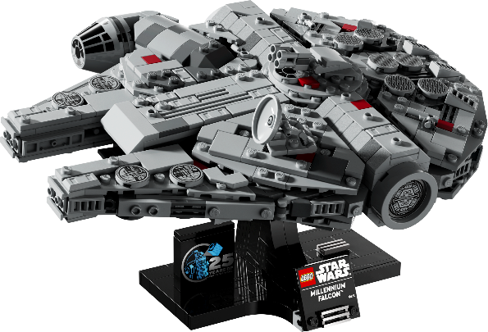

**Entry Fee - $1.00**

**Prize Money 1st $20.00 2nd $15.00 3rd $10.00**

**Chief Steward Jayde Taylor MOB 0468 592 787**

Entries are to be in by 4.00pm Friday 23rd May to the secretary at the show office with entry fee.

Delivery of Entries Sunday 25th May between the hours 9.00am – 11.00am at the main pavilion at the Bundaberg Recreation Precinct.

All entries must be picked up on Saturday 31st May between the hours 9.00am – 11.00am.

Any entries not collected will be destroyed and disposed of unless other arrangements have been made.

**No refunds if change of mind or unable to attend.**

1. **All entries must be *LEGO©* Blocks & built on a *LEGO©* base, this does not include LEGO friends. Entries including LEGO friends will be disqualified.**
2. **Maximum bas size is 30cm square, oversized entries will be disqualified.**
3. **Entries are entered at the owner’s risk. All care will be taken, but no liability will be taken for any loss or damage to entries or any property however such it occurs.**

**Section 25**

**ORIGINAL LEGO CREATION**

**This year’s theme is:-**

**“Bundaberg Show”.**

**CHILDREN**

**25/**1 6 to 9 yrs. Any original Lego creation depicting this year’s theme.

**25//2** 10 to 17yrs Any original Lego creation depicting this year’s theme.

**ADULT**

**25//3** 18 yrs. & over Any original Lego creation depicting this year’s theme.

**USING ANY PURCHASED BOX KIT**

**CHILDREN**

**25/**4 6 to 9 yrs. Using any purchased box kit no larger than 30cm x 30cm

**25//5** 10 to 17yrs Using any purchased box kit no larger than 30cm x 30cm

**ADULT**

**25//6** 18 yrs. & over Using any purchased box kit no larger than 30cm x 30cm

**ORIGINAL /BOX KIT**

**SPECIAL NEEDS Restricted to Intellectually and or Physically Disabled**

**CHILDREN**

**25/**7 6 to 9 yrs. Any original Lego creation

**25//8** 10 to 17yrs Any original Lego creation

**ADULT**

**25//9** 18 yrs. & over Any original Lego creation depicting this year’s theme.

**Champion Children’s**

**Champion Adults**

**Champion Special Needs**

**Supreme Champion**

ENTRY FORM

BUNDABERG A.P. & I SOCIETY INC

THE SECRETARY, SHOWGROUNDS OFFICE

Via UNIVERSITY DRIVE, BUNDABERG QLD 4670

TELEPHONE:- (07) 4138 7605

ABN 21 134 402 026

*EACH EXHIBITOR TO BE ON A SEPARATE FORM*

PLEASE NOTE: MULTIPLE ENTRIES PER SECTION TO BE WRITTEN ON THE ONE FORM. YOU DO NOT NEED TO COMPLETE A SEPARATE ENTRY FORM PER CLASS IN ANY PARTICULAR SECTION.

To the Secretary: Subject to the Rules, By-Laws and Regulations of your Society and the Queensland Chamber of Agricultural Societies, I make the following entries for your forthcoming Show.

EACH SECTION NOT CLASS TO BE ON A SEPARATE FORM

ONE LINE PER ENTRY

|  |  |  |  |  |
| --- | --- | --- | --- | --- |
| SECTION NUMBER | CLASS NUMBER | DESCRIPTION OF EXHIBIT | FOR SALE PRICE | ENTRY FEE |
|  |  |  |  |  |
|  |  |  |  |  |
|  |  |  |  |  |
|  |  |  |  |  |
|  |  |  |  |  |
|  |  |  |  |  |
|  |  |  |  |  |
|  |  |  |  |  |
|  |  |  |  |  |
|  |  |  |  |  |
|  |  |  |  |  |
|  |  |  |  |  |
|  |  |  |  |  |
|  |  |  |  |  |
|  |  |  | TOTAL  FEES |  |

DATE OF BIRTH FOR CHILD EXHIBITOR

PLEASE PRINT

NAME OF EXHIBITOR

ADDRESS

PHONE NUMBER

EMAIL:

DATE ABN

SIGNATURE TO BE COLLECTED