**WEDNESDAY 28th May**

**THURSDAY 29th May**

**FRIDAY 30th May**

2025

Hitz fm 93.9

BUNDABERG

SHOW

**131th**

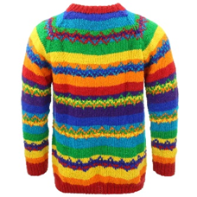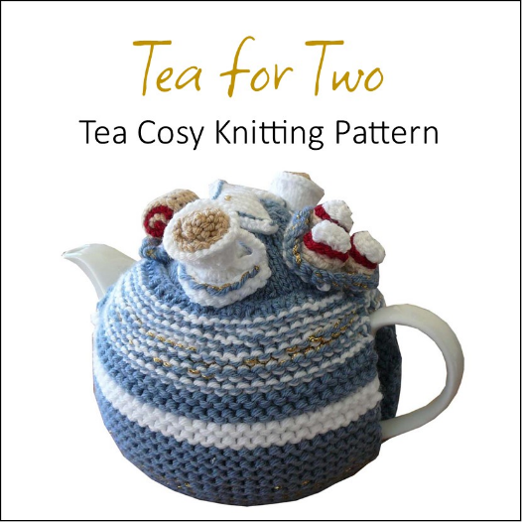

**SECTION 24**

**Crafty Creations**

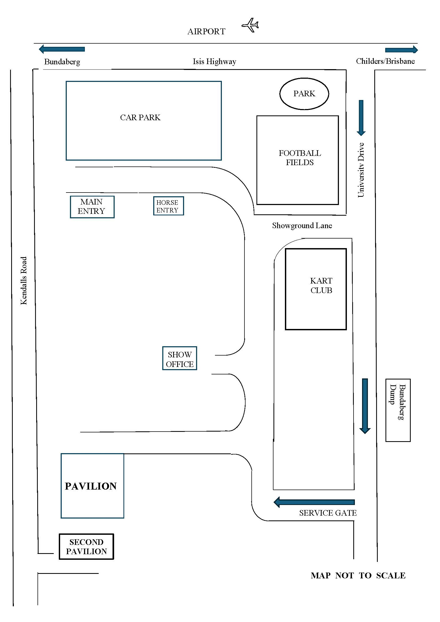

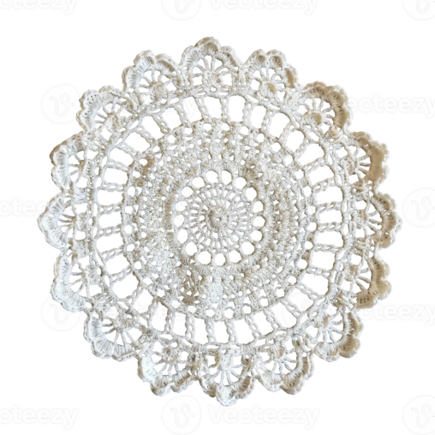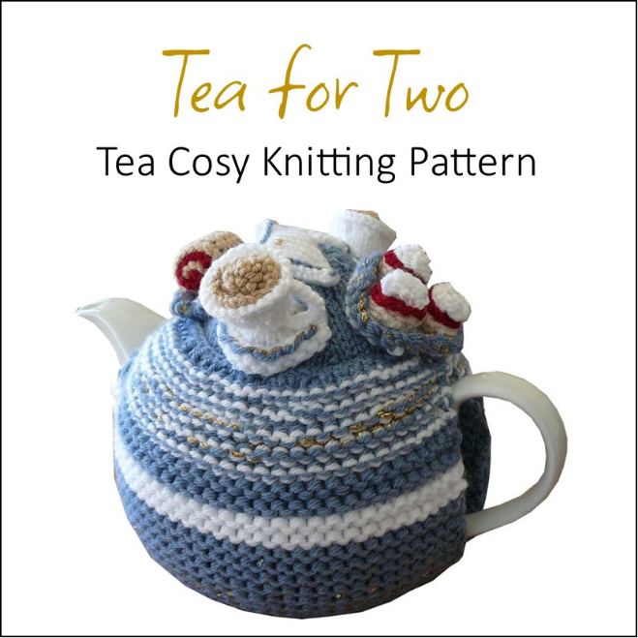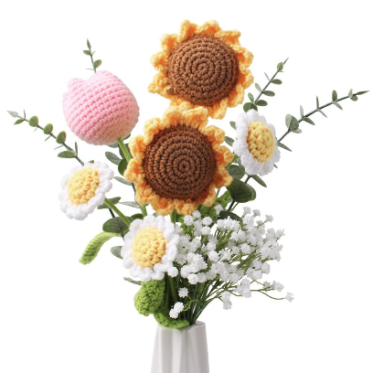

PRIVACY STATEMENT

The Information provided by Exhibitors Is used by the Queensland Chamber of Agriculture Associations Inc. and the Bundaberg A.P. & I, Society Inc. to organize , process and conduct competitions at the Bundaberg AP & I Society Inc show. By entering such competitions, you consent to your personal Information being used for this purpose Including this Information being made available to sponsors, breed Associations, the media, the public, promotional purposes. archival purposes, published in publications or as It Is otherwise required by Law.

All exhibitors have the right to access and alter personal information concerning themselves in the terms of the Privacy Act. This can be done by contacting the QCAS CEO or by writing to QCAS

WORKPLACE HEALTH AND SAFETY

All Queensland Chamber of Agriculture Societies Inc. affiliated Association Showgrounds are designated workplaces within the meaning of the

Workplace Health and Safety Act 2011 and exhibitors/competitors are required to ensure that they and all persons under their direction or control, including their contractors or subcontractors, comply with all requirements of the Act. The Queensland Chamber of Agriculture Associations Inc hold each exhibitor responsible to discharge Its obligations to provide and maintain a safe place and system of work during occupation by the exhibitor/competitor of any area of the affiliated Agricultural Associations Showgrounds/Precinct.

Each exhibitor/competitor will assess the risk to themselves, staff, volunteers, family, other exhibitors, Agricultural Society staff, show visitors, children and any person foreseeably affected by the presentation of their exhibit.

Exhibits will only be held and handled by competent persons whose experience Is known to the Exhibitor/ competitor.

The exhibitors/competitors are advised that the use of Primus Stoves, any heating or lighting appliances of a like character, or any naked light, ls strictly prohibited in Pavilions/stables/barns.

Any exhibitors/competitors Intending to bring electrical equipment to the Showgrounds/Precinct will be required to ensure that such equipment Is fitted with a residual current protection and that all electrical lead s, tools and appliances have been Inspected by a licensed electrical contractor and are currently tagged. The use of double adaptors is prohibited, and all power boards must also be tested and tagged.

All exhibitors/competitors will comply with the requirements of the ACT end Its Regulations and Standards In every respect. This Is essential for the safety of all exhibitors/competitors and the general public. The ACT Imposes very severe penalties in the event of noncompliance with its provisions. Any exhibitors/competitors who do not comply will not be allowed to exhibit at"Queensland Chamber of Agriculture Association. affiliated Shows".

**BUNDABERG SHOW**

GATE ENTRY FEES:

ADULT:------------------------------$20.00

STUDENT: 6 – 17 yrs.------------$10.00

CONCESSION:---------------------$10.00

OVER 75 YEARS :-----------------FREE

UNDER 6 YEARS:-----------------FREE

**PRE-PURCHASE TICKET ONLY**

FAMILY ONE DAY PASS $50.00

(Available until Tuesday 27th May)

(Includes 2 Adult & 2 Children 15 yrs.& under

**HOW TO ENTER THE SECTIONS**

FILL OUT ENTRY FORMS

**All entries must be:**

* **On Official Entry Forms**
* **On SEPARATE Entry Forms for Each Section (NOT CLASS)**
* **Fully completed**
* **Accompanied by Entry Fees (Refer Sections)**
* **Handcraft, Photography and Fruit & Vegetables have separate entry forms**

# **ENTRIES WILL NOT BE ACCEPTED**

* **Without entry fees**
* **Over the telephone**
* **After closing date**

# **DELIVER ENTRY FORMS TO**

**Bundaberg Show Society Office**

**via University Drive, Bundaberg**

**Enquiries – Phone 07 4138 7605**

**Delivery of entry forms: APRIL – Mon Wed & Fri 9am – 1pm**

**MAY – Mon - Fri 9am – 4pm**

# **YOU WILL RECEIVE**

* **Class Ticket stating Section, Class and Entry No.**
* **Receipt**

# **DELIVER EXHIBITS**

* **Accompanied by Class Ticket (ATTACHED)**

**(This is proof of Entry in a Class)**

* **To designated part of Showground by due date and time.**

## PLEASE REFER TO EACH SECTION FOR CLOSING, DELIVERY & COLLECTION

**Prize money** to be collected from the Show Office during the Show from 2pm Wednesday 28th May to 2pm Saturday, 31st May 2025. Office hours 9.00 – 4.00. Prize money NOT COLLECTED will be deemed a donation and returned to Society’s Funds. All prize money/entry fees contain GST which is payable by all competitors whether registered for GST or not registered for GST.

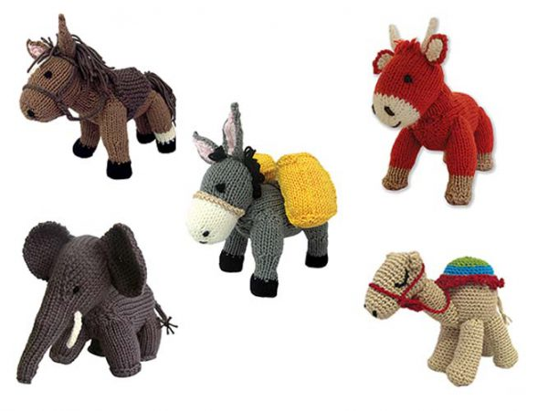

**SECTION 24**

**CRAFTY CREATIONS**

**CHIEF STEWARD**: Marg Faulkner MOB 0418 770 852

**ALL PRIZE MONEY**: 1ST $10.00, 2ND $6.00, 3rd $4.00

**Entry Fee $1.00**

**No refunds if change of mind or unable to attend.**

**ENTRIES CLOSE: FRIDAY 23rd MAY at 4.00pm**

**ENTRIES TO BE DELIVERED TO THE MAIN PAVILLION via UNIVERSITY DRIVE**

**SATURDAY: 24th May Between 9.00am. & 12.00pm.**

**EXHIBITS TO BE COLLECTED**

**SATURDAY 31st May Between 9.00 a.m. & 11.00 a.m.**

***Items not collected will be destroyed.***

**PLEASE READ RULES**

**Before Exhibits are taken to the Stewards**

The white card must be attached to the front of your exhibit.

Please attach by tacking or with small safety pins from under the item, please do not use ordinary sewing pins or staples, they could damage work or another competitors exhibit.

**ALL COMPETITORS:**

1. Limit of two (2) entries per person, per class.
2. A Judge is not compelled to give a prize. All prizes are at the Judge’s discretion.
3. Entries must be completed within 18 months of the first day of the Show, and not have been exhibited in any previous Bundaberg Show.
4. Item never used, or garment never worn, **except** for Bridesmaids, Flower Girls dresses.
5. Soiled items **WILL NOT** be accepted.
6. No exhibit can be entered into more than one class.
7. If an exhibit has more than one article, please present on cardboard that is no more than 2cm bigger than the item, pinned from underneath, not on top. Use minimal amount of safety pins.
8. All exhibits must be Hand Worked Unless otherwise stated.
9. **A quilt with a circle and a circle in the center

   Description automatically generated**All work must be the work of the person whose name appears on the entry form.

**CHILDREN’S ENTRIES:**

Date of birth of the child on the top half of the white card.

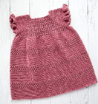

.

**SPECIAL SCHOOL DIVISION**

**Restricted tom Intellectually and or Physically Disabled**

24/1 ANY OTHER CRAFT – Knitting, Crochet, Sewing – Any Article - Max Size 600mmX600mm.

24/2 COLLAGE OF YOUR FAVOURITE THING Max Size A3

**SPECIAL NEEDS DIVISION**

**Restricted to Intellectually and or Physically Disabled**

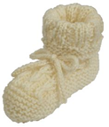 24/3 ANY OTHER CRAFT– Knitting, Crochet, Sewing. Minimum glue Max Size 600 x 600 Mixed medium no larger than 220mm x 220mm

**CHAMPION SPECIAL SCHOOL/ SPECIAL NEEDS DIVISION**

**Selected from 24/1 – 24/3 SOCIETY’S CHAMPION RIBBON AND CARD**

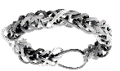

**PRIMARY SCHOOL DIVISION**

**Please state DATE OF BIRTH ON THE TOP OF THE WHITE CARD**

**(Please attach small items on to cardboard at least 2cm larger than the item)**

24/4 NOVELTY ARTICLE - Soft Craft

24/5 ANY BEADED ARTICLE – i.e.: Christmas Decoration, Necklace, Bracelet etc.

24/6 ANY ARTICLE – Knitting, Crochet

24/7 ANY ARTICLE – Hand or Machine Made

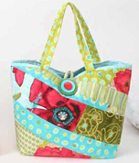24/8 ANY ARTICLE – Using Any Type of Loom Max Size 300X300.

**CHAMPION PRIMARY SCHOOL DIVISION**

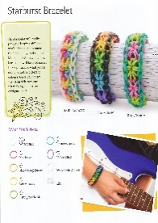**SOCIETY’S CHAMPION RIBBON AND CARD**

**HIGH SCHOOL DIVISION**

**Please state DATE OF BIRTH ON THE TOP OF THE WHITE CARD**

24/9 ANY ARTICLE – Machine Sewing i.e.: Patchwork, Shirt, Blouse, & Bag Etc.

24/10 ANY ARTICLE – Knitting or Crochet

24/11 ANY OTHER CRAFT NOT MENTIONED – Beadwork, Jewellery, Needlework Etc.

24/12 ANY ARTICLE – Using Any Type of Loom Max Size 300mm X 300mm

**CHAMPION HIGH SCHOOL DIVISION**

**SOCIETY’S CHAMPION RIBBON AND CARD**

**EVERY CLASS: ONLY TWO (2) ITEMS PER PERSON PER CLASS**

**HAND KNITTING**

24/13 ADULT CLOTHING – Jumper, Top, Shorts, Dress

24/14 CHILDREN & BABY CLOTHING – Jumper, Top, Jumpsuit, Babywear

24/15 SLIPPERS, SOCKS, BEANIE, GLOVES

24/16 KNITTED LACE – ANY YARN MAX 3PLY TO BE USED – No nylon lace to be used.

24/17 ANY KNITTED ARTICLE – Not already covered in Knitting Section

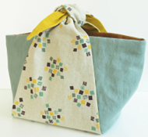 24/18 SHAWL, SCARF, SHRUG

24/19 KNITTED NOVELTY – Max Size 300mm X 300mm

24/20 TOY, DOLL (Any)

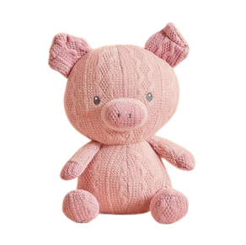 24/21 HOMEWARES – Pillow, Cushion, Table runner, Tablecloth, Basket/Container, tea cosy, (No Washers)

**CHAMPION HAND KNITTING**

**SOCIETY’S CHAMPION RIBBON AND CARD**

**CROCHET**

Please present on contrasting coloured cardboard this will shows off your work.

Cardboard to be no more than 2cm bigger than the item.

**Must be tacked or pinned from underneath, not on top, using small safety pins**

**please attach in only a few places not all around.**

24/22 ANY CROCHET ARTICLE – FINE 40 and OVER (No Washers)

24/23 ANY CROCHET ARTICLE – HEAVY 30, 20, 10 (No Washers)

24/24 ADULT CLOTHING – Jumper, Top, Shorts, Dress etc

24/25 TABLE RUNNER

24/26 CREATIVE CROCHET – ANY ARTICLE

24/27 CHILDREN & BABY CLOTHING – Jumper, Top, Booties, Socks (Pinned together) Jumpsuit, Babywear

24/28 SLIPPERS, SOCKS, BEANIE, GLOVES

24/29 SHAWL, SCARF, SHRUG

24/30 TOY, AMIGURUMI, DOLL (Any)

24/31 KNEE RUG, THROW RUG or RUG TO BE USED WITH A WHEELCHAIR

24/32 RUG – Max Size Queen Size

24/33 ARTICLE with CROCHET EDGE or CORNER – Handkerchief

24/34 ARTICLE with CROCHET EDGE or CORNER – Tea Towel, Washer

24/35 ANY CROCHET ARTICLE – Not already covered in the crochet i.e.: Granny Squares(300mmx300mm), Bag, Jewellery

24/36 NOVELTY – Max Size 300mm X 300mm A NOVELTY IS SOMETHING THAT HAS

LITTLE OR NO USE

**CHAMPION CROCHET**

**SOCIETY’S CHAMPION RIBBON AND CARD**

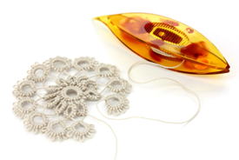

**TATTING, BOBBIN LACE or NEEDLE LACE**

24/37 TATTING – ANY ARTICLE

24/38 ANY ARTICLE – BOBBIN LACE or NEEDLE LACE

24/39 ANY OTHER TYPE OF LACE – ANY ARTICLE

**CHAMPION TATTING, BOBBIN LACE or NEEDLE LACE**

**SOCIETY’S CHAMPION RIBBON AND CARD**

**BEADWORK**

24/40 ANY BEADED ARTICLE – i.e.: Christmas Decorations, No Jewellery

24/41 BEADED JEWELLERY – Necklace, Bracelet, Brooch or Earrings

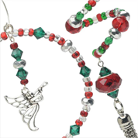24/42 ANY BEADED ARTICLE – i.e.: Belts, Collars, Handbags

**CHAMPION BEADWORK**

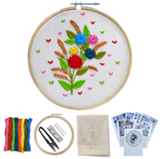**SOCIETY’S CHAMPION RIBBON AND CARD**

**HAND EMBROIDERY**

24/43 OPEN TAPESTRY – Any Article

24/44 LONG STITCH TAPESTRY – Any Article

24/45 CREATIVE CANVAS – Any Article

24/46 HARDANGER – PULLED THREAD – DRAWN THREAD – Any Article

24/47 EVENWEAVE MATERIAL – Counted Thread, Florentine, Myreska

24/48 CREWEL WORK – Any Article

24/49 CROSS STITCH / ASSISI – Any Article – Max Size 600mm X 600mm FRAMED

24/50 RED, BLACK, BLUE, or WHITE – Using Only One Colour

24/51 THREAD PAINTING – Any Article – Using Cotton, Silk or Wool

24/52 GOLD / SILVER WORK – Any Article – Using Gold, Silver or Gilt Metallic Threads

24/53 ANY OTHER EMBROIDERED ARTICLE – Not Already Covered in Hand Embroidery

24/54 HAND EMBROIDERED GIFT or NOVELTY

24/55 SASHIKO – Any Item – 300mm x 300mm

**CHAMPION NEEDLECRAFT EXHIBIT ON FABRIC**

**24/43 – 24/55 SOCIETY’S CHAMPION RIBBON AND CARD**

**PATCHWORK / QUILTING**

24/56 ANY ARTICLE OF PATCHWORK / QUILTING – Max Size Queen Size

24/57 WALL HANGING – Max Size 600mm X 600mm

24/58 PATCHWORK TABLE RUNNER or PLACEMAT

24/59 APPLIQUE – HAND SEWN

**CHAMPION PATCHWORK / QUILTING**

**SOCIETY’S CHAMPION RIBBON AND CARD**

**MISCELLANEOUS**

24/60 ANY OTHER SOFT CRAFT – NOT ALREADY MENTIONED IN SCHEDULE

24/61 FROM SOMETHING OLD TO SOMETHING NEW – Any Article i.e. Old jumper made into a bag, old dress into a pillowcase Etc. Max Size 600mm X 600mm A photo of the old item.

24/62 GREETING CARD – Made from mostly material - Handmade – Stamping, Embossing, Punches

24/63 3D ITEM – Made out of Card 400 x 400mm or mixed medium 220 x 220mm

24/64 COAT HANGER – Any Medium

24/65 CHRISTMAS ITEM – Max Size 600mm X 600mm

24/66 ANY ARTICLE MACHINE EMBROIDERED – Max Size 600mm X 600mm

24/67 THREAD PAINTING – Any Article – Machine Worked

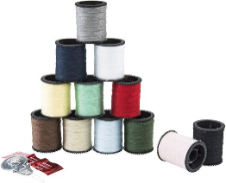24/68 FABRIC PAINTING – ANY ARTICLE ON FABRIC – Using Fabric Paints

24/69 DIAMOND DOT – 300mm x 300mm – Framed or Unframed

24/70 DIAMOND DOT – Any Article – Caps, Hats (**No** recycled items i.e. Skulls)

**SEWING AND TOYS**

24/71 CHILD/INFANT OUTFIT – Machine Made for Child up to 10 yrs.

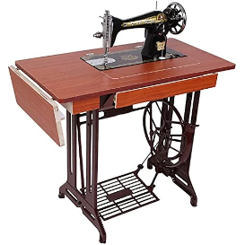24/72 ANY GARMENT – Machine Made for 11yrs. to adult.

24/73 MACHINE MADE DOLL – DRESSED IN MACHINE MADE CLOTHES

24/74 ANY ARTICLE – HAND SEWN

24/75 BEAR – Any Medium – No Lavender

24/76 MACHINE MADE ARTICLE – Not Already Covered i.e. Shopping Bag, Dolls Clothes.

24/77 ANY TOY – Not Already Covered – No Bears or Dolls

24/78 FABRIC NOVELTY – Max Size 300mmx 300mm

24/79 ANY ARTICLE CHRISTMAS DECORATION – MACHINE MADE – Max Size 600mm X 600mm

24/80 MACHINE APPLIQUE – ANY ARTICLE – Max Size 600mm X 600mm

**MACRAME**

24/81 WALL HANGING – Max size 1.5m (Excluding hanger)

24/82 HOMEWARES – Pillow, Cushion, Table Runner, Tablecloth, Basket/Container, Trivet

24/83 ACCESSORIES – Key Chain, Jewellery, Bookmark

24/84 ANY ARTICLE – Not covered above (Max Size 300mm x 300mm)

**Selected From 24/71 – 24/84 SOCIETY’S CHAMPION RIBBON AND CARD**

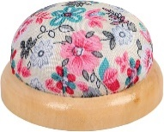

**OVERALL CHAMPION HANDCRAFT EXHIBIT**

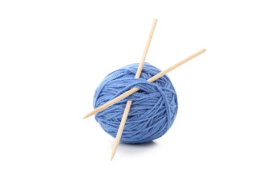**24/13 – 24/84 SOCIETY’S CHAMPION RIBBON AND CARD**

**NOVICE DIVISION**

24/85 ANY ARTICLE – Knitting, Crochet

24/86 ANY ARTICLE – Embroidered

24/87 ANY ARTICLE – Cross Stitch – Max Size 600mm X 600mm

24/88 ANY ARTICLE – Soft Craft Not Already Covered – Max Size 600mm X 600mm

**MATURE AGE 75 YEARS AND OVER, NURSING HOME RESIDENT, AGED CARE & HOSTEL**

24/89 ANY ARTICLE – Soft Craft – Max Size 600mm X 600mm (Unless a Rug)

24/90 ANY ARTICLE – Knitting, Crochet

**CHAMPION MATURE AGE 75 YEARS AND OVER, NURSING HOME RESIDENT, AGED CARE & HOSTEL**

**SOCIETY’S CHAMPION RIBBON AND CARD**

**the show society and handcraft stewards of the BUNDABERG show would like to thank the sponsors for their generosity and support. the exhibitors for their support and for taking the time to exhibit their crafts, without these very important people the show would not be as successful as it is.**

**thank you all and hope to see you all at the next show.**



ENTRY FORM

BUNDABERG A.P. & I SOCIETY INC

THE SECRETARY, SHOWGROUNDS OFFICE

Via UNIVERSITY DRIVE, BUNDABERG QLD 4670

TELEPHONE:- (07) 4138 7605

ABN 21 134 402 026

*EACH EXHIBITOR TO BE ON A SEPARATE FORM*

PLEASE NOTE: MULTIPLE ENTRIES PER SECTION TO BE WRITTEN ON THE ONE FORM. YOU DO NOT NEED TO COMPLETE A SEPARATE ENTRY FORM PER CLASS IN ANY PARTICULAR SECTION.

Subject to the Rules, By-Laws and Regulations of your Society and the Queensland Chamber of Agricultural Societies, I make the following entries for your forthcoming Show.

EACH SECTION NOT CLASS TO BE ON A SEPARATE FORM

ONE LINE PER ENTRY

|  |  |  |  |  |
| --- | --- | --- | --- | --- |
| SECTION NUMBER | CLASS NUMBER | Colour & Type i.e. Brown Bear with black pants, blue bow tie. Green recycled plastic bag with gold buckle.  This helps to identify article when judging. | FOR SALE PRICE | ENTRY FEE |
|  |  |  |  |  |
|  |  |  |  |  |
|  |  |  |  |  |
|  |  |  |  |  |
|  |  |  |  |  |
|  |  |  |  |  |
|  |  |  |  |  |
|  |  |  |  |  |
|  |  |  |  |  |
|  |  |  |  |  |
|  |  |  |  |  |
|  |  |  |  |  |
|  |  |  |  |  |
|  |  |  |  |  |
|  |  |  | TOTAL  FEES |  |

DATE OF BIRTH FOR CHILD EXHIBITOR

PLEASE PRINT

NAME OF EXHIBITOR

ADDRESS

PHONE NUMBER

EMAIL:

DATE ABN

SIGNATURE TO BE COLLECTED