**2025**

**131st**

**Hitz fm 93.9**

**BUNDABERG**

**SHOW**

**Wednesday 28th May**

**Thursday 29th May**

**Friday 30th May**

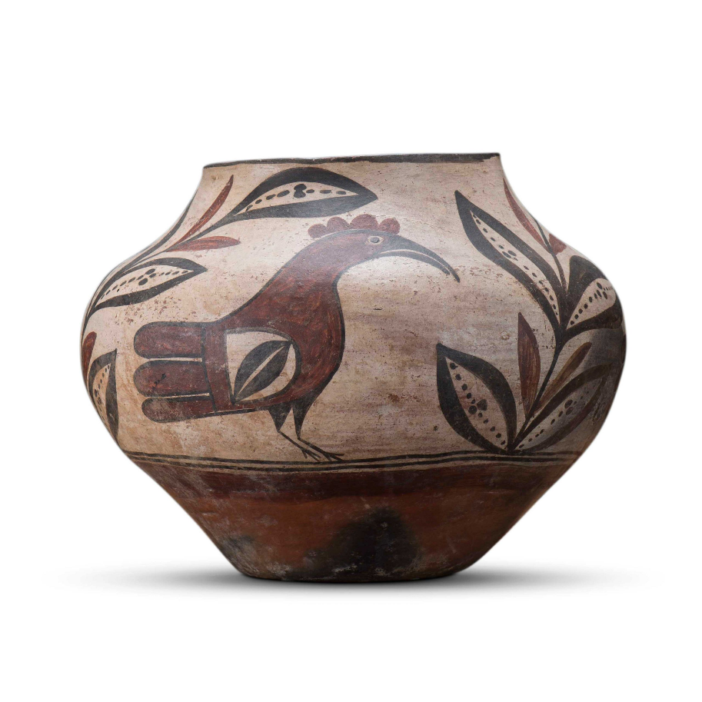

**SECTION 23**

**POTTERY**

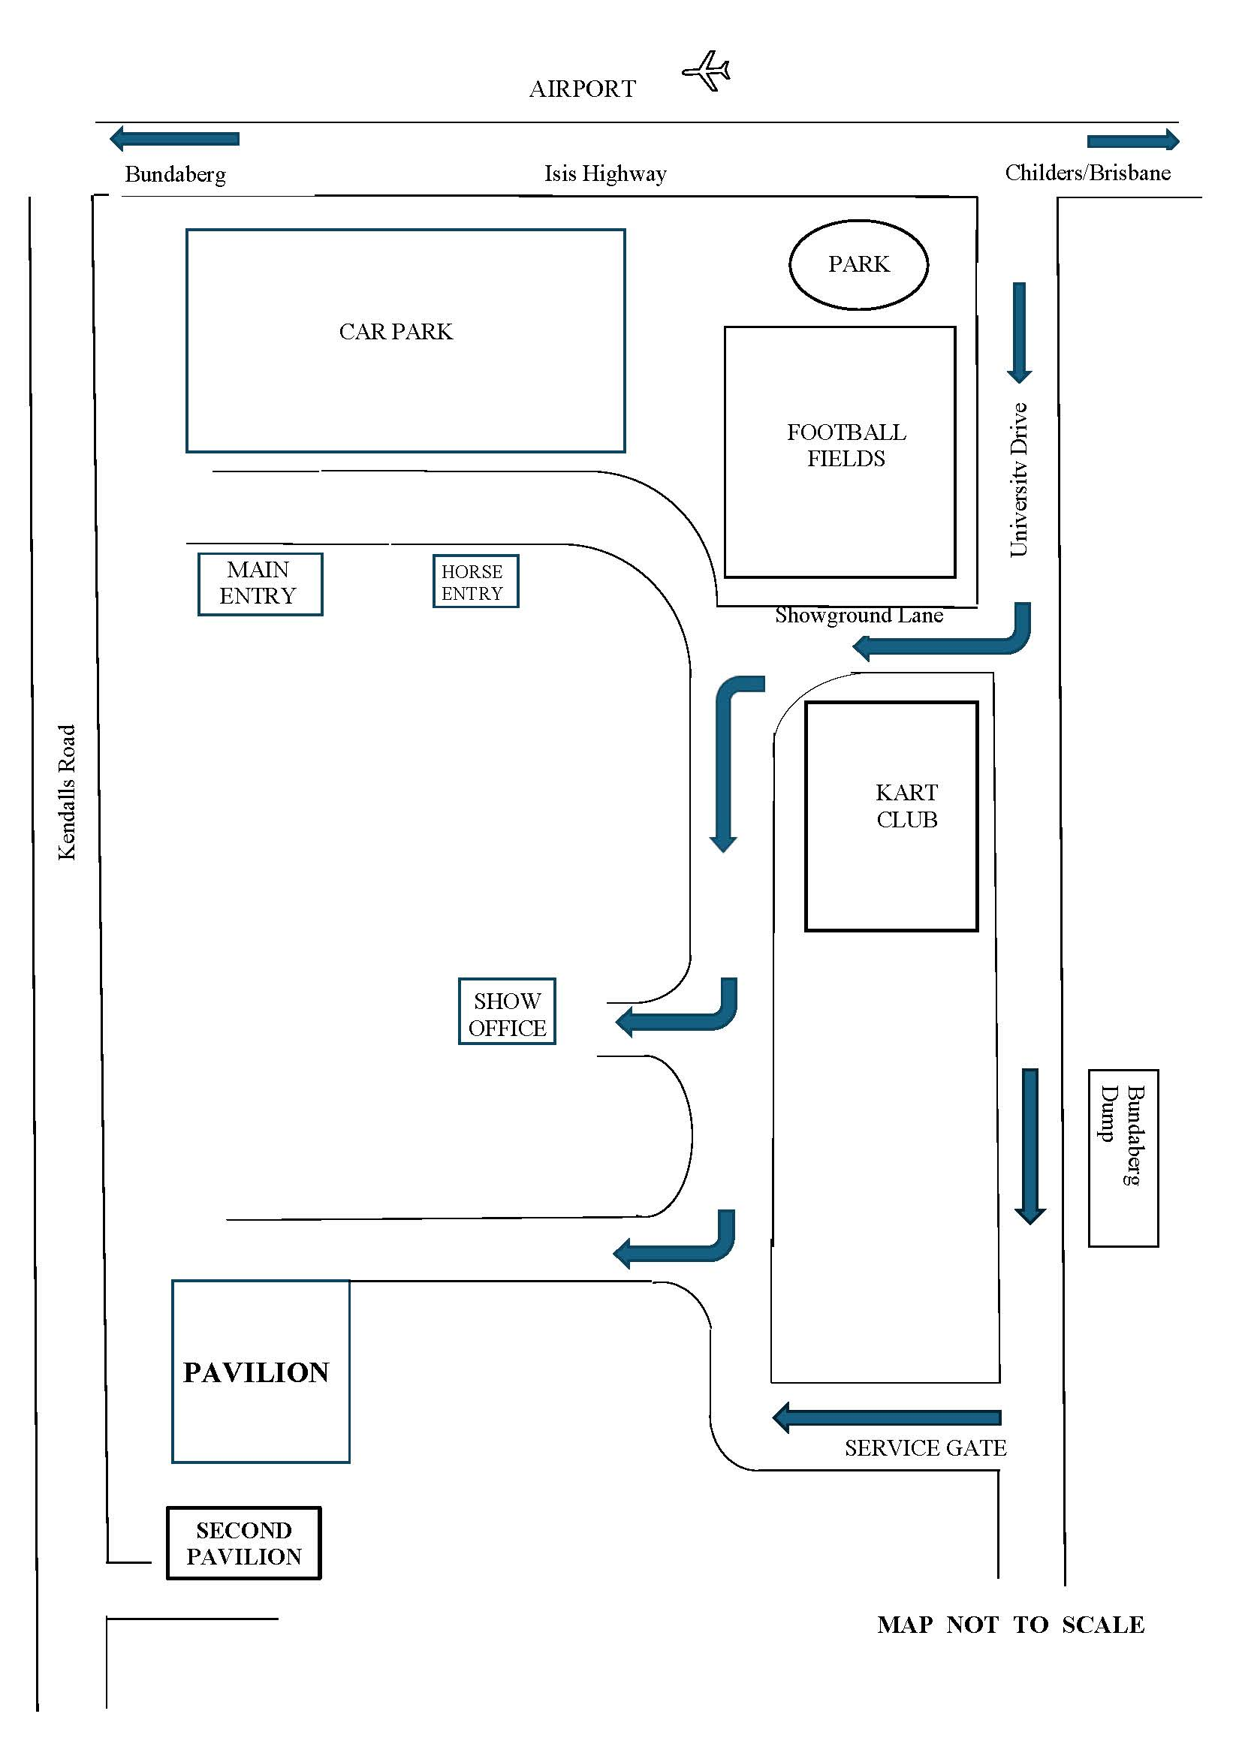

PRIVACY STATEMENT

The Information provided by Exhibitors Is used by the Queensland Chamber of Agriculture Associations Inc. and the Bundaberg A.P. & I, Society Inc. to organize , process and conduct competitions at the Bundaberg AP & I Society Inc show. By entering such competitions, you consent to your personal Information being used for this purpose Including this Information being made available to sponsors, breed Associations, the media, the public, promotional purposes. archival purposes, published in publications or as It is otherwise required by Law.

All exhibitors have the right to access and alter personal information concerning themselves in the terms of the Privacy Act. This can be done by contacting the QCAS CEO or by writing to QCAS

WORKPLACE HEALTH AND SAFETY

All Queensland Chamber of Agriculture Societies Inc. affiliated Association Showgrounds are designated workplaces within the meaning of the

Workplace Health and Safety Act 2011 and exhibitors/competitors are required to ensure that they and all persons under their direction or control, including their contractors or subcontractors, comply with all requirements of the Act. The Queensland Chamber of Agriculture Associations Inc hold each exhibitor responsible to discharge Its obligations to provide and maintain a safe place and system of work during occupation by the exhibitor/competitor of any area of the affiliated Agricultural Associations Showgrounds/Precinct.

Each exhibitor/competitor will assess the risk to themselves, staff, volunteers, family, other exhibitors, Agricultural Society staff, show visitors, children and any person foreseeably affected by the presentation of their exhibit.

Exhibits will only be held and handled by competent persons whose experience Is known to the Exhibitor/ competitor.

The exhibitors/competitors are advised that the use of Primus Stoves, any heating or lighting appliances of a like character, or any naked light, ls strictly prohibited in Pavilions/stables/barns.

Any exhibitors/competitors Intending to bring electrical equipment to the Showgrounds/Precinct will be required to ensure that such equipment Is fitted with a residual current protection and that all electrical lead s, tools and appliances have been Inspected by a licensed electrical contractor and are currently tagged. The use of double adaptors is prohibited, and all power boards must also be tested and tagged.

All exhibitors/competitors will comply with the requirements of the ACT end Its Regulations and Standards In every respect. This Is essential for the safety of all exhibitors/competitors and the general public. The ACT Imposes very severe penalties in the event of noncompliance with its provisions. Any exhibitors/competitors who do not comply will not be allowed to exhibit at"Queensland Chamber of Agriculture Association. affiliated Shows".

**BUNDABERG SHOW**

GATE ENTRY FEES:

ADULT:------------------------------$20.00

STUDENT: 6 – 17 yrs.:-----------$10.00

CONCESSION:---------------------$10.00

OVER 75 YEARS :-----------------FREE

UNDER 6 YEARS:-----------------FREE

**PRE-PURCHASE TICKET ONLY**

FAMILY ONE DAY PASS $50.00

(Available until Tuesday 27th May 2025)

(Includes 2 Adult & 2 Children 15 yrs. & under)

**HOW TO ENTER THE SECTIONS**

FILL OUT ENTRY FORMS

**All entries must be:**

* **On Official Entry Forms**
* **On SEPARATE Entry Forms for Each Section (NOT CLASS)**
* **Fully completed**
* **Accompanied by Entry Fees (Refer Sections)**
* **Handcraft, Photography and Fruit & Vegetables have separate entry forms**

# **ENTRIES WILL NOT BE ACCEPTED**

* **Without entry fees**
* **Over the telephone**
* **After closing date**

# **DELIVER ENTRY FORMS TO**

**Bundaberg Show Society Office**

**via University Drive, Bundaberg**

**Inquiries – Phone 07 4138 7605**

**Delivery of entry forms: APRIL – Mon, Wed, & Fri 9.am – 1pm.**

**MAY – Mon - Fri 9am – 4pm**

# **YOU WILL RECEIVE**

* **Class Ticket stating Section, Class and Entry No.**
* **Receipt**

# **DELIVER EXHIBITS**

* **Accompanied by Class Ticket (ATTACHED)**

**(This is proof of Entry in a Class)**

* **To designated part of Showground by due date and time.**

## PLEASE REFER TO EACH SECTION FOR CLOSING, DELIVERY & COLLECTION

**Prize money** to be collected from the Show Office during the Show from 2pm Wednesday 28th May to 2pm Saturday, 31st May. Office hours 9.00 – 4.00. Prize money NOT COLLECTED will be deemed a donation and returned to Society’s Funds. All prize money/entry fees contain GST which is payable by all competitors whether registered for GST or not registered for GST.

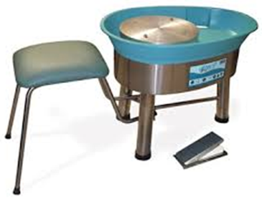

**SECTION 23: POTTERY**

**CONDITIONS OF ENTRY**

1. All entries to be the original work of the exhibitor.
2. Exhibits **must not** have been previously entered in a Bundaberg Show.
3. Novice members who have previously won a Novice Section are not eligible to enter this class.
4. All entries to be completed without supervision or assistance from an instructor.
5. All articles are to be made from clay and fired to at least 1,000**°**C.
6. No Commercial molds are to be used.
7. There will be no limit to the number of entries by one person.
8. Any entry may be entered in one class only.
9. Class entries are to have the entry ticket firmly attached (sticky taped) to the underside of the article with the number clearly visible and the competitors name out of sight.

**Entries Close 4.00pm Friday 23rd May 2025**

**Entries to be delivered to the Pavilion on the Tuesday 27th   May 9.00 am – 11.00 am.**

**Entries to be picked up Saturday 31st May**

**9.00am – 12.00pm.**

**SECTION 23: POTTERY.**

**Stewards: Anne Druitt,** **Josephina Beckers, Maarten Van Bokkel**

**Entry Fee: $2.00**

***No refunds for a change of mind or if unable to attend.***

**23/1: Open Wheel Thrown Piece.**

1st: $25 voucher donated by **The Clay Shed**.

2nd: $10, donated by the Show Society

**23/2: Open Hand built Piece (including Sculpture)** 1st: $25 voucher donated by **Pottery Supplies**.             2Nd: $10, donated by the Show Society

**23/3: Novice.** Potters who have been producing ware for less than 2 years          1st : $25, in memory of Joan Gray 2nd: $10, donated by the Show Society

**23/4: Mythical, Magical Creatures.** A sculptured figure of one or more of the following: gnomes, magicians, fairies, dragons, elves, goblins.

Due to the availability of display space the height & width is not to exceed

25cm x 15cm.

1St : $25, in memory of Vicki Stuart.

2Nd : $10, donated by the Show Society.

**23/5: “Feathers, Fur & Fins”.**

A pottery piece, hand built of wheel thrown depicting an animal, bird or fish.

1St: $25 donated by the Bundaberg Pottery group

2nd: $10, donated by the Show Society.

**23/6: “It’s All About Texture”.**

A pottery piece, hand built or wheel thrown, featuring a unique textured surface. This can be achieved by carving, cutting or adding to the clay. Techniques such as; raised, impressed or carved effects, sgraffito, inlaying, sprigging, piercing, kurinuki, or burnishing can be used.

1St: $25 voucher donated by **The Clay Shed**

2nd:$10 donated by the Show Society.

**Judges Encouragement Award.**

$25 donated by The Bundaberg Pottery Group Tutors. (Awarded to an entry that has not received a prize)

**Supreme Champion Exhibit.** (Awarded to a first prize entry.)  Show Society Ribbon along with perpetual trophy where the winner’s name will be engraved and will remain on display in Pottery Club Rooms.

BUNDABERG A.P. & I SOCIETY INC

THE SECRETARY, SHOWGROUNDS OFFICE

Via UNIVERSITY DRIVE, BUNDABERG   QLD   4670

TELEPHONE:- (07) 4138 7605

ABN 21 134 402 026

*EACH EXHIBITOR TO BE ON A SEPARATE FORM*

PLEASE NOTE: MULTIPLE ENTRIES PER SECTION TO BE WRITTEN ON THE ONE FORM. YOU DO NOT NEED TO COMPLETE A SEPARATE ENTRY FORM PER CLASS IN ANY PARTICULAR SECTION.

|  |  |  |  |  |
| --- | --- | --- | --- | --- |
| SECTION NUMBER | CLASS NUMBER | DESCRIPTION OF EXHIBIT | FOR SALE PRICE | ENTRY FEE |
|  |  |  |  |  |
|  |  |  |  |  |
|  |  |  |  |  |
|  |  |  |  |  |
|  |  |  |  |  |
|  |  |  |  |  |
|  |  |  |  |  |
|  |  |  |  |  |
|  |  |  |  |  |
|  |  |  |  |  |
|  |  |  |  |  |
|  |  |  |  |  |
|  |  |  |  |  |
|  |  |  | TOTAL  FEES |  |

PLEASE PRINT

DATE OF BIRTH FOR A CHILD EXHIBITOR: ______________________________

NAME OF EXHIBITOR

ADDRESS

PHONE NUMBER

EMAIL:

DATE ABN

SIGNATURE

TO BE COLLECTED YES/NO