**2025**

**131st**

**Hitz fm 93.9**

**BUNDABERG**

**SHOW**

# **WEDNESDAY 28th May**

**THURSDAY 29th May**

**FRIDAY 30th May**

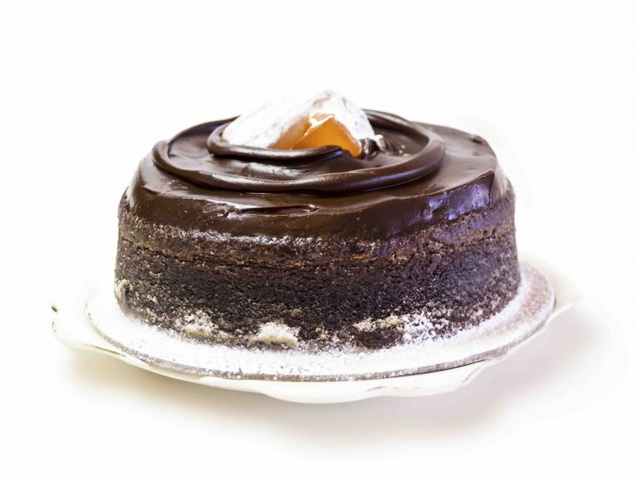

**SECTION**

**18 & 19**

**COOKING**

**ICED CAKES**



PRIVACY STATEMENT

The Information provided by Exhibitors Is used by the Queensland Chamber of Agriculture Associations Inc. and the Bundaberg A.P. & I, Society Inc. to organize , process and conduct competitions at the Bundaberg AP & I Society Inc show. By entering such competitions, you consent to your personal Information being used for this purpose Including this Information being made available to sponsors, breed Associations, the media, the public, promotional purposes. archival purposes, published in publications or as It Is otherwise required by Law.

All exhibitors have the right to access and alter personal information concerning themselves in the terms of the Privacy Act. This can be done by contacting the QCAS CEO or by writing to QCAS

WORKPLACE HEALTH AND SAFETY

All Queensland Chamber of Agriculture Societies Inc. affiliated Association Showgrounds are designated workplaces within the meaning of the

Workplace Health and Safety Act 2011 and exhibitors/competitors are required to ensure that they and all persons under their direction or control, including their contractors or subcontractors, comply with all requirements of the Act. The Queensland Chamber of Agriculture Associations Inc hold each exhibitor responsible to discharge Its obligations to provide and maintain a safe place and system of work during occupation by the exhibitor/competitor of any area of the affiliated Agricultural Associations Showgrounds/Precinct.

Each exhibitor/competitor will assess the risk to themselves, staff, volunteers, family, other exhibitors, Agricultural Society staff, show visitors, children and any person foreseeably affected by the presentation of their exhibit.

Exhibits will only be held and handled by competent persons whose experience Is known to the Exhibitor/ competitor.

The exhibitors/competitors are advised that the use of Primus Stoves, any heating or lighting appliances of a like character, or any naked light, ls strictly prohibited in Pavilions/stables/barns.

Any exhibitors/competitors Intending to bring electrical equipment to the Showgrounds/Precinct will be required to ensure that such equipment Is fitted with a residual current protection and that all electrical lead s, tools and appliances have been Inspected by a licensed electrical contractor and are currently tagged. The use of double adaptors is prohibited, and all power boards must also be tested and tagged.

All exhibitors/competitors will comply with the requirements of the ACT end Its Regulations and Standards In every respect. This Is essential for the safety of all exhibitors/competitors and the general public. The ACT Imposes very severe penalties in the event of noncompliance with its provisions. Any exhibitors/competitors who do not comply will not be allowed to exhibit at "Queensland Chamber of Agriculture Association. affiliated Shows".

**BUNDABERG SHOW**

GATE ENTRY FEES:

ADULT:------------------------------$20.00

STUDENT: 6 – 17 yrs.:------------$10.00

CONCESSION:---------------------$10.00

OVER 75 YEARS :-----------------FREE

UNDER 6 YEARS:-----------------FREE

**PRE-PURCHASE TICKET ONLY**

FAMILY ONE DAY PASS $50.00

(Available until Tuesday 27th May)

(Includes 2 Adult & 2 Children 15 yrs. & under)

**HOW TO ENTER THE SECTIONS**

FILL OUT ENTRY FORMS

**All entries must be:**

* **On Official Entry Forms**
* **On SEPARATE Entry Forms for Each Section (NOT CLASS)**
* **Fully completed**
* **Accompanied by Entry Fees (Refer Sections)**
* **Handcraft, Photography and Fruit & Vegetables have separate entry forms**

# **ENTRIES WILL NOT BE ACCEPTED**

* **Without entry fees**
* **Over the telephone**
* **After closing date**

# **DELIVER ENTRY FORMS TO**

**Bundaberg Show Society Office**

**via University Drive, Bundaberg**

**Enquiries – Phone 07 4138 7605**

**Delivery of entry forms:- April – Mon, Wed, & Fri 9am – 1pm.**

**May – Mon to Fri, 9am – 4pm**

# **YOU WILL RECEIVE**

* **Class Ticket stating Section, Class and Entry No.**
* **Receipt**

# **DELIVER EXHIBITS**

* **Accompanied by Class Ticket (ATTACHED)**

**(This is proof of Entry in a Class)**

* **To designated part of Showground by due date and time.**

## PLEASE REFER TO EACH SECTION FOR CLOSING, DELIVERY & COLLECTION

**Prize money** to be collected from the Show Office during the Show from 2.00 pm Wed 28th May until 2.00 pm Sat 31st May. Office hours 9.00 – 4.00. After the show all prize money not collected will be returned to the Society’s Funds.

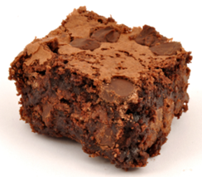

## SECTION 18 COOKING AND SWEETS

CONDITIONS OF ENTRY

1. Cut cakes will not be accepted.
2. Exhibits are to be bought in on paper plates
3. Bar cakes, scones and biscuits on oblong foam trays.
4. FOAM TRAYS FOR THIS SECTION ARE AVAILABLE AT THE SECRETARY’S OFFICE,UNIVERSITY DRIVE ENTRANCE, BUNDABERG SHOWGROUNDS - COST 5 FOR $1.00.
5. All exhibits must be the bona fide work of the exhibitor.
6. **ENTRIES CLOSE** Friday 23rd May at 4.00pm.
7. Exhibits to be delivered at Main Pavilion on Monday 26th May between 12 noon and 6.00pm.
8. Exhibits collected SATURDAY 31st May from 9am till 10am.
9. We take no responsibility for your entry if lost or stolen.
10. No refunds if change of mind or unable to attend.

***HINT****: To stop cakes, etc., sticking to plastic plates – place a piece of Glad Bake paper on all plates*

**CHIEF STEWARD** **SHIRLEY BALDWIN**

Mobile 0403 880 059

**ENTRY FEE** $1.00 per entry unless otherwise stated, Includes GST.

* * * * * *

**CHAMPION OPEN DIVISION**

## *(Excludes Section 42)*

Prize plus SOCIETY’S CHAMPION RIBBON

$50.00

## RESERVE CHAMPION-OPEN DIVISION

## *(Excludes Section 42)*

$20.00

# **CHAMPION NOVICE DIVISION**

$50.00

# **CHAMPION BUTTER CAKE - JUNIOR DIVISION**

Trophy plus SOCIETY’S CHAMPION RIBBON

## RESERVE CHAMPION - BUTTER CAKE - JUNIOR DIVISION

$15.00

**CHAMPION COOKING-CHILDREN’S DIVISION**

SOCIETY’S CHAMPION RIBBON

$10.00

## RESERVE CHAMPION-CHILDREN’’S DIVISION

$5.00

## SUPREME CHAMPION EXHIBIT OF THE SHOW

Prize plus SOCIETY’S RIBBON

## MOST ENTRIES-ADULT SECTION

Bundaberg Show Society $20.00

**SWEET SECTION**



**SECTION 18**

**18/1 ANY FUDGE** - One plate of six

**18/2 MARSHMALLOWS** - One plate of six

**18/3 ROCKY ROAD** – One plate of six

**18/4 MOULDED CHOCOLATES** – 1 plate of 6

**18/5 MOULDED CHOCOLATES –** With any filling – 1 plate of 6

***1st $10.00 2nd $6.00 3rd $4.00***

# **CAKE SECTION**

**18/6 CHOCOLATE CAKE** – Bar or loaf tin-Iced on top only

**18/7 BANANA CAKE** - Round tin 20cm-lemon icing on top only

**18/8 KENTISH CAKE** – Bar or Loaf Tin Iced on top only with chocolate icing & sprinkled with coconut

**18/9 ORANGE CAKE** - Bar or loaf tin-Iced on top

**18/10 PACKET CAKE** – Iced on top only, butter icing. Packet mix, ANY VARIETY – *to include top of packet with name. – Excluding Orange and Poppyseed cakes*

**18/11 CUSTARD KISSES** – Plate of six

**18/12 COFFEE CAKE** - 20cm round tin - Coffee icing on top only

**18/13 PEANUT BISCUITS –** Plate of six

**18/14 GINGER CAKE** – Round tin approx. 20cm, iced on top only

**18/15 DATE BAR** – Bar or loaf tin, not iced

**18/16 CARROT & WALNUT CAKE** – Round tin approx. 20 cm - Iced on top only

**18/17 MARBLE CAKE** – Round tin 20cm, iced with pale pink icing on top only

**18/18 CINNAMON TEA CAKE** - Round tin approx. 20cm

**18/19 GINGER SLICE** – Plate of six

**18/20 OPEN BUTTER CAKE** - Bar or loaf tin-Iced on top only

**18/21 BANANA MUFFINS -** Plate of six

**18/22** **ORANGE & POPPYSEED PACKET CAKE** – Iced on top only – To include packet top

**18/23 ANY OTHER CAKE NOT MENTIONED IN SCHEDULE –** To be named

**18/24 ANZAC BISCUITS** - One plate of six

**18/25** **SHORTBREAD BISCUITS** - Plain-One plate of six

**18/26 ANY MUFFINS** - Plate of six **–** Excluding banana

**18/27 CHOCOLATE SLICE** - Plate of six

**18/28 SLICE OF OWN CHOICE** - One plate of six – *Excluding chocolate*

**18/29 SMALL CAKES-ICED -** In patty papers -One plate of six

**18/30 LEMON CAKE** – Round tin approx. 20 cm – Iced on top only

**18/31 BUTTERFLY CAKES** - One plate of six-Not in patty papers

**18/32 DATE SLICE–**  plate of six

**18/33 PIKELETS** - One plate of six

**18/34 PLAIN SCONES** - One plate of six - Not touching

**18/35 SAVOURY SCONES** - One plate of six - Not touching

**18/36 PUMPKIN SCONES** - One plate of six - Not touching

**18/37 SULTANA SCONES** – One plate of six - Not touching

***1st $10.00 2nd $6.00 3rd $4.00***

**18/38 PUMPKIN FRUIT CAKE with approx. 2 cups SULTANAS, no icing** - Round tin approx. 20cm, no icing

***Entry Fee:*** *$1.50*

**18/39 BOILED FRUIT CAKE with 375G packet mixed fruit** - Round tin only approx. 20cm

***Entry Fee:*** *$1.50*

**18/40 LIGHT FRUIT CAKE** - Square tin only approx. 20cm

***Entry Fee:*** *$1.50*

**18/41 DARK FRUIT CAKE** - Square tin only approx. 20cm

***Entry Fee:*** *$1.50*

***1st $15.00 2nd $10.00 3rd $5.00***

**18/42 RICH DARK FRUIT CAKE COMPETITION**

Burnett Sub Chamber of Agricultural Societies

***SUB CHAMBER RICH DARK FRUIT CAKE COMPETITION***

***First prize winning cakes from all Show Societies in the C.Q. Chamber*** *(which includes Bundaberg, Gin Gin, Biggenden, Eidsvold, Gayndah, Monto, Mt Perry, Mundubbera and Tee Bar)* ***will be eligible to enter their cake in the finals to be held in Gayndah Saturday 28thJune 2025***

Own recipe can be used: To be ½ pound (250gm) mixture with approx. 1.12kg of fruit to be used including currants, (whole) sultanas and raisins (cut), mixed peel, cherries and nuts optional. To be baked in a square tin not exceeding 20cm (8 inches).

**Entry fee: $5.00** including GST

***1st $50.00 2nd $30.00 3rd $10.00***

**18/42A ANZAC BISCUITS For ages 18 – 40yrs**

Burnett Sub Chamber of Agricultural Societies

***SUB CHAMBER ANZAC BUISCUT COMPETITION***

***First prize winning biscuits from all Show Societies in the C.Q. Chamber*** *(which includes Bundaberg, Gin Gin, Biggenden, Eidsvold, Gayndah, Monto, Mt Perry, Mundubbera and Tee Bar)* ***will be eligible to enter their biscuits in the finals to be held in Gayndah Saturday 28thJune 2025***

**Recipe Makes 24**:- 125gm butter, chopped, 1cup plain flour, ½ tsp bicarb soda, 1 cup rolled oats, 2tbs golden syrup, 2 tbs boiling water, ¾ cup desiccated coconut. **Method:-** Combine butter and golden syrup in a pan, stir over heat until butter is melted. Stir in combined soda and water, then remaining ingredients. Mix well. Drop rounded teaspoons of mixture about 4cm apart on greased oven trays and flatten slightly. Bake in slow oven for about 20 minutes or until slightly brown. Cool on tray.

**Entry Fee: $5.00** including GST

***1st $50.00 2nd $30.00 3rd $10.00***

**18/43 PLUM PUDDING -** Steamed

***Entry Fee:*** *$****1.50*** includes GST

**18/44 STEAMED DATE PUDDING**

***Entry Fee: $1.50*** includes GST

***1st $15 2nd $10.00 3rd $5.00***

**NOVICE SECTION**

*Open only to people who have not won a first prize in that section of the Bundaberg Show*

**18/45 ANY SLICE** – Any slice to be named

**18/46 BUTTER CAKE** – Bar or loaf tin, iced on top only

**18/47 CHOCOLATE CAKE** – Bar or loaf tin, iced on top only

**18/48 CHOC CHIP MUFFINS** – Plate of six

**18/49 BANANA CAKE** – Round tin approx. 20cm – Lemon icing on top only

**18/50 ANY OTHER CAKE NOT MENTIONED IN THE NOVICE SECTION** – To be named

***1st $10.00 2nd $6.00 3rd $4.00***

**18/51 BOILED FRUIT CAKE with 375G packet mixed fruit** –round tin approx. 20cm

***Entry fee: $1.50***

***1st $15.00 2nd $10.00 3rd $5.00***

**MEN’S COOKING DIVISION**

**18/52 FRUIT CAKE - BOILED -** Round tin approx. 20cm

***Entry fee: $1.50***

***1st $15.00 2nd $10.00 3rd $5.00***

**18/53 ANY MUFFINS –** one plate of six **–** To be named

**18/54 BISCUITS –** Any variety – 1 plate of 6 **–** To be named

**18/55 BAKING-OWN-CHOICE -** This class has been created for men who have one specialty can include anything in schedule. To be named.

**18/56** **ANY PACKET CAKE –** Iced on top only with butter icing &include top of packet

***1st $10.00 2nd $6.00 3rd $4.00***

##### **BREAD**

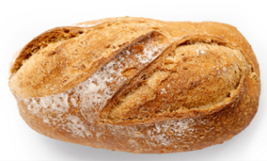***Entry fee: $1.50***

**18/57 WHITE LOAF** - Machine Bread Maker

##### **18/58** **ANY OTHER LOAF** – Machine Bread Maker

***1st $15.00 2nd $10.00 3rd $5.00***

##### **JUNIOR DIVISION**

Restricted to girls & boys under 17 years - Baked by exhibitor.

***Recipe*** ***to be used for each Age Section***

***Overall, Champion Junior Butter Cake will be chosen from the 5 1st place winners in each age category***

**JUNIOR BUTTER CAKE** - Iced on top only with vanilla icing

*BUTTER CAKE RECIPE*

115g butter, 2 eggs, ¾ cup sugar, ½ cup of milk, 1½ cups of self-raising flour

*Method*

Beat the butter and sugar until soft and creamy.

Beat the eggs and add a little at a time, beating well after each addition.

Add a little vanilla, then sifted flour and a pinch of salt alternately with milk, beginning and ending with flour. This is usually done with three additions of flour and two of milk.

Stir lightly until the mixture is soft dropping consistency. Spread in a loaf tin approx. 21x15cm, greased with butter and cook in middle of the oven, heated to 180C for 35-40 minutes.

##### **Children’s Division**

Children may enter age group only

**Entry fee** – $1.00 includes G.S.T.

##### **Up to & including 6 yr. old’s**

**18/60 JUNIOR BUTTER CAKE**

**18/61 ICED AND DECORATED PATTY CAKES** –one plate of six.

***1st $10.00 2nd $6.00 3rd $4.00***

##### **7 , 8 & 9 Years**

**18/62 DECORATED MILK ARROWROOT BISCUITS** - one plate of six

**18/63 PACKET CAKE** - Any variety-Iced on top - *to include top of packet with name.*

**18/64 ICED AND DECORATED PATTY CAKES** - one plate of six

**18/65 JUNIOR BUTTER CAKE**

***1st $10.00 2nd $6.00 3rd $4.00***

**10 and 11 Years**

**18/66 ORANGE & POPPY SEED PACKET CAKE** – Iced on top only

**18/67 SLICE –** Any variety, six pieces – to be named

**18/68 JAM DROPS** - One plate of six

**18/69 JUNIOR BUTTER CAKE**

***1st $10.00 2nd $6.00 3rd $4.00***

**12 - 13 - 14 Years**

**18/70 ANY MUFFINS**– One plate of six – To be named

**18/71 CHOCOLATE CAKE** - Bar or Loaf Tin-Iced on top only

**18/72 ANY SLICE** - One plate of six –To be named

**18/73 JUNIOR BUTTER CAKE**

***1st $10.00 2nd $6.00 3rd $4.00***

**15 - 16 - 17 Years**

**18/74 ANY MUFFINS -** One plate of six –To be named

**18/75 ORANGE CAKE –** Bar or loaf tin – iced on top only

**18/76 BUTTERFLY CAKES** - One plate of six

**18/77 JUNIOR BUTTER CAKE**

***1st $10.00 2nd $6.00 3rd $4.00***

##### **SPECIAL NEEDS**

*This section is for people with special needs, any age.*

**18/78 ANY SLICE** –To be named – Iced on top only - one plate of six.

**18/79 PACKET CAKE** – Any Variety, Iced on top, to include packet top

***1st $10.00 2nd $6.00 3rd $4.00***

## 

## Section

**19**

**ICED WORKS**

## CONDITIONS OF ENTRY

1. There will be a NO limit of entries per class per exhibitor.

2. No entry can be entered in more than one class.

3. All exhibits must be the bona fide work of the exhibitor.

4. Entries are to be iced and decorated on fruitcakes with the exception of the Sugar Craft Section.

5. Judges have the right to pierce cakes for foreign matters.

6. A points system will be used for judging.

7. Use of manufactured pillars (including wine glasses), tulle, ribbon, cachous, stamens (manufactured or handmade), floral tape, fine wire and a minimum amount of silver or gold paints are permitted.

8. Natural fine dried stems used with restraint and in conjunction with icing, to form part of sprays or floral arrangement is permissible, otherwise all iced work and decorations to be made using a sugar and edible medium.

9. Moulds and cutters may be used to assist in the making of icing decorations or accessories.

10. Use of dolls, toys or any glass, wooden, tin, plastic or any other manufactured materials are not permitted. No soft icings (cream, butter icings etc.) are allowed.

11. All baseboards to have small legs or runners for ease of handling and boards may be covered as a matter of choice. The entire entry must fit within the perimeter of the baseboard (no part of exhibit is allowed to protrude past board edge.

12. No restrictions have been made regarding size of exhibit boards, but we ask competitors to be realistic for ease of handling and exhibiting in showcases.

13. Once an entry is benched, cabinets must not be opened without permission of the Pavilion Manager or Chief Steward.

14. Failure to comply with these rules will result in disqualification.

15. Exhibitors who wish their entries to be sold can notify Stewards of the prices. The Bundaberg Regional Show Committee will charge a Commission of 10% for any exhibit sold during the Show.

16. **ENTRIES CLOSE** Friday, 23rd May at 4.00 pm.

17. Entries to be lodged at;-  
**THE SECRETARY’S SHOWGROUNDS OFFICE, UNIVERSITY DRIVE ENTRANCE. BUNDABERG, 4670**

18. Exhibits to be delivered to the Main Pavilion on Monday 26th May between 12 noon and 6.00pm**.**

19. Exhibits to be collected on Saturday 31st May from 9am till 10am.

20. No refunds if change mind or unable to attend.

**Prize money** To be collected from Show Office during the show Wednesday 28th May 2.00 pm until Saturday 31st May 2025, 2.00 pm. Office hours 9.00 – 4.00.

After the show, prize money not collected will be returned to the Society’s Funds.

**CHIEF STEWARD** **SHIRLEY BALDWIN** - Ph Mobile 0403 880 059

**ENTRY FEES** As Stated in each class.

**PRIZEMONEY** As Stated in each class.

**If entries are not up to show standard, prizes may not be awarded.**

**CHAMPION ICED WORK OF THE SHOW** –

SOCIETY'S CHAMPION RIBBON

**MOST SUCCESSFUL EXHIBITOR - Open Division** –

SOCIETY'S CHAMPION RIBBON

**CHAMPION EXHIBITOR - Restricted Division** –

(Novice and under 16 Years Classes).

**ENCOURAGEMENT AWARD**– **Judges Choice** –

### OPEN DIVISION

**19/01 SPECIAL OCCASION CAKE *Entry Fee $4.00***

One tier - Iced & decorated - excluding novelty.

Judged on suitability for occasion - e.g., Birthday, Engagement, Christening, Anniversary, Christmas, 21st etc.

***Alternatives will be accepted for this class e.g.: styrofoam, cake tin, etc.***

Prizes: 1ST $50.00 2ND $30.00 3RD $15.00

**19/02a WEDDING CAKE – traditional design *Entry Fee $8.00***

Iced & Decorated – 1or more tiers.

Arranged and presented on a common baseboard.

***Alternatives will be accepted for this class e.g.: styrofoam, cake tin, etc.***

Prizes: 1ST $100.00 2ND $50.00 3RD $25.00

**19/02b WEDDING CAKE – modern design *Entry Fee $8.00***

Iced & Decorated – 1or more tiers.

Arranged and presented on a common baseboard.

***Alternatives will be accepted for this class e.g.: styrofoam, cake tin, etc.***

Prizes: 1ST $100.00 2ND $50.00 3RD $25.00

**19/03 SUGAR CRAFT *Entry Fee $4.00***

No cake - Floral Arrangement or Novelty on baseboard.

Prizes: 1ST $50.00 2ND $25.00 3RD $15.00

**19/04 CAKE SUITABLE FOR A MALE OCCASION *Entry Fee $4.00***

One tier - iced & decorated.

Prizes: 1ST $50.00 2ND $25.00 3RD $15.00

***Alternatives will be accepted for this class e.g.: styrofoam, cake tin, etc.***

**19/05 NOVELTY CAKE *Entry Fee $4.00***

Iced & decorated. Fruitcake used in entry must be at least equivalent to a 16cm. Square cake. Can be more than one cake.

Prizes: 1ST $50.00 2ND $25.00 3RD $15.00

#### 19/06 NOVELTY CAKE Entry Fee $4.00

Using a fancy shaped pan - Mainly consisting of tube work.

Prizes: 1ST $50.00 2ND $25.00 3RD $15.00

#### 19/07 MINIATURE SPECIAL OCCASION CAKE Entry Fee $1.50

One tier – iced & decorated – *excluding novelty*.

Special occasion e.g., Birthday, Christening, Anniversary etc.

Baseboard restriction – Board & Entry must fit within the perimeter of 17cm. Square.

***Alternatives will be accepted for this class e.g.: styrofoam, cake tin, etc.***

Prizes: - 1ST $15.00 2ND $10.00 3RD $5.00

#### RESTRICTED DIVISIONS

*Novice applies to any exhibitor who has not won a first prize in an iced work section at any previous Bundaberg Show*

**19/08 SPECIAL OCCASION CAKE *Entry Fee $2.50***

One tier - iced & decorated - excluding novelty.

Judged on suitability for occasion, e.g., Birthday, Engagement, Christening, Anniversary, and Christmas, 21st etc.

***Alternatives will be accepted for this class e.g.: styrofoam, cake tin, etc.***

Prizes: 1ST $25.00 2ND $15.00 3RD $5.00

**UNDER 16 YEARS**

(Date of birth to be shown on entry form.)

**19/09 DECORATED CAKE *Entry Fee $2.50***

One tier - iced & decorated.

Prizes: 1ST $25.00 2ND $15.00 3RD $5.00

*The Society would like to thank the following sponsors for their generous support with the Iced Works Section*

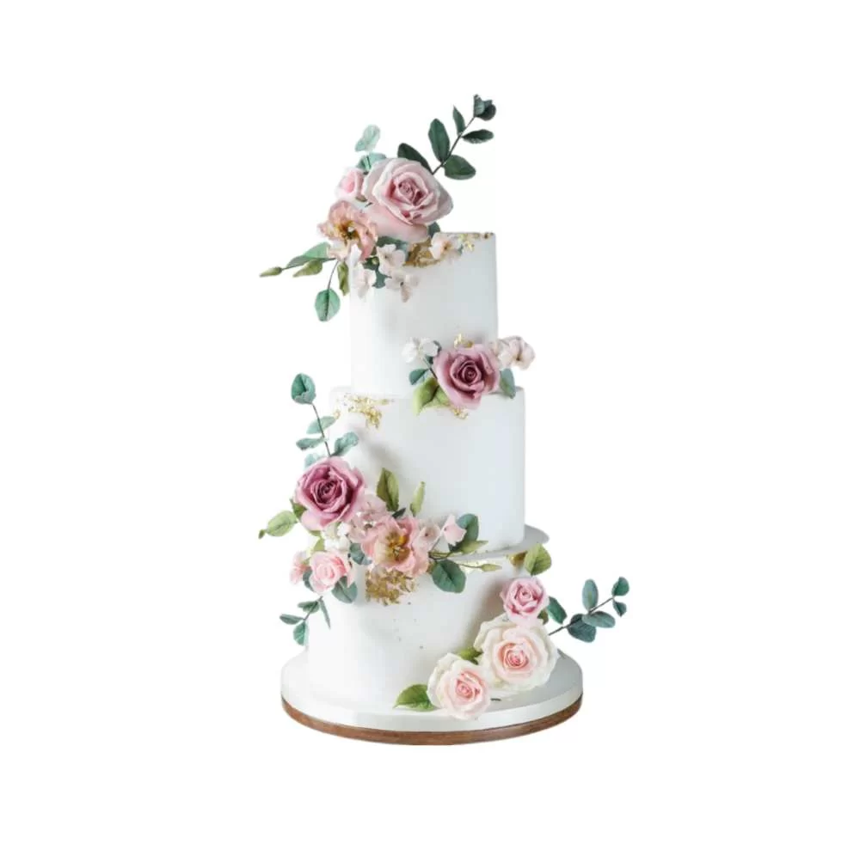

ENTRY FORM

BUNDABERG A.P. & I SOCIETY INC

THE SECRETARY, SHOWGROUNDS OFFICE

Via UNIVERSITY DRIVE, BUNDABERG QLD 4670

TELEPHONE:- (07) 4138 7605

ABN 21 134 402 026

*EACH EXHIBITOR TO BE ON A SEPARATE FORM*

PLEASE NOTE: MULTIPLE ENTRIES PER SECTION TO BE WRITTEN ON THE ONE FORM. YOU DO NOT NEED TO COMPLETE A SEPARATE ENTRY FORM PER CLASS IN ANY PARTICULAR SECTION.

` Subject to the Rules, By-Laws and Regulations of your Society and the Queensland Chamber of Agricultural Societies, I make the following entries for your forthcoming Show.

EACH SECTION NOT CLASS TO BE ON A SEPARATE FORM

ONE LINE PER ENTRY

|  |  |  |  |  |
| --- | --- | --- | --- | --- |
| SECTION NUMBER | CLASS NUMBER | DESCRIPTION OF EXHIBIT | FOR SALE PRICE | ENTRY FEE |
|  |  |  |  |  |
|  |  |  |  |  |
|  |  |  |  |  |
|  |  |  |  |  |
|  |  |  |  |  |
|  |  |  |  |  |
|  |  |  |  |  |
|  |  |  |  |  |
|  |  |  |  |  |
|  |  |  |  |  |
|  |  |  |  |  |
|  |  |  |  |  |
|  |  |  |  |  |
|  |  |  |  |  |
|  |  |  | TOTAL  FEES |  |

DATE OF BIRTH FOR CHILD EXHIBITOR

PLEASE PRINT

NAME OF EXHIBITOR

ADDRESS

PHONE NUMBER

EMAIL:

DATE ABN

SIGNATURE TO BE COLLECTED YES/NO