**2025**

**131st**

**Hitz fm 93.9**

**BUNDABERG**

**SHOW**

# **WEDNESDAY 28th May**

**THURSDAY 29th May**

**FRIDAY 30th May**



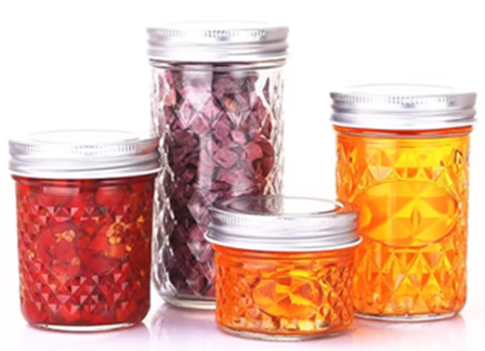

**SECTION 17**

**PICKLES, JAMS, JELLIES & HONEY**



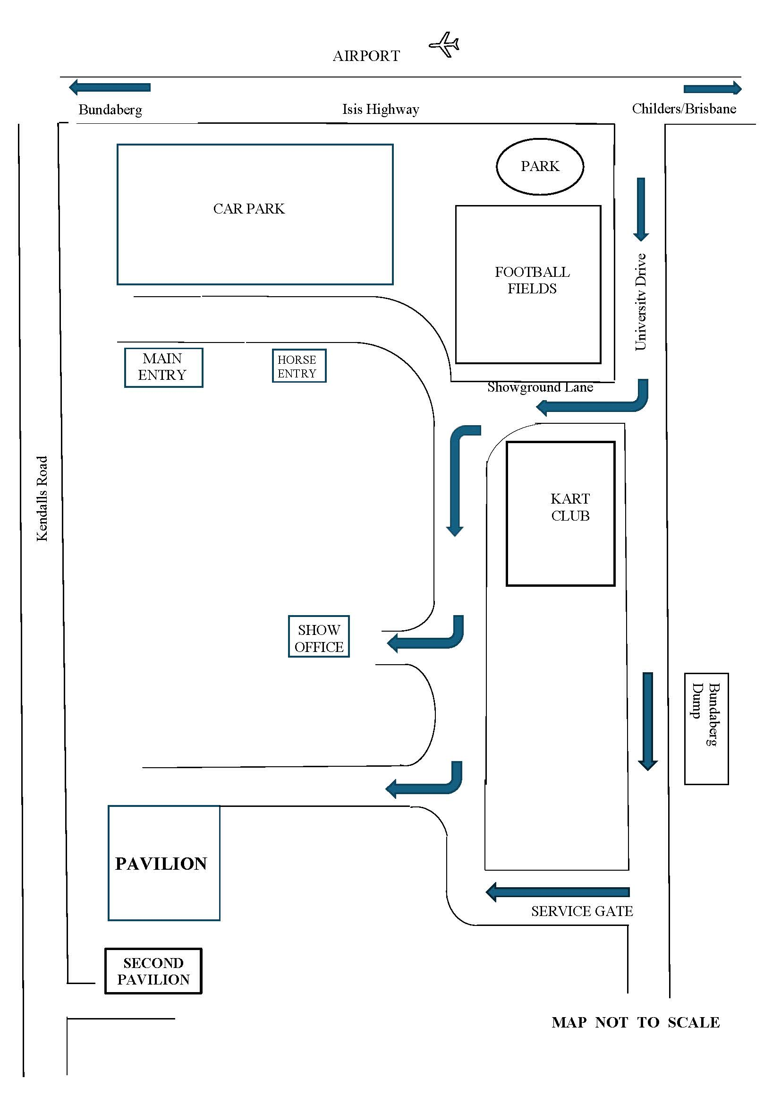

The Information provided by Exhibitors Is used by the Queensland Chamber of Agriculture Associations Inc. and the Bundaberg A.P. & I, Society Inc. to organize , process and conduct competitions at the Bundaberg AP & I Society Inc show. By entering such competitions, you consent to your personal Information being used for this purpose Including this Information being made available to sponsors, breed Associations, the media, the public, promotional purposes. archival purposes, published in publications or as It Is otherwise required by Law.

All exhibitors have the right to access and alter personal information concerning themselves in the terms of the Privacy Act. This can be done by contacting the QCAS CEO or by writing to QCAS

WORKPLACE HEALTH AND SAFETY

All Queensland Chamber of Agriculture Societies Inc. affiliated Association Showgrounds are designated workplaces within the meaning of the

Workplace Health and Safety Act 2011 and exhibitors/competitors are required to ensure that they and all persons under their direction or control, including their contractors or subcontractors, comply with all requirements of the Act. The Queensland Chamber of Agriculture Associations Inc hold each exhibitor responsible to discharge Its obligations to provide and maintain a safe place and system of work during occupation by the exhibitor/competitor of any area of the affiliated Agricultural Associations Showgrounds/Precinct.

Each exhibitor/competitor will assess the risk to themselves, staff, volunteers, family, other exhibitors, Agricultural Society staff, show visitors, children and any person foreseeably affected by the presentation of their exhibit.

Exhibits will only be held and handled by competent persons whose experience Is known to the Exhibitor/ competitor.

The exhibitors/competitors are advised that the use of Primus Stoves, any heating or lighting appliances of a like character, or any naked light, ls strictly prohibited in Pavilions/stables/barns.

Any exhibitors/competitors Intending to bring electrical equipment to the Showgrounds/Precinct will be required to ensure that such equipment Is fitted with a residual current protection and that all electrical lead s, tools and appliances have been Inspected by a licensed electrical contractor and are currently tagged. The use of double adaptors is prohibited, and all power boards must also be tested and tagged.

All exhibitors/competitors will comply with the requirements of the ACT end Its Regulations and Standards In every respect. This Is essential for the safety of all exhibitors/competitors and the general public. The ACT Imposes very severe penalties in the event of noncompliance with its provisions. Any exhibitors/competitors who do not comply will not be allowed to exhibit at "Queensland Chamber of Agriculture Association. affiliated Shows".

**BUNDABERG SHOW**

GATE ENTRY FEES:

ADULT:------------------------------$20.00

STUDENT: 6 – 17 yrs.:------------$10.00

CONCESSION:---------------------$10.00

OVER 75 YEARS :-----------------FREE

UNDER 6 YEARS:-----------------FREE

**PRE-PURCHASE TICKET ONLY**

FAMILY ONE DAY PASS $50.00

(Available until Tuesday 27th May )

(Includes 2 Adult & 2 Children 15 yrs. & under)

**HOW TO ENTER THE SECTIONS**

FILL OUT ENTRY FORMS

**All entries must be:**

* **On Official Entry Forms**
* **On SEPARATE Entry Forms for Each Section (NOT CLASS)**
* **Fully completed**
* **Accompanied by Entry Fees (Refer Sections)**
* **Handcraft, Photography and Fruit & Vegetables have separate entry forms**

# **ENTRIES WILL NOT BE ACCEPTED**

* **Without entry fees**
* **Over the telephone**
* **After closing date**

# **DELIVER ENTRY FORMS TO**

**Bundaberg Show Society Office**

**via University Drive, Bundaberg**

**Enquiries – Phone 07 4138 7605**

**Delivery of entry forms :April – Mon, Wed & Fri - 9am – 1pm.**

**May - Mon-Fri 9am- 4pm.**

# **YOU WILL RECEIVE**

* **Class Ticket stating Section, Class and Entry No.**
* **Receipt**

# **DELIVER EXHIBITS**

* **Accompanied by Class Ticket (ATTACHED)**

**(This is proof of Entry in a Class)**

* **To designated part of Showground by due date and time.**

## PLEASE REFER TO EACH SECTION FOR CLOSING, DELIVERY & COLLECTION

**Prize money** to be collected from the Show Office during the Show from 2pm Wednesday, 28th May to 2pm Saturday 31st May. Office hours 9.00 – 4.00. Prize Money NOT COLLECTED will be deemed a donation and returned to Society Funds. All prize money/entry fees contain GST whether registered or not for GST purposes.

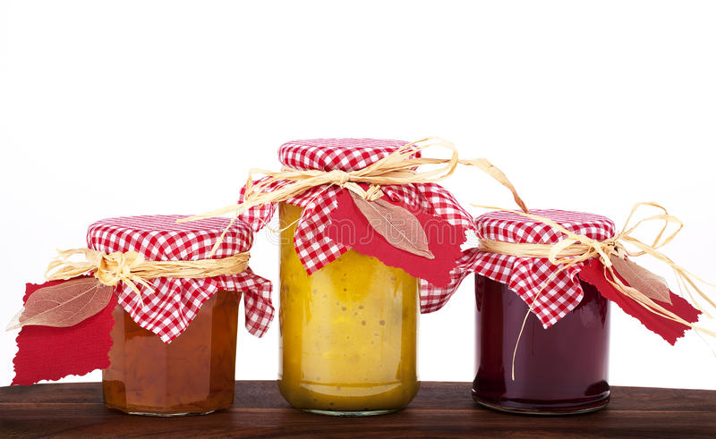

**SECTION 17**

**PICKLES, JAMS, JELLIES & HONEY**

**CONDITIONS OF ENTRY**

1. There will be no limit of entries.
2. No entry can be entered in more than one class.
3. All exhibits must be the bona fide work of the exhibitor.
4. **Two (2) jars**, - (each containing 250g) required for **all** Classes
5. Total content weight of jars to be 500 g.
6. Screw top jars please and each jar to be labelled.
7. **ENTRIES CLOSE** Friday 23rd May at 4.00pm.

10. Entry Forms to be lodged at **THE SECRETARY’S OFFICE, AT THE SHOWGROUNDS, via UNIVERSITY DRIVE, (OPPOSITE BUNDABERG AIRPORT).**

11. Exhibits to be delivered to the Main Pavilion, via University Drive, on Monday 26th May between 2.00 pm and 5.30pm.

12. Exhibits to be collected on Saturday 31st May between 9.00 and 10.00am.

13. No refunds if change of mind or unable to attend.

***ANY EXHIBIT NOT COLLECTED BETWEEN THOSE TIMES WILL BE DESTROYED.***

**Prize money** to be collected from the Show Office during the Show from 2pm Wednesday, 28th May to 2pm Saturday, 31st May. Office hours 9.00 – 4.00. Prize Money NOT COLLECTED will be deemed a donation and returned to Society Funds. All prize money/entry fees contain GST whether registered or not for GST purposes.

**CHIEF STEWARD** **Mrs Julie HALE** – MOB - 0418 611 581

**ENTRY FEES** Classes 17/1 to 17/30- $1.00 per entry, incl G.S.T.

**PRIZEMONEY** 1ST $10.00 2ND $6.00 3RD $4.00 (Classes 17/1 to 17/30)

If there are fewer than three (3) entries in a class, **only one prize will be awarded.**

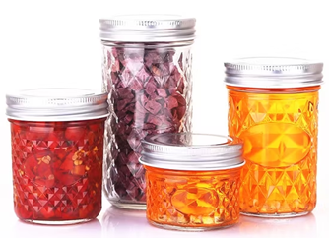

**CLASS DETAILS**

17/1 RELISH - Tomato

17/2 PICKLES – Any variety

17/3 PICKLED ONIONS

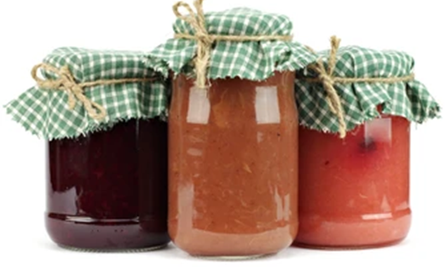17/4 CHUTNEY - Mango

17/5 CHUTNEY - Any Other

17/6 MARMALADE – Any Variety

17/7 JAM - Tomato

17/8 JAM - Rosella

17/9 JAM - Pineapple

17/10 JAM - Dried Apricot

17/11 JELLY - Any Variety

17/12 JAM - Mango

17/13 JAM - Any other Variety

17/14 LEMON CHEESE

17/15 PASSIONFRUIT BUTTER

17/16 SAUCE – Any variety

### MEN’S DIVISION

17/23 RELISH - Own Choice - Two (2) Jars

17/24 CHUTNEY - Own Choice - Two (2) Jars

17/25 JAM - Own Choice - Two (2) Jars

17/26 SAUCE - Own Choice - Two (2) Bottles

**SPECIAL NEEDS SECTION**

*This section is for people with special needs, any age.*

17/27 RELISH – Own choice – two (2) jars

17/28 CHUTNEY – Own choice – two (2) jars

17/29 JAM – Own choice – two (2) jars

17/30 SAUCE – Own choice – two (2) bottles

***Labels are to have the type of jam, relish or chutney clearly on all jars or bottles***.

**CHAMPION JAMS, PICKLES & JELLIES** **EXHIBIT**

Will be awarded the Society's Champion Ribbon

**RESERVE CHAMPION**

Will be awarded the Society’s Reserve Champion Ribbon.

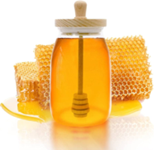

**HONEY**

**CONDITIONS OF ENTRY**

1. Refer General Rules of Competition at the back of Schedule.

2. Unless stipulated, all exhibits must be the property and the produce of the exhibitor's own apiaries, except in class 33/8.

3. No exhibits can be entered in more than one class.

4. Multiple entries are allowed in all classes, provided each entry is of a different floral source.

5. There will be no limit of entries.

6. Natural coloured wax is only permitted in classes 17/37 & 17/38.

7. Honey will be in two (2) x 500g jars and will be liquid extracted.

8. The exhibitor's name must not appear on any exhibit, unless specifically stipulated. Please cover any name on label.

9. **ENTRIES CLOSE** Friday 24th May at 4.00 pm.

10. Entry forms **must** be lodged at THE SECRETARY’S OFFICE, SHOWGROUNDS’ OFFICE, via UNIVERSITY DRIVE, BUNDABERG.

11. Exhibits to be delivered to the Main Pavilion, via University Drive, on Monday 27th May between 3.00 pm and 5.30 pm.

12 Exhibits to be collected on Saturday 1st June 2024 between 9.00 and 10.00am

13. No refunds if change of mind or unable to attend.

14. All exhibits must have the type of honey printed on labels.

15. All bottles to be labeled.

**CLASSES**

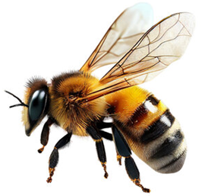

17/33 LIGHT HONEY (0-34 P’ Fund Honey Colour)

17/34 GOLDEN HONEY (35-50 P’ Fund Honey Colour)

17/35 AMBER HONEY (51-65 P’ Fund Honey Colour)

17/36 DARK HONEY (66+ P’ Fund Honey Colour)

17/37 GRANULATED HONEY

17/38 CREAMED HONEY

17/39 COMB IN HONEY 2 x 500gm jars

17/40 ONE FRAME OF COMB HONEY

17/41 BEES WAX – A MOULDED BLOCK – 2kg approx. (natural coloured wax only)

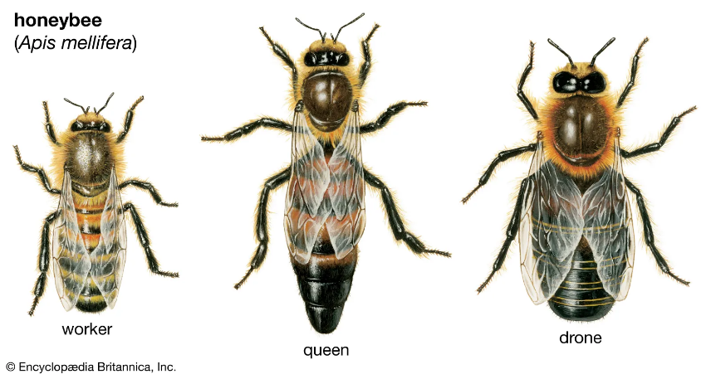

ENTRY FORM

BUNDABERG A.P. & I SOCIETY INC

THE SECRETARY, SHOWGROUNDS OFFICE

Via UNIVERSITY DRIVE, BUNDABERG QLD 4670

TELEPHONE:- (07) 4138 7605

ABN 21 134 402 026

*EACH EXHIBITOR TO BE ON A SEPARATE FORM*

PLEASE NOTE: MULTIPLE ENTRIES PER SECTION TO BE WRITTEN ON THE ONE FORM. YOU DO NOT NEED TO COMPLETE A SEPARATE ENTRY FORM PER CLASS IN ANY PARTICULAR SECTION.

Subject to the Rules, By-Laws and Regulations of your Society and the Queensland Chamber of Agricultural Societies, I make the following entries for your forthcoming Show.

EACH SECTION NOT CLASS TO BE ON A SEPARATE FORM

ONE LINE PER ENTRY

|  |  |  |  |  |
| --- | --- | --- | --- | --- |
| SECTION NUMBER | CLASS NUMBER | DESCRIPTION OF EXHIBIT | FOR SALE PRICE | ENTRY FEE |
|  |  |  |  |  |
|  |  |  |  |  |
|  |  |  |  |  |
|  |  |  |  |  |
|  |  |  |  |  |
|  |  |  |  |  |
|  |  |  |  |  |
|  |  |  |  |  |
|  |  |  |  |  |
|  |  |  |  |  |
|  |  |  |  |  |
|  |  |  |  |  |
|  |  |  |  |  |
|  |  |  |  |  |
|  |  |  |  |  |
|  |  |  | TOTAL  FEES |  |

DATE OF BIRTH FOR CHILD EXHIBITOR

PLEASE PRINT

NAME OF EXHIBITOR

ADDRESS

PHONE NUMBER

EMAIL:

DATE ABN

SIGNATURE TO BE COLLECTED YES/NO