**131st**

**Hitz fm 93.9**

**BUNDABERG SHOW**

**2025**

**Wed 28th May**

**Thurs 29th May**

**Fri 30th May**

**Section 11**

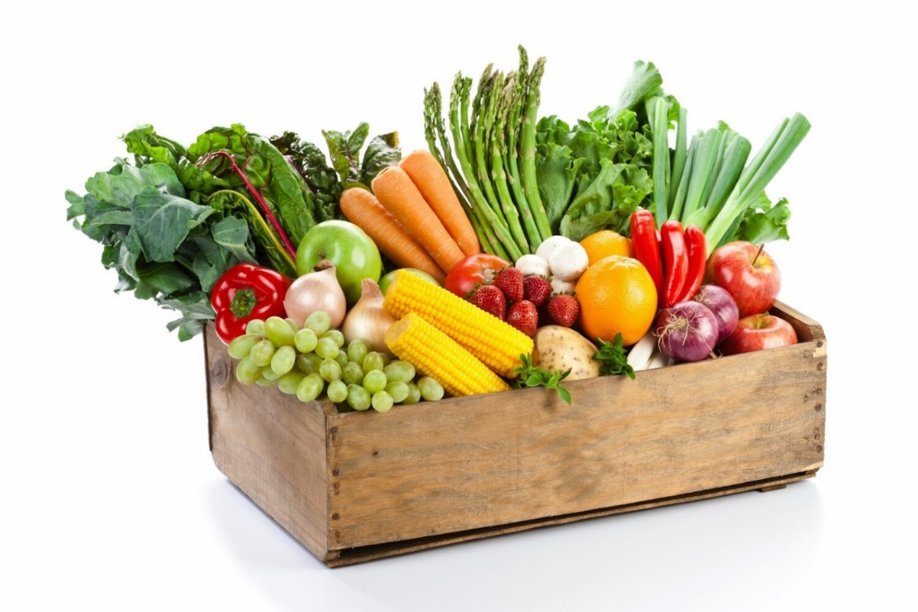 Fruit & Veg

PRIVACY STATEMENT

The Information provided by Exhibitors Is used by the Queensland Chamber of Agriculture Associations Inc. and the Bundaberg A.P. & I, Society Inc. to organize , process and conduct competitions at the Bundaberg AP & I Society Inc show. By entering such competitions, you consent to your personal Information being used for this purpose Including this Information being made available to sponsors, breed Associations, the media, the public, promotional purposes. archival purposes, published in publications or as It is otherwise required by Law.

All exhibitors have the right to access and alter personal information concerning themselves in the terms of the Privacy Act. This can be done by contacting the QCAS CEO or by writing to QCAS

WORKPLACE HEALTH AND SAFETY

All Queensland Chamber of Agriculture Societies Inc. affiliated Association Showgrounds are designated workplaces within the meaning of the

Workplace Health and Safety Act 2011 and exhibitors/competitors are required to ensure that they and all persons under their direction or control, including their contractors or subcontractors, comply with all requirements of the Act. The Queensland Chamber of Agriculture Associations Inc hold each exhibitor responsible to discharge Its obligations to provide and maintain a safe place and system of work during occupation by the exhibitor/competitor of any area of the affiliated Agricultural Associations Showgrounds/Precinct.

Each exhibitor/competitor will assess the risk to themselves, staff, volunteers, family, other exhibitors, Agricultural Society staff, show visitors, children and any person foreseeably affected by the presentation of their exhibit.

Exhibits will only be held and handled by competent persons whose experience Is known to the Exhibitor/ competitor.

The exhibitors/competitors are advised that the use of Primus Stoves, any heating or lighting appliances of a like character, or any naked light, ls strictly prohibited in Pavilions/stables/barns.

Any exhibitors/competitors Intending to bring electrical equipment to the Showgrounds/Precinct will be required to ensure that such equipment Is fitted with a residual current protection and that all electrical lead s, tools and appliances have been Inspected by a licensed electrical contractor and are currently tagged. The use of double adaptors is prohibited, and all power boards must also be tested and tagged.

All exhibitors/competitors will comply with the requirements of the ACT end Its Regulations and Standards In every respect. This Is essential for the safety of all exhibitors/competitors and the general public. The ACT Imposes very severe penalties in the event of noncompliance with its provisions. Any exhibitors/competitors who do not comply will not be allowed to exhibit at"Queensland Chamber of Agriculture Association. affiliated Shows".

**BUNDABERG SHOW**

GATE ENTRY FEES:

ADULT:------------------------------$20.00

STUDENT: 6 – 17 yrs.:------------$10.00

CONCESSION:---------------------$10.00

OVER 75 YEARS :-----------------FREE

UNDER 6 YEARS:-----------------FREE

**PRE-PURCHASE TICKET ONLY**

FAMILY ONE DAY PASS $50.00

(Available until Tuesday 27th May)

(Includes 2 Adult & 2 Children 15 yrs. & under)

**HOW TO ENTER THE SECTIONS**

FILL OUT ENTRY FORMS

All entries must be:

* On Official Entry Forms
* On SEPARATE Entry Forms for Each Section (NOT CLASS) Fully completed
* Accompanied by Entry Fees (Refer Sections)
* Handcraft, Photography and Fruit & Vegetables have separate entry forms

ENTRIES WILL NOT BE ACCEPTED

* Without entry fees
* Over the telephone
* After closing date

DELIVER ENTRY FORMS TO

Bundaberg Show Society Office

via University Drive, Bundaberg

Enquiries - Phone 07 4138 7605

Delivery of entry forms – : April, Mon, Wed & Fri 9am – 1pm .

May, Mon - Fri, 9am - 4pm**.**

YOU WILL RECEIVE

* Class Ticket stating Section, Class, and Entry No.
* Receipt

DELIVER EXHIBITS

* Accompanied by Class Ticket (ATTACHED)

(This is proof of Entry in a Class)

* To designated part of Showground by due date and time.

PLEASE REFER TO EACH SECTION FOR CLOSING, DELIVERY & COLLECTION

Prize Money

PRIZE MONEY: To be collected from the Show Office over the show period from 2pm Wednesday 28th May to 2pm Saturday 31st May. Office hours 9.00 – 4.00.

Prize money not collected during that time will be returned to the Society’s funds. All prize money and entry fees include GST which is payable by all competitors whether registered or not for GST purpose.

EXHIBITS & PRIZE CARDS/RIBBONS

All exhibits must be clearly marked to be collected or destroyed. Any exhibit /Prize cards or ribbons not collected within the designated time slot WILL BE DESTROYED.

**SECTION 11**

**FRUIT & VEGETABLES**

**Grow Your Own**

**Entries Close 4.00pm**

**Friday 23rd May 2025**

**Chief Steward: Jenny Haack Phone: 0447 345 586**

**How to Enter this Section**: Entry Forms, fully completed and signed, should be lodged at the Show Office by Friday 23rd May by 4.00pm.

**Entry**: Fees: As per each class

**No refunds if change of mind or unable to attend.**

**Where & when to bring exhibits**: Exhibits are to be benched at the Main Pavilion between 3.00pm and 5.00pm on Tuesday 27th May 2025.

**When to collect exhibits**: Exhibits may be collected on Saturday 31st May between 8am and 10am unless otherwise arranged. Entries not collected by 10am will be forfeited.

**Number of entries limit**: There will be a limit of two (2) entries per class on all entries. Any entry may be entered in one class only.

**Conditions - acceptance of exhibits**: Any entry in this section may be cut at the discretion of the judge.

**Presentation of exhibits**: Plates will be provided for small quantities.

**Standard of exhibits**: The judges may withhold a prize if, in their opinion, any entry is not of sufficient quality to warrant same, especially in awarding Championships. No correspondence will be entered into.

**Ownership of exhibits**: All exhibits must be the bona fide produce of the exhibitors at the time of entry.

**Exhibit reclassification**: If in the chief Steward's opinion an exhibit is entered in a wrong class, such exhibit may be re-classed and judged accordingly.

**Judging**: The Judge's decision will be final, and no discussion or correspondence will be entered into it. Judging criteria are available from the Chief Steward upon request.

**Acceptance of entries**: The attention of intending exhibitors is drawn to the fact that entries are accepted subject to the rules of the Queensland Chamber of Agricultural Societies and to the Constitution and Rules of this Society, in addition to any special regulations which appear within this Schedule.

***Disclaimer****: The Bundaberg AP. & I. Society Inc. will not be responsible for any error which may appear in this Schedule, or for any entry being in the wrong class; nor will it be responsible or accountable for anything that may happen (from any cause or circumstance whatsoever) to visitors, or exhibitors or to any animal, plant or article exhibited by them, or property brought to the Showground.*

Prizemoney Information: Prize money for this section Is as stated at the beginning of each division, and extra prize money will be clearly stated throughout the classes in the Schedule. Prize Money to be collected from 2pm on Wednesday 29th May to 2pm Saturday 1st June 2024. Any prize money not collected will be returned to Society Funds. All prize money and entry fees include GST which is payable by all competitors whether registered or not for GST purposes.

# **DIVISION "A" VEGETABLES**

Entry Fee: $1.00

**Prize Money:** 1st $10.00 2nd $5.00 3rd $3.00 *unless otherwise stated*

|  |  |  |  |
| --- | --- | --- | --- |
| Class | Description |  | **Quantity** |
|  |  |  |  |
| 1 | Beans | Any one variety | 500g |
| 2 | Beetroot | Any one variety | 3 only |
| 3 | Broccoli | Any one variety | 1 only |
| 4 | Cabbage | Any one variety | 1 only |
| 5 | Capsicum | Any one variety | 3 only |
| 6 | Carrots | Any one variety | 1 bunch |
| 7 | Cauliflower | Any one variety | 1 only |
| 8 | Celery | Any one variety | 1 bunch |
| 9 | Chilies | Any one variety | 1 dish |
| 10 | Chokos | Any one variety | ;:sonly |
| 11 | · Cucumbers | Any one variety | 3 only |
| 12 | Eggplant | Any one variety | 3 only |
| 13 Eschalots | | Any one variety | 1 bunch |
| **14** | Kale | Any one variety | 1 bunch |
| 15 | Leeks | Any one variety | 1 bunch |
| **16** | Lettuce | lceberq | 1 only |
| 17 | Lettuce | Fancy | 3 only |
| 18a | Peanuts | Any one variety | 1 dish nuts |
| 18b | Pecan Nuts | Any one variety | 1 dish nuts |
| 18c | Walnuts | Any one variety | 1 dish nuts |
| 18d | Macadamia Nuts | Any one variety | 1 dish nuts |
| 19 | Onions | Any one variety | 3 only |
| 20 | Peas | Pod | 1 dish |
| 21 | Peas | Snow | 1 dish |
| 22 | Potatoes | English - Anv one variety | 3 only |
| 23 | Potatoes | Sweet - Any one variety | 3 only |
| **24** | Pumpkin | Butternut | 1 only |
| 25 | Pumpkin | Jap | 1 only |
| 26 | Pumpkin | Other | 1 only |
| 27 | Radish | Any one variety | 1 bunch of 5 |
| 28 | Silverbeet | Any one variety | 1 bunch |
| 29 | Spring onions | Any one variety | 1 bunch |
| 30 | Squash | Any one variety | 3 only |
| 31 | Sweetcorn | Any one variety | 3 only |
| 32 | Tomatoes | Coloured - Any one variety | 3 only |
| 33 | Tomatoes | Cherry (small) - Any one variety | 1 punnet |
| 34 | Tomatoes | Green - Any one variety | 3 only |
| I 35 | Turnips | Any one variety | 3 only |
| 36 | Zucchini | Any one variety | 3 only |
| 37 Any other vegetable not  specified | | Any one variety - named | 1 dish or 3 only |

# 

# **DIVISION "B" FRUIT**

**ENTRY FEE $1.00**

**Prize Money:** 1st $10.00 2nd $5.00 3rd $3.00 *unless otherwise stated*

|  |  |  |  |  |  |  |  |
| --- | --- | --- | --- | --- | --- | --- | --- |
| **Class** | **Description** |  |  |  | I | **Quantity** | |
| **38** | Avocados |  |  | , | - Any one variety | 3 only | |
| 39 | Bananas | | | | Cavendish | 1 small hand | |
| **40** | Bananas - | | | | Lady Fingers | 1 | small hand |
| **41** | Bananas | | | | Sugar | 1 small hand | |
| **42** | Custard apples | | | | Any one variety | 3 only | |
| **43** | Grapefruit |  | - |  | Any One variety | 3only | |
| **44** | Lemons | | | | Any one variety | 3 only | |
| **45** | Limes | - |  |  | ·Any one variety | 3only | |
| **46** | Mandarins | | | | Any one variety | 3 only | |
| **47** | Melon | | | | Honeydew | 1 only | |
| **48** | Melon | | | | Rockmelon | 1 | only |
| **49** | Melon | | | | Watermelon | 1 only | |
| **50** | Oranges | | | | Any one variety | 3 only | |
| **51** | Passionfruit | | | | Any one variety | 3 | only |
| **52** | Pawpaw · | | | | Any one variety | 1 | only |
| **53** | Pineapples· | | | | Any one variety | 1 | only |
| **54** | Rhubarb | | | | Any one variety | 1 bunch | |
| **55** | Rosellas | | | | Any one variety | 1 | dish |
| **56** | Strawberries | | | | Any one variety | 1 | punnet |
| **57** | Any other fruit not specified | | | | Any one variety - named | 1 dish or  3 only | |

# **DIVISION "C" OTHER**

**Entry Fee $1.00**

**Prize Money:** 1st $20.00 2nd $10.00 3rd $5.00 *unless otherwise stated*

|  |  |  |  |  |  |  |  |
| --- | --- | --- | --- | --- | --- | --- | --- |
| **Class** | **Description** |  |  |  | I | **Quantity** | |
| **58** | EGGS |  |  | , | Fresh – White or Brown, judged on uniformity & colour in carton | 1 dozen | |
| 59 | MIXED HERBS | | | | Best Collection, any 4 varieties |  | |
| **60** | LARGEST DIAMETER PUMPKIN | | | |  |  |  |
|  |  | | | |  |  | |

# **DIVISION "D**"

**ENTRY FEE $1.00**

# **CLASS 61**

BEST ANIMAL SHAPE

Made from Fruit or Vegetables

*Make your favourite animal (named).*

Ages 4 to 10 years

**Prize Money:** 1st $15-00 2nd $10.00 3rd $5.00

# 

# **CLASS 62**

**Table Top Scarecrow**

Make your own Tabletop Scarecrow (any description)

(Individuals/Families)

**Prize Money:** 1st $20-00 2nd $15.00 3rd $10.00

# **CLASS 63**

**Scarecrow**

Schools/Business/Organisations

Make your own full size scarecrow

**Entry Fee**: $1:00

**Prize Money:** 1st $50.00 2nd $30.00 3rd $20.00

**___________________________**

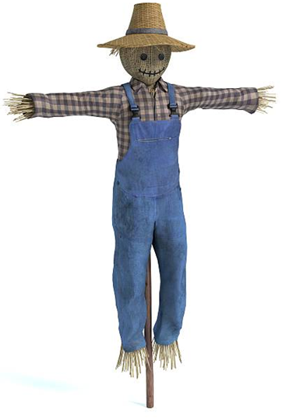

ENTRY FORM

BUNDABERG A.P. & I SOCIETY INC

THE SECRETARY, SHOWGROUNDS OFFICE

Via UNIVERSITY DRIVE, BUNDABERG QLD 4670

TELEPHONE:- (07) 4138 7605

ABN 21 134 402 026

*EACH EXHIBITOR TO BE ON A SEPARATE FORM*

PLEASE NOTE: MULTIPLE ENTRIES PER SECTION TO BE WRITTEN ON THE ONE FORM. YOU DO NOT NEED TO COMPLETE A SEPARATE ENTRY FORM PER CLASS IN ANY PARTICULAR SECTION.

Subject to the Rules, By-Laws and Regulations of your Society and the Queensland Chamber of Agricultural Societies, I make the following entries for your forthcoming Show.

EACH SECTION NOT CLASS TO BE ON A SEPARATE FORM

ONE LINE PER ENTRY

|  |  |  |  |  |
| --- | --- | --- | --- | --- |
| SECTION NUMBER | CLASS NUMBER | DESCRIPTION OF EXHIBIT |  | ENTRY FEE |
|  |  |  |  |  |
|  |  |  |  |  |
|  |  |  |  |  |
|  |  |  |  |  |
|  |  |  |  |  |
|  |  |  |  |  |
|  |  |  |  |  |
|  |  |  |  |  |
|  |  |  |  |  |
|  |  |  |  |  |
|  |  |  |  |  |
|  |  |  |  |  |
|  |  |  |  |  |
|  |  |  |  |  |
|  |  |  |  |  |
|  |  |  | TOTAL  FEES |  |

DATE OF BIRTH FOR CHILD EXHIBITOR

PLEASE PRINT

NAME OF EXHIBITOR

ADDRESS

PHONE NUMBER

EMAIL:

DATE ABN

SIGNATURE TO BE COLLECTED YES/N